Analysis and Use of Crosstalk in the CMS Silicon Strip Detector

J. Rogers and T. Adams

Senior Thesis, Fall 2016

Analysis and Use of Crosstalk in the CMS Silicon Strip Detector

The Compact Muon Solenoid (CMS) detector at CERN’s Large Hadron Collider (LHC) is a general purpose detector built to study high energy particles resulting from proton-proton collisions. Charged particles pass through grids of active silicon strip channels in the inner tracking system and deposit energy. Even when only one strip channel is affected, signals can be induced on the neighboring strip channels via a process known as crosstalk. Crosstalk causes particle hits to appear as clusters of affected strip channels. Models of crosstalk are used to reconstruct the energy deposition of highly ionizing particles causing saturation in strip channels. Current models of crosstalk predict the way energy is distributed across a strip cluster will be the same across all inner silicon detector modules. This work will focus on determining the behavior of crosstalk in the CMS data and simulation. To determine if the profile of the energy distribution due to crosstalk varies several cases were investigated. The energy distribution profile of crosstalk may be dependent on silicon detector module, strip channel energy, saturation, or other factors not accounted for. If the distribution profile is found to have any of these dependencies, by accounting for these dependencies, energy reconstruction methods for saturated clusters may be refined. By studying unsaturated strip clusters the behavior of crosstalk can be determined. To study the properties of the energy distribution profiles, and to assess the accuracy of the current model of crosstalk, data from collisions at $\sqrt{s}=13 TeV$ are analyzed and compared to standard model simulations.

Introduction

The silicon tracker inside the Compact Muon Solenoid¹ (CMS) is the largest silicon detector in the world with more than 75 million separate readout channels and about 200 m² of active detecting silicon. The detector takes position measurements through several radial detector layers to observe particle tracks. The tracker is comprised of the silicon pixel detector and the silicon microstrip detector. The silicon strip detector has about 9.6 million silicon microstrip detector channels and covers the radius between $0.2 m<r<1.16 m$ from the interaction point. The silicon strip detector is further divided into several inner subdetectors constituting different regions of the detector. Each subdetector is further divided into individual silicon detector modules. Tracker hits are readout when charged particles pass through and ionize silicon strips thus depositing energy. Strips are typically between $320 μm-500 μm$ thick and have an average pitch between $80 μm-180 μm$.
Due to electrical couplings between neighboring strips, readout signals can be induced on neighboring strip channels via a process known as crosstalk. Crosstalk causes tracker hits to appear as clusters of affected strips. The crosstalk energy distribution profiles of these strip clusters are Gaussian in form and usually affect 3-7 strips. The energy distribution profile is expected to be nearly constant across the inner subdetectors.
The silicon strips are also subject to a readout saturation. When no strip channels in a cluster are saturated, the total energy deposited can be found by summing the energies of each strip channel in the cluster. Finding the total energy is more complicated when one or more strip channels are saturated because the readout value for saturated strips does not have quantitative meaning. The energy distribution profile of the crosstalk may be used to calculate the energy of a saturated strip channel, giving an opportunity to recover the total energy of the saturated cluster.
The energy of the saturated strip channels can most easily be recovered for an idealized case of crosstalk where the particle passes through and saturates only one strip channel. In this case, energy readout from neighboring strip channels must be the result of crosstalk. For this case the energy distribution profile can be used to reconstruct the energy in the saturated strip channel and the energy of the cluster.
Accurate reconstruction of the energy deposited by saturating particles is important to the search for singly and multiply charged heavy stable charged particles (HSCPs). This is because slow moving HSCPs impose more ionization on the silicon and have a higher chance of causing saturation. Since energy deposition is dependent on charge, multiply charged particles are even more likely to cause saturation.
The goal of this work is to study the behavior of crosstalk in the CMS data and simulation. Data are selected to acquire a sample with a high proportion of “ideal clusters” where the energy of the cluster is deposited into a single strip channel and then shared via crosstalk. Due to the statistical nature of high energy physics, the profile of the energy distribution may show a large variance between individual clusters but, statistically, should be constant.
Slight inconsistencies in data imply energy distribution profiles may have subdetector and/or saturation dependence. By observing the distribution profiles from experimental data we seek to describe the distribution profile for each of the different subdetectors. If the distribution models are found to vary then reconstruction methods may be modified to be more accurate.

Tracker Layout
The inner tracking system of CMS is composed of several different layers of detecting modules. By taking many position measurements on transiting charged particles, high resolution particle tracks can be reconstructed. The silicon pixel detector is the innermost detector, occupying the radial region $0 m<r < 0.1 m$. The silicon strip tracker occupies the region $0.2 m <r < 1.16 m$ and has four distinct subdetectors known as the Tracker Inner Barrel (TIB), Tracker Inner Disks (TID), Tracker Outer Barrel (TOB), and Tracker Endcaps (TEC). The CMS tracker layout is detailed in Fig.1. This work will focus on determining the properties and dependencies of crosstalk in the CMS silicon strip tracker. Full specifications about the CMS silicon tracker can be found in Sec. 3 of Ref. 1.

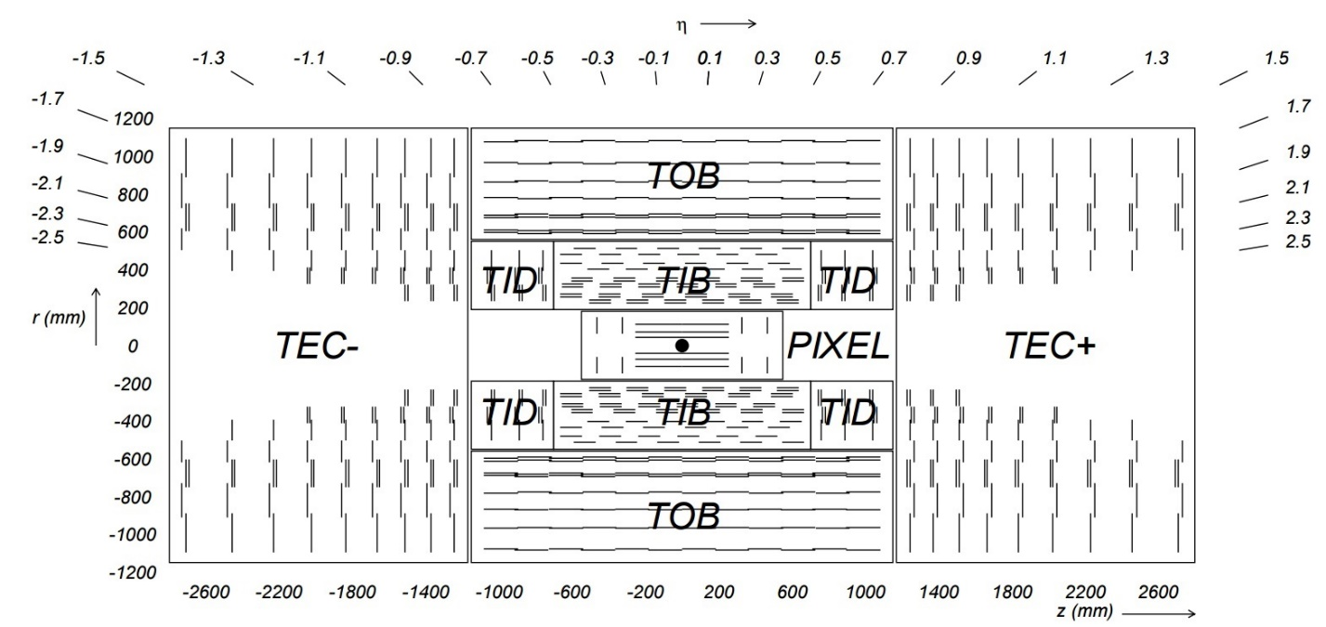
Figure 1: Schematic of the CMS tracking system¹. Lines represent the layers of silicon modules discussed below.

Silicon Strip Detector
The TIB and TID of the CMS silicon strip detector occupy the region $0.2 m <r < 0.55 m$. The TIB has 4 barrel layers and the TID has 3 disk layers on each end. The silicon modules in the TIB and TID are 320 μm thick. The strip pitch of the TIB for layers 1-2 is 80μm and for layers 3-4 is 120 μm. The mean pitch of the TID varies between 110 μm – 141 μm.
The TOB occupies the region $0.55 m <r < 1.16 m$ and has 6 barrel layers of module thickness 500 μm. The strip pitch of the TOB for layers 1-4 is 183 μm and for layers 5-6 is 122 μm. The TOB occupies the region $\left|z\right|= 1.18 m$ where the $z$ axis is parallel to the beam pipe and $z$= 0 corresponds to the collision point in the detector.
The TEC covers the region $1.24 m <|z| < 2.82 m$ and $.225 m <r < 1.135 m$. Each half of the TEC has 9 disks where each disk has up to 7 rings of detector modules. The strip thickness for rings 1-4 is 320 μm and for rings 5-7 is 500 μm with radial strips of average pitch between 97 μm – 184 μm.
Signals are readout from silicon strip channels using a custom readout circuit, the APV25², developed for use in the CMS detector (shown in Fig. 2). It is a 128 channel analog pipeline chip designed for high radiation tolerance and low signal to noise ratios. Upon triggering, the APV25 sends analog signals into the Front End Driver boards, where the analog-to-digital conversion (ADC) takes place.

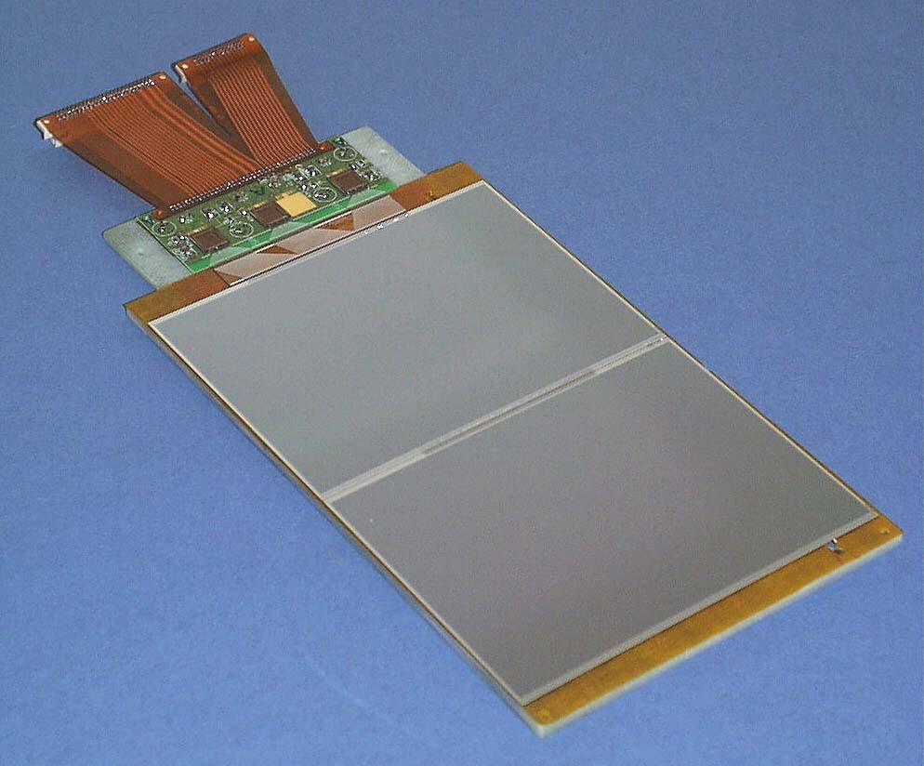
Figure 2: The APV25 readout chip and silicon detector module. On each of the two large panels of silicon there are grids of silicon microstrip channels too small to be seen.
In total, CMS has 14 different module geometries; 2 rectangular shaped sensors each for the TIB and TOB, and 10 wedge shaped sensors each for the TID and TEC. Each silicon module either has 512 or 768 silicon strip channels and are typically about 6 x 12 ${cm}^{2}$ in the inner barrel and 10 x 10${cm}^{2}$in the outer barrel. Table 1 shows which sensor geometries correspond to each subdetector module.

Table 1: Description of naming and numbering for the inner subdetectors.
Subdetector Number | Detector Module Abbreviation | Detector Module
1 | IB1 | TIB
2 | IB2
3 | OB1 | TOB
4 | OB2
5 | W1A | TID
6 | W2A
7 | W3A
8 | W1B
9 | W2B
10 | W3B
11 | W4 | TEC
12 | W5
13 | W6
14 | W7

Energy Deposition
When charged particles transit the silicon strips they ionize the strips, thus depositing energy. The energy deposited by a particle is proportional to its charge and is modeled by the Bethe formula³. The Bethe formula describes the stopping power, or the energy deposition, as a function of depth in the material in question. This equation generates the Bragg curve⁴, shown in Fig. 3, where the energy deposited increases proportionally with increasing depth and, at some point, peaks dramatically before falling to zero. This implies energy deposition due to heavy, slow moving, particles is significantly larger than that of light, fast particles. The momentum of particles is found using curved particle tracks in the detector but, since momentum is the product of mass and velocity, neither the mass nor velocity can be explicitly determined from this. The energy deposition of a particle is related to its velocity and, with information about the particle’s momentum and velocity, its mass can be calculated.
To deal with the immense quantities of data generated by the CMS detector, each strip readout value is limited to 8 bits in size, thus imposing a readout saturation and limiting values between 0-255 ADC counts. Highly ionizing particles can cause saturation in the silicon strips when the energy they deposit exceeds the maximum ADC threshold. The actual energy deposited into a saturated strip is ambiguous because the readout value for a saturated strip is equivalent to only a “max value”. Strip channel energies of 254 and 255 refer to saturated strips such that valid readout values will be integer values between 0-253. A readout value of 254 or 255 implies the energy deposited was greater than or equal to $254$ ADC counts.

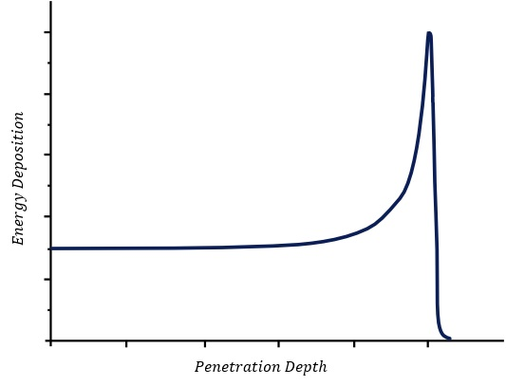
Figure 3: The Bragg curve models the energy deposited as a function of depth in material. Note that at some critical point the energy deposition begins to rapidly increase until the particle ultimately deposits all its energy. The details of where this happens depends upon the energy of the incident particle and the material.

Crosstalk
Crosstalk is a phenomenon that arises due to the capacitive coupling between neighboring strip channels. It is the process by which an affected strip channel can induce a signal on its neighboring strip channels. When a particle passes through only one strip channel, the affected strip distributes some portion of its energy to its neighboring strips creating a strip cluster. If no saturation occurs, the total energy deposited by the particle is the sum of the energies in each strip such that finding the total energy of the cluster is straightforward. The form of the energy distribution profile is expected to be constant across all inner subdetectors.
When highly ionizing particles saturate strip channels the total energy deposited is ambiguous but, using an idealized model of crosstalk, the energy might be reconstructed. This is possible because the type of saturation in the strip channels is a readout saturation. A readout saturation only limits the size of the readout values and the silicon strip still actually experiences energy deposition greater than that of the saturated readout value. If the energy distribution profile is known, the energy in a saturated strip can be approximated using its neighboring strips (if they are unsaturated).
Current models predict when one central strip channel is affected that energy will be distributed symmetrically to the neighboring strips creating a strip cluster. In an ideal strip cluster the central strip channel, each first neighbor, and each second neighbor will receive 72%, 10%, and 4% of the energy respectively. An ideal strip cluster with these ratios is shown in Fig. 4. Of course, rarely do strip clusters exactly fit this idealized case.

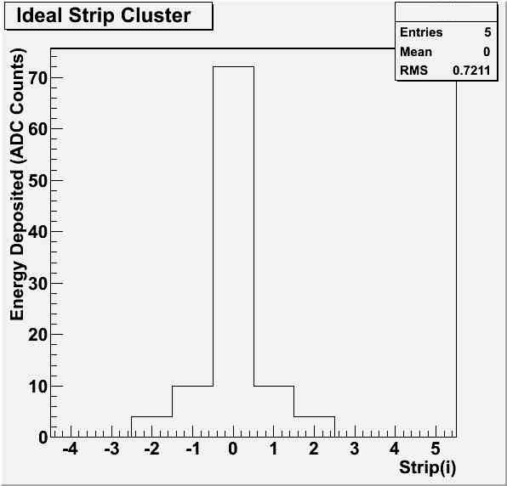
Figure 4: An example of an ideal strip cluster per the current model of crosstalk. Using the notation $E\left(0\right)=E_{m}$, where $m$ refers to the index of the strip with the maximum energy in the cluster, the above cluster has energies $E_{m}=72, E_{m±1}=10,$ and $E_{m±2}= 4$. Also, $\sum_{i=-2}^{2}{E_{m+i}}=100.$

An example of an “ideal” saturated strip cluster from data that may be subject to reconstruction is shown in Fig. 5. It is important to note that although the energy in each first neighbor is not equal, they are within a small margin of one another. Since this cluster is likely caused via the ideal case of crosstalk, knowing the ratio of energy that is supposed to be shared with each first neighbor, the energy in the central saturated strip channel can be approximated.

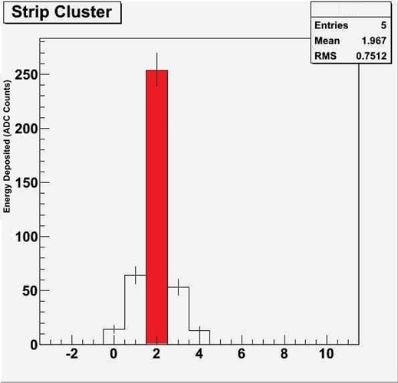
Figure 5: An example of a saturated strip cluster that would be subject to energy reconstruction. Since the middle strip in the cluster is saturated (red) the energy deposited in that channel is greater than or equal to 254 ADC counts. Also, each first and second strip channel are approximately equal to one another.

Only unsaturated ideal clusters of 5 affected strips were considered to select clusters that fit the ideal crosstalk process. It was also required that the middle strip in the cluster was the maximum and each of the first neighboring strips were within 15% of one another (Eq. 1). Furthermore, it was required for each cluster that $E_{m-1}>E_{m-2}$ and $E_{m+1}>E_{m+2}$. These selection criteria were imposed to select clusters that fit the ideal case of crosstalk.

$\left|\frac{E_{m-1}-E_{m+1}}{\left(\frac{E_{m-1}+E_{m+1}}{2}\right)}\right|≤ 0.15$ (1)
Strip Ratios
To analyze properties of the crosstalk across different module geometries only unsaturated, ideal strip clusters were considered. Unsaturated strip clusters contain unambiguous information about the energy deposited in each strip. The distribution profile of the crosstalk will be determined using these clusters. The portion of energy distributed to each strip is investigated using two types of strip ratios: strip-to-sum ratios and strip-to-strip ratios or $R_{i}$ (Eq.2) and $R_{i/j}$ (Eq. 3) respectively. Current models of crosstalk predict values for these ratios are given in Table 2.

$R_{i}=\frac{E_{i}}{\sum_{i=-2}^{2}{E_{m+i}}}$ (2)
$R_{i/j}=\frac{E_{i}}{E_{j}}$ (3)

Table 2: Strip-to-sum ($R_{i}$) and strip-to-sum ($R_{i/j}$) ratios predicted by the current model of crosstalk.
$$R_{i_{predicted}}$$ | $$R_{i/j predicted}$$
$$R_{m}≈ 0.72$$ | $$R_{m-1/m}≈R_{m+1/m}≈ 0.14$$
$$R_{m-1}≈R_{m+1}≈ 0.10$$ | $$R_{m-2/m}≈R_{m+2/m}≈ 0.06$$
$$R_{m-2}≈R_{m+2}≈ 0.04$$ | $$R_{m-2/(m-1)}≈R_{m+2/(m+1)}≈ 0.4$$

Each strip-to-sum ratio represents the ratio of the energy in the i^{th} channel to the sum of all the strip energies in the cluster. Similarly, strip-to-strip ratios give the ratio of the energy deposited in the i^{th} strip to that of the j^{th} strip. These ratios may have a large variance between individual clusters but when considering many clusters from each data set, statistically, the strip ratios can be determined.
It should be noted that the only strip ratios listed above that will still have meaning when dealing with saturated strips are $R_{m±2/(m±1)}$. In the case of saturation, any ratios involving $E_{m}$ will not be well defined.

Data
Data were collected by the CMS detector during the LHC’s 2015 run at $\sqrt{s}=13 TeV$. Data are compared with Drell-Yan (DY) standard model background simulations to assess the ability of the current model of crosstalk to accurately recreate observations. Scaled histograms were generated for the strip ratios defined by Eq. 2 and Eq.3 using both data and simulation and are shown in Fig. 6. It is evident that simulation using the current model of crosstalk is effective in recreating observation as the peaks for $R_{i}$ and $R_{i/j}$ generally agree with prediction and behave consistently between data and simulation. Peaks occur at $R_{m}≈0.70, R_{m±1}≈0.10,$ and $R_{m±2}≈0.05$ which are close to the values predicted given in Table 2. $R_{m±1/m}$ is also sometimes referred to as the charge ratio⁵ and the form and peak observed here matches that which is expected.
The strip-to-sum ratio histograms have a second anomalous peak located at $R_{m}≈0.35$ and $R_{m±1}≈ 0.25$. This peak occurs in both data and simulation implying that although the source of these anomalous strip clusters is unknown they are predicted by standard model simulations and do not imply any unknown physical processes occurring. Table 3 gives examples of typical strip clusters that fit the two distinct cluster profiles and indicates that clusters with $R_{m}≈0.35$ make up the same population of clusters with $R_{m±1}≈0.25$. A smaller value of $R_{m}$ means a larger portion of the total energy is being distributed across the cluster instead of being deposited into the central strip.

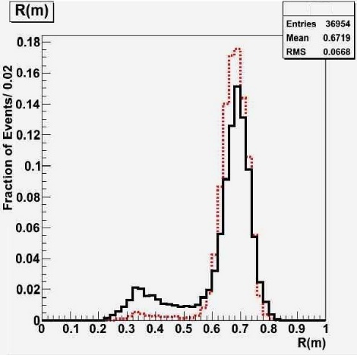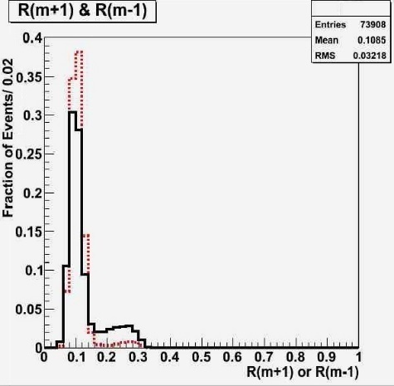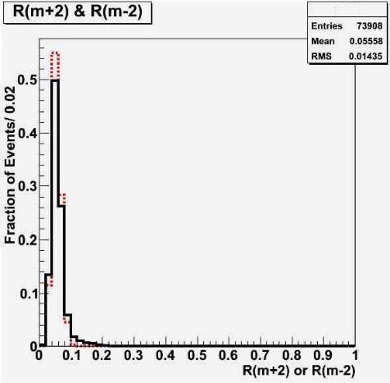
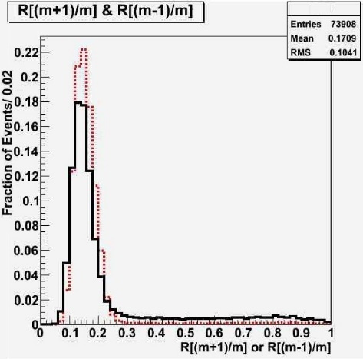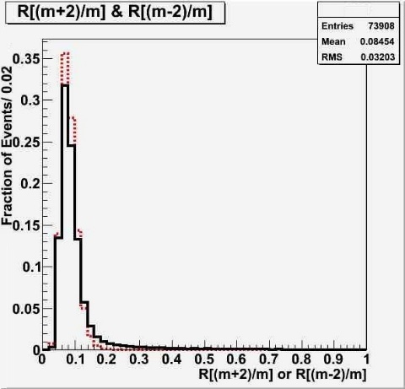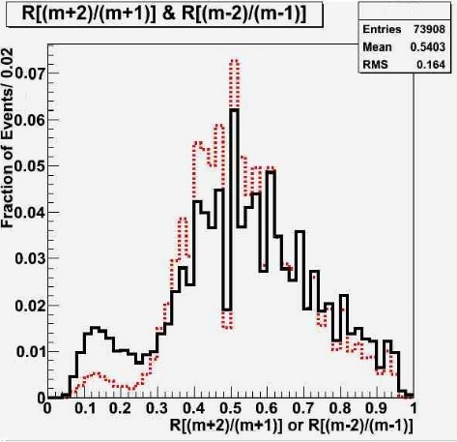
Figure 6: Distributions showing the frequency of strip-to-sum and strip-to-strip ratios in ideal clusters from data (black-solid line) and simulation (red-dashed line). The peaks of these histograms are consistent with the predicted values in table 2.

Although the source of these clusters is unknown, there are two proposed explanations for the formation of these clusters. The first possible source of these clusters is the passing of particles through the plane of the silicon strips at non-normal angles of incidence. In this case, a particle may pass through multiple strips creating a strip cluster not resulting from crosstalk. The second process may be the case where a particle jet symmetrically distributes energy across a strip cluster. Although clusters generated via these processes are usually not symmetric or ideal, the selection algorithm throws out the non-symmetric clusters for these cases, thus leaving only the ones that appear ideal. Further investigation would be required to reveal the nature of these clusters.

Table 3: Examples of the strip energies of clusters from different populations of $R_{m}$ values from CMS data.
Type of Cluster | Strip Energy (ADC Counts) |  |  |  |  | Strip Ratios
 | $$E_{m-2}$$ | $$E_{m-1}$$ | $$E_{m}$$ | $$E_{m+1}$$ | $$E_{m+2}$$ | $$R_{m}$$ | $$R_{m∓1}$$
Ideal Cluster | 17 | 25 | 223 | 27 | 12 | 0.73 | 0.086
 | 9 | 19 | 131 | 18 | 9 | 0.70 | 0.099
 | 18 | 31 | 252 | 36 | 16 | 0.79 | 0.095
Anomalous Cluster | 26 | 132 | 202 | 133 | 12 | 0.40 | 0.262
 | 11 | 143 | 217 | 156 | 18 | 0.40 | 0.274
 | 35 | 94 | 133 | 96 | 52 | 0.32 | .0232
Each plot in Fig. 6 contains data for all ideal strip clusters in the given dataset, regardless of which subdetector module the hit came from. It is possible that different silicon strip geometries may lead to different crosstalk energy distribution profiles. Since silicon strip geometries vary between different detector modules, the properties of crosstalk may be subdetector dependent. To investigate the nature of the crosstalk in different subdetectors, histograms of $R_{m}$ were generated for each subdetector module type and are shown above in Fig. 7.

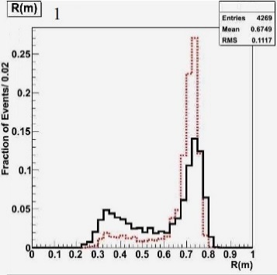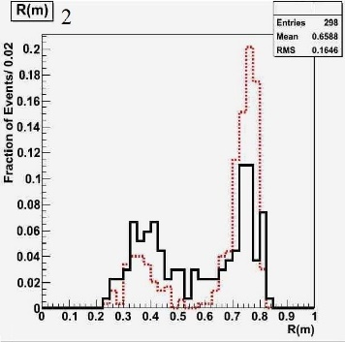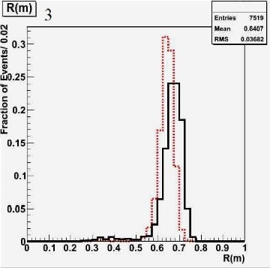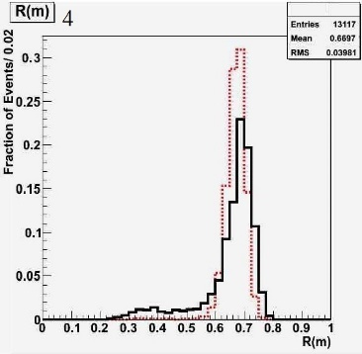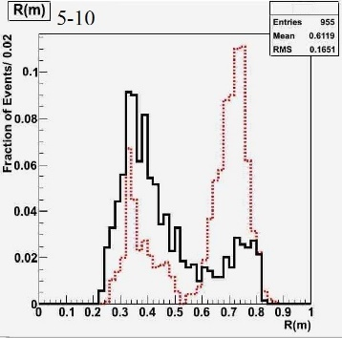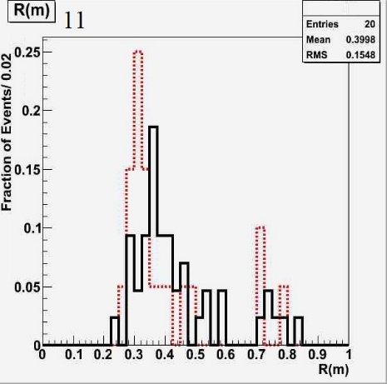
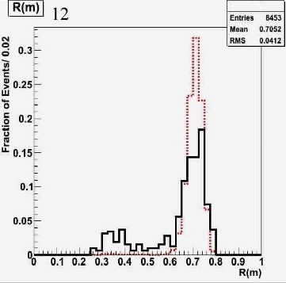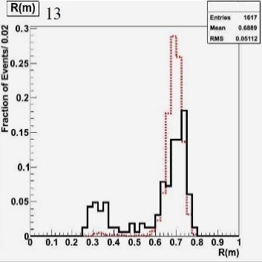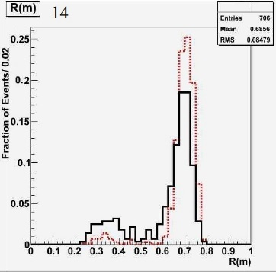
Figure 7: (continued on next page…)
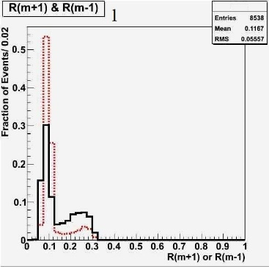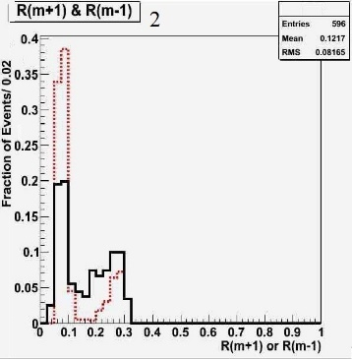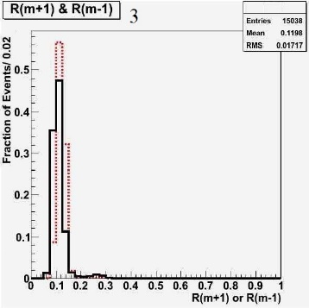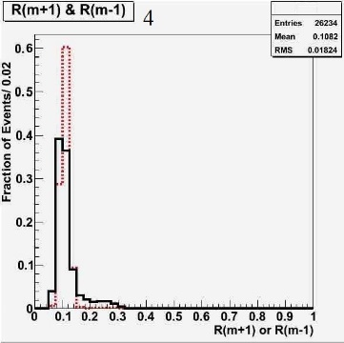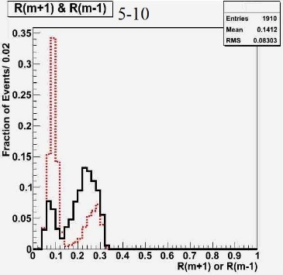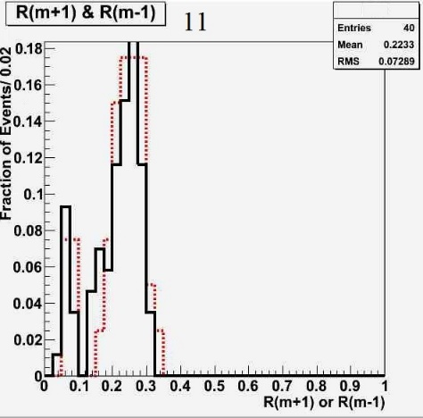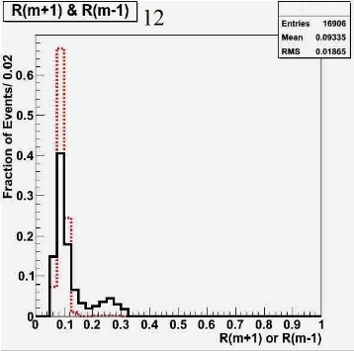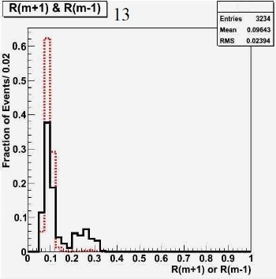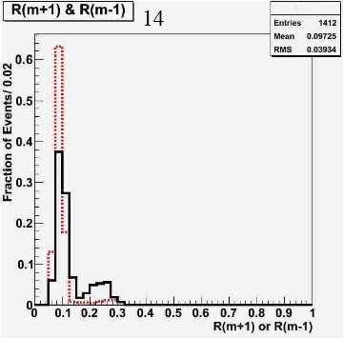
Figure 7: Distributions of $R_{m}$ and $R_{m±1}$ for each subdetector. Data are shown by the black-solid line and simulation by the red-dashed line. Each plot contains ideal clusters coming from the subdetector noted, corresponding to the numbering in Table 1. Subdetectors 5-10 were plotted together because each of the silicon modules had small frequencies of ideal clusters but were similar in form. By combining them the form of the distribution becomes more clear.

Each plot in Fig. 6 contains data for all ideal strip clusters in the given dataset, regardless of which subdetector module the hit came from. It is possible that different silicon strip geometries may lead to different crosstalk energy distribution profiles. Since silicon strip geometries vary between different detector modules, the properties of crosstalk may be subdetector dependent. To investigate the nature of the crosstalk in different subdetectors, histograms of $R_{m}$ were generated for each subdetector module type and are shown above in Fig. 7.
These plots demonstrate that energy distribution profiles may have some small module dependence but the variation in the distribution profiles is not significant and is still consistent with current models of crosstalk. The TIB, TOB, and TEC behave most consistently with the current model of crosstalk as the peak in $R_{m}≈0.72± 0.04$ for all subdetectors, as expected. Histograms generated from simulation generally agree with observation thus further increasing confidence in the current model of crosstalk.
The simulation of TID module clusters seems to deviate most from observation. Subdetectors 5-10 of the TID are combined into one histogram because each had similar distribution profiles but small frequencies of ideal clusters. In general, simulation seems to underestimate the frequency of the anomalous peak at $R_{m}≈0.35$. Again, this small inconsistency is negligible because overall the simulation is still effective in reproducing observation. Also, the number of ideal clusters occurring in the TID is small compared to that of other subdetectors. Based on the layout of the tracker, the TID is expected to experience a higher frequency of particles with non-normal angles of incidence. This is contrasted with subdetectors 3-4 of the TOB which are expected to experience more particles with normal incidence. Since the anomalous peak occurs in TID clusters and is absent from TOB clusters, this further implies the extra peak may be a result of non-ideal crosstalk cases occurring due to non-normal angles of incidence. If this is the case, the extra peak should be considered noise as it not actually a case of interest. If this peak is just noise, then the energy reconstruction selection algorithm can be improved by ignoring these anomalous clusters. These clusters would have to be identified using $R_{m±2/(m±1)}$ values for saturated clusters because the value of $E_{m}$ does not have quantitative meaning.
Although crosstalk may have some module dependence, based on these analyses, the variation observed between modules was not significant and still implies current models of crosstalk are effective in predicting observation. This means reconstruction algorithms using the current model of crosstalk should be able to accurately reproduce the energy deposited in saturated strips.
While the properties of crosstalk may be consistent for varying strip geometries, there are still other factors that may affect the distribution profile of the crosstalk. The form of the crosstalk distribution profile may change with varying strip energies. By plotting contour plots of $R_{m}$ and $R_{m±1}$ as a function of $E_{m}$ any dependencies on maximum strip energy should be found. These plots are shown in Fig. 8.
The plots in Fig. 8 demonstrate that $R_{m}≈0.70$ and $R_{m±1}≈0.10$occurs for all $E_{m}$ and the form of each plot is similar in both data and simulation; each seems to exhibit a small upward slope in $R_{m}$ for increasing $E_{m}$. In data, clusters where $R_{m}≈0.35$ also occur at all strip energies implying this phenomenon does not depend on $E_{m}$.

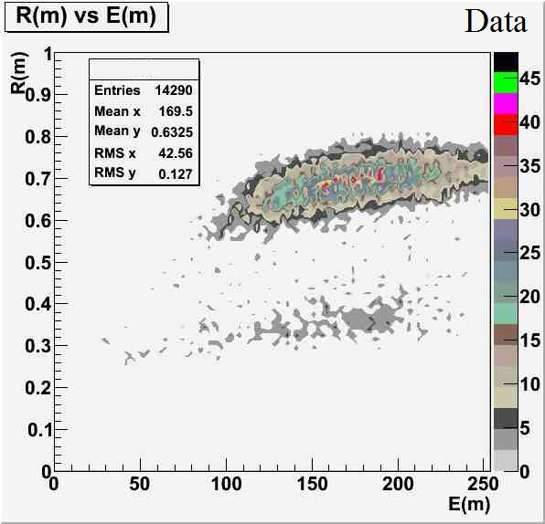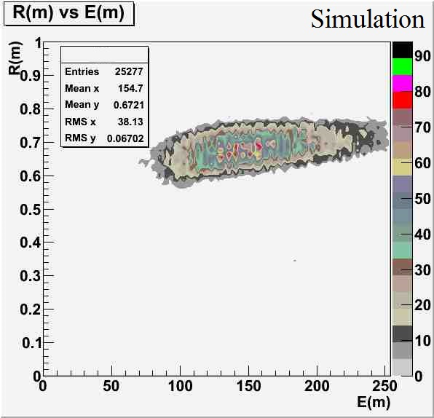
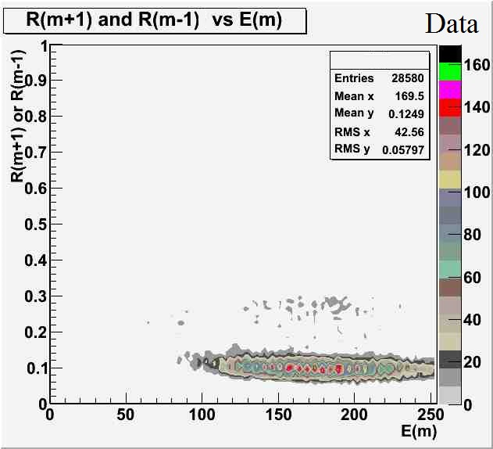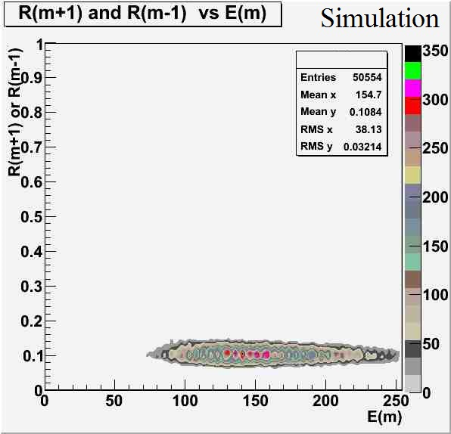
Figure 8: $R_{m}$ and $R_{m±1}$ as a function of $E_{m}$ for both data and simulation (DY). Note that these plots seem to imply clusters at $R_{m}≈0.35$ and $R_{m±1}≈0.25$ are not occurring in simulation. This is not the case as the small frequency of the anomalous clusters in simulation has resulted in the suppression of their appearance in the plots.

Finally, the distribution profile may depend on whether a cluster is saturated. Above, $R_{i}$ and $R_{i/j}$ could be directly determined as values of $E_{i}$ are unambiguous in each unsaturated strip cluster. An ideal saturated cluster will have one central saturated strip channel ($E_{m}=254$-$255$). This means all values of $R_{i}$ can no longer be directly determined as the total energy in the cluster in unknown. $R_{m±1/m}$ and $R_{m±2/m}$ can also no longer be determined for the same reasons. The only strip ratio from above that will still have meaning is $R_{(m±1)/(m±2)}$. Another strip ratio will also be used to compare clusters with and without saturation, defined in Eq. 4. Note that this ratio will exclude the value of $E_{m}$ such that Eq. 4 will still have quantitative meaning when dealing with saturated clusters. Figure 9 shows $S_{m±1}$ for saturated and unsaturated clusters. Current models of crosstalk predict $S_{m±1}≈0.36.$

$S_{m±1}=\frac{E_{m±1}}{(\sum_{n=1}^{5}{E_{n})-E_{m}}}$ (4)

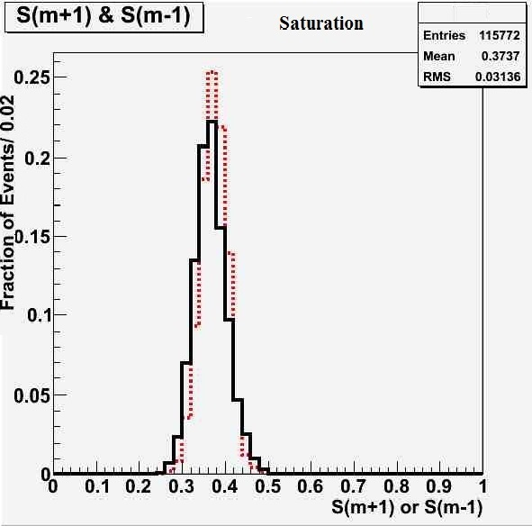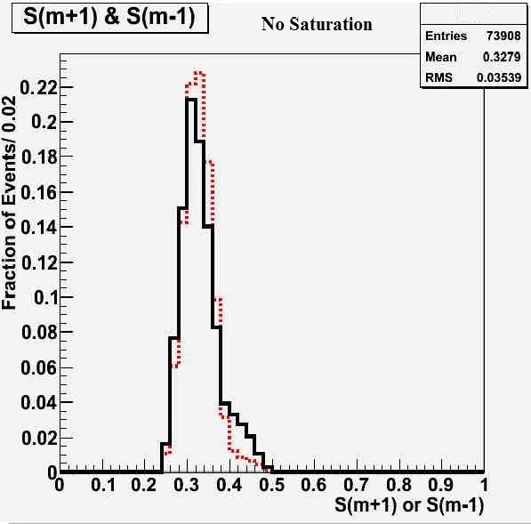
Figure 9: Histograms for $S_{m±1}$ for unsaturated (left) and saturated (right) clusters. Data (solid-black) and DY (dashed red) correspond in both cases, even though $S_{m±1}$ seems to vary with saturation.

Figure 9 demonstrates that the peak in $S_{m±1}$ for saturated and unsaturated clusters occurs at different values. This implies that the form of crosstalk may depend on saturation. Despite this possible dependence, the changing profiles are predicted by simulation and are therefore consistent with the current model of crosstalk.

Conclusion
Various distributions of strip ratios from ideal clusters imply that simulations using current models of crosstalk are effective in reproducing observation and therefore the current model of crosstalk is an accurate representation of the physical phenomenon. Analyses show that the energy distribution profiles have little dependence, if any, on the factors considered. Crosstalk appears mostly uniform across all subdetectors and, besides the anomalous clusters, matches the predicted distribution ratios. Crosstalk also seems to follow a constant distribution profile regardless of the energy deposited in the maximum strip channel of a cluster. If the trend of the plots in Fig. 8 continues in the region $E_{m}≥254$, which it is expected to, reconstruction of ideal saturated cluster energies should be accurate even when the amount of energy deposited in $E_{m}$ is much larger than the threshold for saturation. Although $S_{m±1}$ values exhibit some saturation dependence, the changing distribution profiles correlate in both simulation and data furthering confidence in the current model of crosstalk. Overall, crosstalk behaves consistently with predictions besides the anomalous clusters with $R_{m}≈0.35$. These clusters are likely not a result of ideal cases of crosstalk and, if so, should be regarded as noise in the reconstruction of energy deposited in saturated clusters.

References
¹CMS Collaboration, The CMS Experiment at the CERN LHC. JINST 3, S08004 (2008). doi:10.1088/1748-0221/3/08/S0800
²M. Raymond et al., The CMS Tracker APV25 0.25 $μm$ CMOS Readout Chip, CERN/LHCC 2000-41 (2000), (https://cds.cern.ch/record/478270/files/raymond.pdf)

³W. Newhauser and R. Zhang, The Physics of Proton Therapy. Phys. Med. Biol. 60 R155–209, (http://iopscience.iop.org/article/10.1088/0031-9155/60/8/R155/)
⁴ P. Sigmund, Particle Penetration and Radiation Effects. (Springer Series in Solid State Sciences, Berlin, Heidelberg, 2006), pp. 151.
⁵R. Demina, Commissioning and Performance of the CMS Silicon Microstrip Detector. (9th International Conference on Large Scale Applications and Radiation Hardness of Semiconductor, Florence, Italy, 2009), pp. 4

