The Creation of Elements in Stars
Angele Thiac
PHY 3091
October 20, 2001
The Creation of Elements in Stars
Introduction:
Just after the big bang the only elements present in the universe were Hydrogen and Helium. Yet, our world is made of many other elements, many much heavier then Hydrogen and Helium. We also have evidence that much of the universe has other elements present with in it too. Where did these elements come from? Most of the elements in the universe were formed in stars in a process that begins with the fusion of light elements, proceeds through the fusion of heavier elements, and ends with the heaviest elements being formed through neutron capture. This process progresses as stars evolve during their lifetime.

Fusion is the process through which two light nuclei combine to form a heavier nucleus. This process releases energy that is the excess binding energy of the heavier nucleus as compared to the lighter nuclei. In order for fusion to occur, the mutual Coulomb repulsion of the two nuclei must be overcome. For instance, take the reaction in equation (1).
(1) ²H₁ + ²H₁ → ³H₂ + ¹H₀
In this reaction 4.0 MeV of energy are released, or about 1 MeV per nucleon.
Stars produce their energy through the process of fusion. A protostar is an object that may eventually become a star. That is to say if a protostar has at least 0.08 times the mass of our sun and has a temperature of at least 10⁷ K, hydrogen fusion can begin in it and it will become a star. Hydrogen fusion is the longest stage in an active stars life and so is considered the main sequence of a star. All stars are on this main sequence for ninety percent of their lifetimes. [2] How this hydrogen fusion occurs in a particular star, however, depends on both the stars temperature and its composition. [1]
If a star has a temperature of at least 10⁷ K but less then 2x10⁷ K or if only Hydrogen and Helium are present in the star then Hydrogen fusion will occur by a process known as the proton – proton cycle. This cycle gets its name because it is the most basic fusion process in which four protons combine to form one ⁴He atom. Depending on the exact composition of the star this process can occur in several ways. Other proton- proton cycles can be seen in figure 1 of this paper, however the most basic proton – proton cycle is:
(2) ¹H₀ + ¹H₀ → ²H₁ + e⁺ + ν
(3) ²H₁ + ¹H₀ → ³He₁ + γ
(4) ³He₁ + ³He₁ → ⁴He₂ + 2¹H₀
The reactions in equation (2) and (3) must occur twice in order for the two ³He needed for the reaction in equation (4) to be present. The entire fusion net process can be written as:
(5) 4¹H₀ → ⁴He₂ + 2e⁺ + 2ν +2 γ
This process releases 26.7 MeV of energy. For a star the size of our sun with an equivalent power output of 4x10²⁶ W there must be 10³⁸ fusion reactions per second. [1]
The other process through which hydrogen can fuse into helium in a star is called the carbon cycle. This process will occur if the star has carbon present with in it and if the stars temperature is 2x10⁷ K or greater. Equations (6)-(11) outline the series of reactions that occur in the carbon cycle.
(6) ¹²C + ¹H → ¹³N + γ
(7) ¹³N → ¹³C + e⁺ + ν
(8) ¹³C + ¹H → ¹⁴N + γ
(9) ¹⁴N + ¹H → ¹⁵O + γ
(10) ¹⁵O → ¹⁵N + e⁺ + ν
(11) ¹⁵N + ¹H → ¹²C + ⁴He
In this series of reactions ¹²C is no more then a catalyst, it is neither produced nor consumed. The net process for the fusion process is still 4¹H₀ → ⁴He₂ and the amount of energy released is still 26.7 MeV. However because of the carbon catalyst this process will occur much faster because it does not have to wait for the beta decay that occurred in equation (2) and was needed for the proton – proton cycle. [1] This means that a star that’s hydrogen fusion occurs by the carbon cycle will use all of its hydrogen up faster then a star that’s hydrogen fusion occurs by the proton – proton cycle.
In either case, the star will eventually convert most of its hydrogen into helium and gravitational collapse will begin. As the star collapses the outer shell of the star will expand as the little hydrogen left, which was not hot enough before to fuse, is converted to helium. This is the red giant stage of a stars lifetime. A star the size of our sun will get 10-100 times larger in diameter during this time. The helium core has an increasing mass as it continues to contract. [2] The core heats and will eventually reach temperatures around 10⁸ K. [1] If the star is 0.4 times the mass of our sun or smaller it will become a red dwarf. However, if the star is greater than that, then helium fusion will occur. [2] In this reaction ⁴He is converted to ¹²C by the process outlined in equations (12) and (13).
(12) ⁴He + ⁴He → ⁸Be + γ
(13) ⁸Be + ⁴He → ¹²C + γ
This process produces 7.3 MeV. [1] Depending on the mass of the star this process will occur in two different ways with in the star. If the star has a mass greater then 3 times the mass of our sun it will contract rapidly and as its core heats up fusion will begin gradually. Less massive stars contract more slowly but contract to the point that their cores become degenerate. These means the gas is so dense electrons are not free to change their energy. As the temperature reaches 10⁸ K helium fusion will begin. Because the gas is degenerate as the temperature rises due to the fusion the pressure does not increase leading to increased fusion and an explosion called helium flash in which the star produces more energy for a few minutes then the entire galaxy. In a matter of minutes to hours the heat produced by the flash makes the gas become no longer degenerate and the helium fusion reaction is brought under control by pressure. The star will then begin to burn helium normally. [2]
Stars with mass less then 3 solar masses will eventually become white dwarfs and burn out as they use up all their helium. However, once enough ¹²C has been made by helium fusion other alpha particle reactions can occur in stars greater then 3 solar masses. Some of these possible reaction are seen in equations (14), (15), and (16). [1]
(14) ¹²C + ⁴He → ¹⁶O
(15) ¹⁶O + ⁴He → ²⁰Ne
(16) ²⁰Ne + ⁴He → ²⁴Mg
These reactions become possible once the temperature has reached 6x10⁸ K and once enough of each individual element has been made. [2] They are all exothermic reactions and contribute a few MeV to the total energy of the star. [1] As temperatures in the core continue to get higher more reactions with carbon become possible. This network of possible reactions involving carbon can be seen in figure 2. [2]
Once most of the helium is used up gravitational collapse will occur again as the core contracts and a helium fusion shell will form under the hydrogen fusion shell that formed earlier. This shell is made up of what little helium did not get hot enough to fuse earlier. The star expands and its surface cools once again. [2]
However, as the core contracts it will continue to heat up. Once the temperature in the core is high enough carbon can begin to fuse with itself. Equations (17) and (18) show the two most probable reactions. [1]
(17) ¹²C + ¹²C → ²⁰Ne + ⁴He
(18) ¹²C + ¹²C → ²³Na + ¹H
Once most of the carbon is used up gravitational collapse will once again occur. Now what little carbon is left will form a carbon shell under the helium shell and will ignite there, expanding the star once again until its surface cools. This type of core fusion and then shell fusion will continue with each successive element from now on until ⁵⁶Fe is made. [2]
As the carbon burning phase ends, a brief neon-burning phase can begin to occur. This occurs because of a process called photodisintegration. This is a reaction through wich photons produce nuclear changes via reaction pathways like (γ,n), (γ,p), and (γ,α). The photodisintegration produces more ⁴He particles, which can be used in the neon burning reaction shown in equation (19).
(19) ²⁰Ne + ⁴He → ²⁴Mg
It also produces more ¹⁶O which can be used in the next phase of heavy element fusion.[3]
As the core reaches 10⁹ K oxygen burning becomes possible. The star will begin to burn the oxygen that was produced earlier and has been left in the core. Oxygen fuses with itself in the reactions shown in equations (20), (21) and (22). [3]
(20) ¹⁶O + ¹⁶O → ²⁸Si + ⁴He
(21) ¹⁶O + ¹⁶O → ³¹P + ¹H
(22) ¹⁶O + ¹⁶O → ³²S + γ
As the oxygen in the core is used up gravitational collapse will once again occur and the left over oxygen will form a shell under the carbon shell just as the elements before have done. [2]
As the core gets hotter silicon burning can then begin in which ²⁸Si will convert to ⁵⁶Fe. It is possible other reactions involving previously made elements and ²⁸Si will occur at this time also.[2] Once ⁵⁶Fe is reached no further energy can be produced by fusion in the star. [1] The shells of elements in the star can be seen in figure 3. The heavier elements are used up much faster because they produce less energy per fusion reaction then the lighter elements. Therefore the further into the process of heavier element burning the star gets the faster each stage occurs until iron is reached. [2] Helium burning takes only about a half million years for a star of approximately 20 solar masses. Carbon burning would take only a few hundred years for the same star. This would be followed by a year or so of neon burning and then a few months of oxygen burning. The iron core would take only a few days to form [3]
Once iron is reached in a massive star the star has reached the end of its evolution. No further energy can be gained from fusion. This is because nuclear fusion releases energy because it combines less tightly bound elements into more tightly bound elements. This cannot happen with iron because ⁵⁶Fe is the most tightly bound of nuclei as can be seen in figure 4. Because of this, heavier elements have to be made by a process other then fusion that can occur as the star dies. [2]
This process is neutron capture. Before neutron capture can occur, neutrons must be formed. This will occur if there are enough heavy isotopes that are neutron heavy. Equations (23), (24), and (25) are examples of three reactions that can produce neutrons. [1]
(23) ¹³C + ⁴He → ¹⁶O + n
(24) ¹⁷O + ⁴He → ²⁰Ne + n
(25) ²¹Ne + ⁴He → ²⁴Mg + n
Once neutrons are formed heavy elements can be built up by neutron capture. Equations (26), (27), and (28) show the first three steps in heavy element building by neutron capture. [1]
(26) ⁵⁶Fe + n → ⁵⁷Fe (stable)
(27) ⁵⁷Fe + n → ⁵⁸Fe (stable)
(28) ⁵⁸Fe + n → ⁵⁹Fe (t_{1/2} =45 days)
Because ⁵⁹Fe has the relatively short half-life of 45 days, what happens next depends on the number of neutrons available. Neutrons capture will either proceed down the s-process or p-process. [1]
The s-process or slow process will occur if the number of available neutrons is small. That is to say, if the number of neutrons is small the chances of ⁵⁹Fe encountering a neutron before it decays to ⁵⁹Co are slim. Therefore the process may proceed as shown in equations (29), (30), and (31). [1]
(29) ⁵⁹Fe → ⁵⁹Co + e⁻ + ν
(30) ⁵⁹Co + n → ⁶⁰Co
(31) ⁶⁰Co → ⁶⁰Ni + e⁻ + ν
A chart of more of the s-process can also be seen in figure 5. The heaviest element that can be built up by the s-process is ²⁰⁹Bi because the half-lives of isotopes beyond this are to short and they will decay to fast for the s-process to continue. [1] Neutron production for the s-process is favored when low amounts of hydrogen and nitrogen are present, because otherwise these two gases would use the neutrons to form deuterium and ¹⁴C. [3]
The other process through which neutron capture can occur is called the r-process, or rapid process. This process occurs when the number of neutrons available is very large. This is because the large quantity of neutrons makes it likely that neutron capture will occur before beta decay can occur. A section of the r-process can be seen in figure 6. The r-process shown in figure 6 is only one possible r-process path as it is possible for a beta decay to occur at any point in the path depending on whether the nucleus happens to encounter a neutron before that or not. Another possible r-process sequence might begin with the reactions shown in equations (32), (33), and (34). [1]
(32) ⁵⁹Fe + n → ⁶⁰Fe (t_{1/2} = 3x10⁵ y)
(33) ⁶⁰Fe + n → ⁶¹Fe (t_{1/2} = 6 m)
(34) ⁶¹Fe → ⁶¹Co + e⁻ + ν
The r-process most likely occurs during the supernova explosion of a dieing massive star. The implosion of a star during a supernova produces an enormous neutron flux on the order of perhaps 10²³ n/cm²/s. This occurs in a time frame lasting on the order of seconds. [1]
Since some elements can only be formed by the s-process and some elements can only be formed by the r-process the relative abundance of elements in the universe tells us that both of these processes must be active in our universe. Figure 7 shows the relative abundance of elements in the universe. The presence on earth of both ⁷⁰Zn, which can only be formed in the r-process, and ⁶⁴Zn, which can only be formed through the s –process lead to the conclusion that both process must have been active in this region of space before the solar system was formed. [1]
There are a number of proton rich nuclei that occur in nature that cannot be accounted for by either neutron capture in either the s-process or the r-process. They occur between A = 70 and A =200 so also cannot be accounted for by fusion. It is believed that these nuclei may be accounted for by the p-process. This is a process through which photonuclear reactions occur in which neutrons are ejected following the absorption of gamma rays. In addition, the injection of small amounts of hydrogen during the neutron capture process could provide protons that could undergo capture to form these proton rich nuclides. Some nuclides thought to be formed this way are ⁷⁸Kr, ¹¹²Sn, ¹²⁰Te, ¹²⁴Xe, ¹⁴⁴Sm, and ¹⁸⁴Os. They are stable or very long half- life nuclei and are very rare. They are about 1% of the abundance of their more neutron rich neighbors. [3]
At the end of a massive stars life, once an iron core has built up, it will die. The core will cool with out fusion to heat it and gravitational collapse will occur. This leads to the supernova explosion mentioned in the r-process. [2] The elements built up in the star through all of the processes mentioned above will be hurled into space where they can become part of new star systems. [1] This is how all of the elements heavier then hydrogen and helium were formed after the universe began. Because of this, succeeding generations of stars have increased the amount of heavier elements in the universe. This means that there are more of the elements heavier then Hydrogen and Helium now then there were 5 billion years ago and there were more five billion years ago then there were at the beginning of the universe. This process of enriching the universe with more abundance of elements heavier then hydrogen and helium is called the element building cycle. [2]

Conclusion:
Earth as well as other planets could not have existed around a star formed shortly after the big bang because the heavy elements that make up the earth had not yet formed. The Earth was able to form because generations of stars have added to the heavy element abundance in the universe through the element building cycle. This occurs because stars are fueled by the fusion process, which builds up elements all the way from the Hydrogen it starts with to Iron. Heavier elements are then made as the star dies through neutron capture in the s and r processes, with some rare elements being made in the p-process. Supernovae of massive stars then scatter the elements built with in them into the surrounding space allowing new stars and star systems that form later in that space to be enriched by the heavier elements.

Figures:
Figure 1: The proton-proton Cycle: This flow chart shows various paths through which the proton-proton cycle can occur.
³He + ³He → ⁴He + 2¹H

¹H + ¹H → ²H+ e⁺ + ν
²H + ¹H → ³He + γ

³He + ⁴He → ⁷Be + γ
⁷Be + e⁻ → ⁷Li + ν
⁷Li + ¹H →2⁴He

³He + ⁴He → ⁷Be + γ
⁷Be + ¹H → ⁸B + γ
⁸B → ⁸Be + e⁺ + ν
⁸Be → 2⁴He

Figure 2: Carbon Fusion Network: Carbon fusion occurs in a network that involves many possible reactions through which numerous heavy atoms are built. Here you can see through what steps it can form other elements then the ones listed in the equations in the paper.
¹²C
¹³N
¹³C
¹⁴N
¹⁵N
¹⁶O
¹⁷O
¹⁸O
¹⁸F
²⁰Ne
²¹Ne
²²Ne
²¹Na
²²Na
²³Na
²⁴Na
²³Mg
²⁴Mg
²⁵Mg
²⁶Mg
²⁵Al
²⁶Al
²⁷Al
²⁸Si
Figure 3: Star Shells: Here you see the fusion shells that are all that is left of each phase of fusion in a massive star.
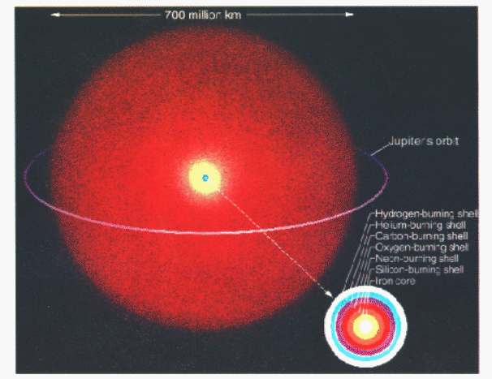

Figure 4: Binding Energy Per Nucleon: You can see on the graph that the maximum binding energy is at ⁵⁶Fe.
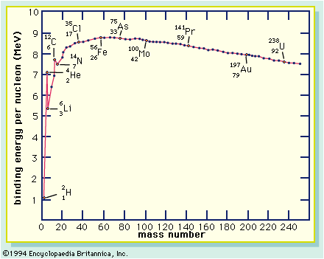
Figure 5: The S-Process: Here you see the s-process of nuetron capture. Notice the diffrent paths that the process can take.
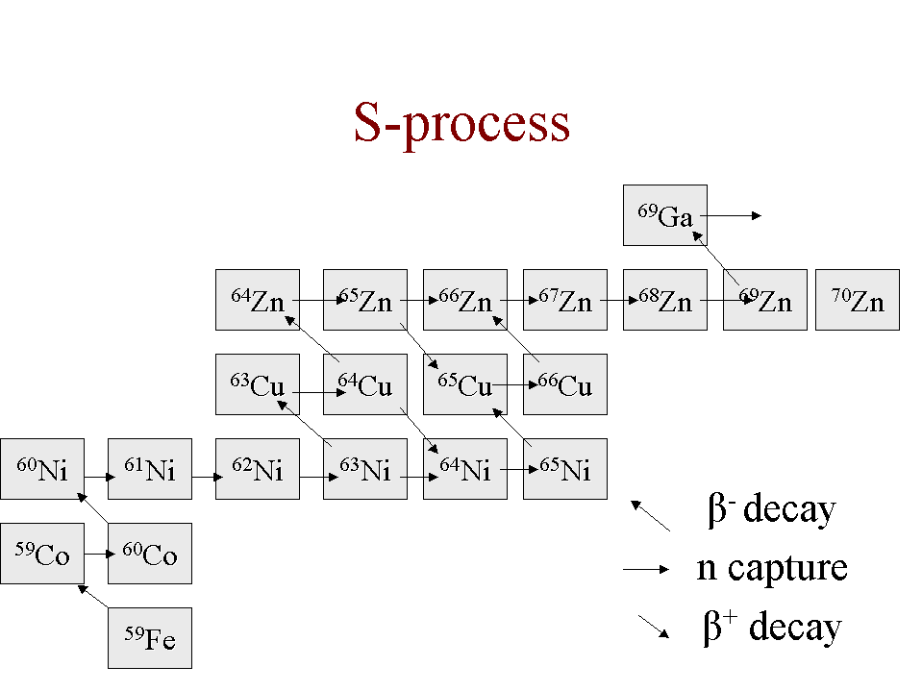

Figure 6: The R- Process: This is one path the R- process can take. Notice how many neutron captures can happen before beta decay ever occurs.
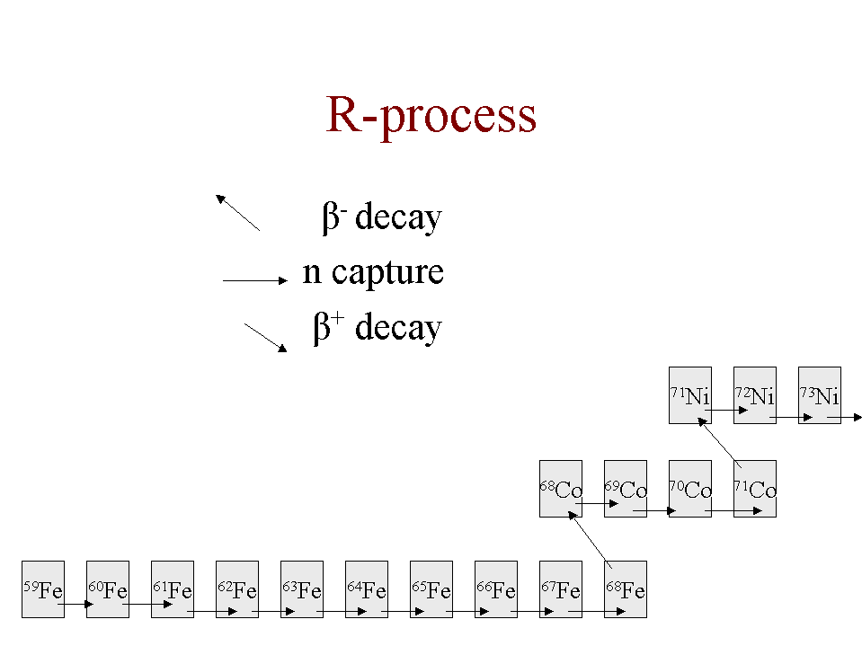
Figure 7: Relative Abundance of Elements:
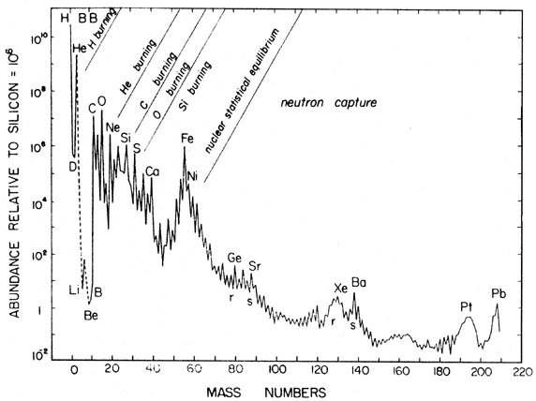
Source: http://nedwww.ipac.caltech.edu/level5/Pagel/Pagel1_3.html
References:
1. Krane, Kenneth. Modern Physics 2nd Edition, Wiley (1996) p428-p431, p497-506

2. Seeds, Michael A. Horizons, Exploring the Universe, 6th Edition, Brooks/Cole (2000), p161-166, p191-192, p181-186, p234-236

3. Ehmann, William D. Radiochemistry and Nuclear Methods of Analysis ,Wiley (1991), p420-429

