The Creation of Elements in Stars
Angele Thiac
PHY 3091
October 20, 2001
Abstract:
Stars produce their energy through fusion, the process in which two light nuclei combine to form a heavier nucleus. Main sequence stars do this by converting hydrogen in to ⁴He. This occurs through the proton - proton cycle if the stars temperature is at least 10⁷ K but is below 2x10⁷ K and if no carbon is present. If the stars temperature is 2x10⁷ K or higher and if carbon is present, the carbon can act as a catalyst causing hydrogen to convert to ⁴He through the Carbon cycle. Once a star has converted as much hydrogen to helium as possible the star will begin to contract causing its temperature to increase. When the temperature reaches around 10⁸ K, ⁴He will begin fusing into ¹²C. When enough ¹²C is present other alpha particle (⁴He) reactions can occur forming other elements such as ¹⁶O, ²⁰ Ne, and ²⁴Mg. As the temperture increases ¹²C will begin to fuse with itself into ²⁰Ne or ²³Na. When most of the Carbon is used up a short stage of neon burning will begin in which ²⁰Ne fuses with helium to form ²⁴ Mg. After this, once gravatational collapse has caused the temperature to reach 10⁹ K, oxygen burning will begin in which ¹⁶O fuses with itself to form ²⁸Si in the most likely reaction. After the oxygen is used up gravatational collapse once again causes the core to heat and at a high enough temperture silicon buring begins in which ²⁸Si fuses to form iron. Once iron is reached the star can gain no further energy by fusion. If enough of the heavier isotopes such as ¹³C, ¹⁷O, and ²¹Ne are present then alpha particle reactions can occur in which neutrons are produced. ⁵⁶Fe can then capture neutrons to form new isotopes. If the number of neutrons available is small then the s-process will occur in which slowly through many beta decays and some neutron captures other heavier elements up to ²⁰⁹Bi can be formed. If the number of neutrons is very large, such as during the conditions of a supernova, the r-process can occur in which rapidly through neutron capture with very few beta decays elements up to A=260 can be formed. A few other proton reach nuclides, which exist but cannot be explained by any of the aforementioned process, maybe formed by proton capture in the p-process. The supernova that occurs in riches the interstellar gas with the elements that had been formed in the star.
Outline:
I. Introduction
II. The Life Cycle of a Star
A. Protostar
B. Main Sequence
C. Red Giant
D. Supernova
III. The Fusion Process
IV. The Formation of Elements Lighter then Iron
A. Hydrogen Fusion
1. Proton-Proton Cycles
2. Carbon Cycle
B. Helium Fusion
C. Carbon Burning
D. Neon Burning
E. Oxygen Burning
F. Silicon Burining
V. The Formation of Elements Heavier the Iron
A. Neutron Capture
1. Neutron Production
2. S process
3. R process
B. Proton Capture
VI. The Element Building Cycle
VII. Conclusion

The Creation of Elements in Stars
Introduction:
Just after the big bang the only elements present in the universe were Hydrogen and Helium. Yet, our world is made of many other elements, many much heavier then Hydrogen and Helium. We also have evidence that much of the universe has other elements present with in it too. Where did these elements come from? Most of the elements in the universe were formed in stars in a process that begins with the fusion of light elements, proceeds through the fusion of heavier elements, and ends with the heaviest elements being formed through neutron capture. This process progresses as stars evolve during their lifetime.

The Life Cycle of A Star
A protostar is an object that may eventually become a star. It is a collapsing cloud of gaseous material. The further the gaseous cloud contracts inward, the more rotational speed increases. As this occurs it increases in both temperature and density. If a protostar has at least 0.08 times the mass of our sun and has a temperature of at least 10⁷ K, hydrogen fusion can begin in it and it will become a star [2].
Once hydrogen fusion begins the star is said to be a Main Sequence star. This is because hydrogen fusion is the longest stage in a stars lifetime and therefore the stage in which the majority of stars are in at any given time. All stars are on this main sequence for ninety percent of their lifetimes. Once most of their hydrogen has been burned up they will move of the main sequence and into the next phase of their lifetime [2].
Stars on the main sequence with less then 0.4x the mass of the sun are called red dwarfs. When most of there hydrogen is used up they will contract to white dwarfs. From here they will slowly cool and die [2].
However, stars that are greater then 0.04x the mass of the sun will proceed to another fusion stage once most of their hydrogen is used up. These stars will expand to red giants and begin helium fusion. After the helium burning stage stars smaller then 3x the mass of the sun will contract to white dwarfs and cool. However, stars greater then 3x the mass of the sun will continue as a red giant through heavier element fusion until an iron core is reached [2].
Once an iron core is reached in these massive stars, the star will begin to die. The iron core will collapse rapidly. It will contract far enough to become incredibly dense and will either form a black hole or a neutron star. At the same time the envelope of the star will be blasted out away from the star in a huge explosion called a supernova [2]. The diffrent stages of a stars life have been compiled into a chart in figure (1).

The Fusion Process
Fusion is the process through which two light nuclei combine to form a heavier nucleus. This process releases energy that is the excess binding energy of the heavier nucleus as compared to the lighter nuclei. Figure (2) is a chart of binding energy per nucleon as a function of mass number. Fusion can only occur if the reactants have lower binding energy per nucleon then the product. Looking on the chart you will see that iron has the highest binding energy per nucleon so fusion can not occur to form elements more massive then iron. In order for fusion to occur, the mutual Coulomb repulsion of the two nuclei must be overcome. For instance, take the reaction in equation (1), in which two deuterium atoms fuse to form a hydrogen- atom and a hydrogen-1 atom.
(1) ²H₁ + ²H₁ → ³H₂ + ¹H₀
This reaction could occur if deuterium gas was heated to temperature high enough such that each deuterium atom has about 0.25 MeV of thermal kinetic energy. Then in a collision between two deuterium atoms the 0.50 MeV of kinetic energy would be enough to overcome the Coulomb repulsion. The difficulty in doing this in a laboratory experiment is in heating the deuterium gas to a high enough temperature. In order for the thermal kinetic energy for each atom of deuterium to be 0.25 MeV, the gas would have to be heated to 10⁹ K. There are as yet, no conditions on Earth, at which anywhere near this temperature can be reached. The deuterium gas most also have a high density for fusion to occur. This is because high density makes it more probable for individual deuterium atoms to collide. Both the high temperatures and density needed for the fusion process occur in stars [1].

The Formation of Elements Lighter than Iron
Stars produce their energy through the process of fusion. For ninety percent of all stars’ lifetimes, the fusion that occurs is hydrogen fusion. [2] How this hydrogen fusion occurs in a particular star, however, depends on both the stars temperature and its composition [1].
If a star has a temperature of at least 10⁷ K but less then 2x10⁷ K or if only Hydrogen and Helium are present in the star then Hydrogen fusion will occur by a process known as the proton – proton cycle. This cycle gets its name because it is the most basic fusion process in which four protons combine to form one ⁴He atom. Depending on the exact composition of the star this process can occur in several ways. Other proton- proton cycles can be seen in figure (3) of this paper, however the most basic proton – proton cycle is:
(2) ¹H₀ + ¹H₀ → ²H₁ + e⁺ + ν
(3) ²H₁ + ¹H₀ → ³He₁ + γ
(4) ³He₁ + ³He₁ → ⁴He₂ + 2¹H₀
The reactions in equation (2) and (3) must occur twice in order for the two ³He needed for the reaction in equation (4) to be present. The entire fusion net process can be written as:
(5) 4¹H₀ → ⁴He₂ + 2e⁺ + 2ν +2 γ
This process releases 26.7 MeV of energy. For a star the size of our sun with an the same power output of 4x10²⁶ W there must be 10³⁸ fusion reactions per second [1].
The other process through which hydrogen can fuse into helium in a star is called the carbon cycle. This process will occur if the star has carbon present with in it and if the stars temperature is 2x10⁷ K or greater. Equations (6)-(11) outline the series of reactions that occur in the carbon cycle.
(6) ¹²C + ¹H → ¹³N + γ
(7) ¹³N → ¹³C + e⁺ + ν
(8) ¹³C + ¹H → ¹⁴N + γ
(9) ¹⁴N + ¹H → ¹⁵O + γ
(10) ¹⁵O → ¹⁵N + e⁺ + ν
(11) ¹⁵N + ¹H → ¹²C + ⁴He
In this series of reactions ¹²C is no more then a catalyst, it is neither produced nor consumed. The net process for the fusion process is still 4¹H₀ → ⁴He₂ and the amount of energy released is still 26.7 MeV. However because of the carbon catalyst this process will occur much faster because it does not have to wait for the proton to convert to a neutron which occurred in equation (2) and was needed for the proton – proton cycle [1]. This means that a star that’s hydrogen fusion occurs by the carbon cycle will use all of its hydrogen up faster then a star that’s hydrogen fusion occurs by the proton – proton cycle.
In either case, the star will eventually convert most of its hydrogen into helium and gravitational collapse will begin. As the star collapses the outer shell of the star will expand as the little hydrogen left, which was not hot enough before to fuse, is converted to helium. This is the red giant stage of a stars lifetime. A star the size of our sun will get 10-100 times larger in diameter during this time. The helium core has an increasing mass as it continues to contract [2]. The core heats and will eventually reach temperatures around 10⁸ K. [1] If the star is greater than that, then helium fusion will occur. [2] In this reaction ⁴He is converted to ¹²C by the process outlined in equations (12) and (13).
(12) ⁴He + ⁴He → ⁸Be + γ
(13) ⁸Be + ⁴He → ¹²C + γ
This process produces 7.3 MeV. [1] Depending on the mass of the star this process will occur in two different ways with in the star. If the star has a mass greater then 3 times the mass of our sun it will contract rapidly and as its core heats up fusion will begin gradually. Less massive stars contract more slowly but contract to the point that their cores become degenerate. These means the gas is so dense electrons are not free to change their energy. Normally in a star as temperature rises pressure increases causing the star to expand and cool, slowing down the nuclear reactions. This is called the Pressure- Temperature Thermostat and also works in the opposite direction in stars. This Pressure- Temperature Thermostat keeps the nuclear reactions from becoming to fast or to slow. However, once the gas in the star becomes degenerate the Pressure- Temperature Thermostat is not in effect. As the temperature reaches 10⁸ K helium fusion will begin. Because the gas is degenerate, as the temperature rises due to the fusion the pressure does not increase. Therefore the star is not expanded and cooled. This leads to increased fusion and an explosion called helium flash. Here, the star produces more energy for a few minutes then the entire galaxy. In a matter of minutes to hours the heat produced by the flash makes the gas become no longer degenerate and the helium fusion reaction is brought under control by pressure. The star will then begin to burn helium normally [2].
Once enough ¹²C has been made by helium fusion other alpha particle reactions can occur in stars greater then 3 solar masses. Some of these possible reaction are seen in equations (14), (15), and (16) [1].
(14) ¹²C + ⁴He → ¹⁶O
(15) ¹⁶O + ⁴He → ²⁰Ne
(16) ²⁰Ne + ⁴He → ²⁴Mg
These reactions become possible once the temperature has reached 6x10⁸ K and once enough of each individual element has been made [2]. They are all exothermic reactions and contribute a few MeV to the total energy of the star [1]. As temperatures in the core continue to get higher more reactions with carbon become possible. This network of possible reactions involving carbon can be seen in figure (4). [2]
Once most of the helium is used up gravitational collapse will occur again as the core contracts and a helium fusion shell will form under the hydrogen fusion shell that formed earlier. This shell is made up of what little helium did not get hot enough to fuse earlier. The star expands and its surface cools once again [2].
However, as the core contracts it will continue to heat up. Once the temperature in the core is high enough carbon can begin to fuse with itself. Equations (17) and (18) show the two most probable reactions [1].
(17) ¹²C + ¹²C → ²⁰Ne + ⁴He
(18) ¹²C + ¹²C → ²³Na + ¹H
Once most of the carbon is used up gravitational collapse will once again occur. Now what little carbon is left will form a carbon shell under the helium shell and will ignite there, expanding the star once again until its surface cools. This type of core fusion and then shell fusion will continue with each successive element from now on until ⁵⁶Fe is made [2].
As the carbon burning phase ends, a brief neon-burning phase can begin to occur. This occurs because of a process called photodisintegration. This is a reaction through which photons produce nuclear changes via reaction pathways like (γ,n), (γ,p), and (γ,α). The photodisintegration produces more ⁴He particles, which can be used in the neon burning reaction shown in equation (19).
(19) ²⁰Ne + ⁴He → ²⁴Mg
It also produces more ¹⁶O which can be used in the next phase of heavy element fusion [3].
As the core reaches 10⁹ K oxygen burning becomes possible. The star will begin to burn the oxygen that was produced earlier and has been left in the core. Oxygen fuses with itself in the reactions shown in equations (20), (21) and (22). [3]
(20) ¹⁶O + ¹⁶O → ²⁸Si + ⁴He
(21) ¹⁶O + ¹⁶O → ³¹P + ¹H
(22) ¹⁶O + ¹⁶O → ³²S + γ
As the oxygen in the core is used up gravitational collapse will once again occur and the left over oxygen will form a shell under the carbon shell just as the elements before have done [2].
As the core gets hotter silicon burning can then begin in which ²⁸Si will convert to ⁵⁶Fe. It is possible other reactions involving previously made elements and ²⁸Si will occur at this time also [2]. Once ⁵⁶Fe is reached no further energy can be produced by fusion in the star [1]. The shells of elements in the star can be seen in figure (5). The heavier elements are used up much faster because they produce less energy per fusion reaction then the lighter elements. Therefore the further into the process of heavier element burning the star gets the faster each stage occurs until iron is reached [2]. Helium burning takes only about a half million years for a star of approximately 20 solar masses. Carbon burning would take only a few hundred years for the same star. This would be followed by a year or so of neon burning and then a few months of oxygen burning. The iron core would take only a few days to form [3].

The Formation of Elements Heavier than Iron
Once iron is reached in a massive star the star has reached the end of its evolution. No further energy can be gained from fusion. This is because nuclear fusion releases energy because it combines less tightly bound elements into more tightly bound elements. This cannot happen with iron because ⁵⁶Fe is the most tightly bound of nuclei as can be seen in figure (2). Because of this, heavier elements have to be made by a process other then fusion that can occur as the star dies [2].
This process is neutron capture. Before neutron capture can occur, neutrons must be formed. This will occur if there are enough heavy isotopes that are neutron heavy. Equations (23), (24), and (25) are examples of three reactions that can produce neutrons. [1]
(23) ¹³C + ⁴He → ¹⁶O + n
(24) ¹⁷O + ⁴He → ²⁰Ne + n
(25) ²¹Ne + ⁴He → ²⁴Mg + n
Once neutrons are formed heavy elements can be built up by neutron capture. This occurs because atoms can become more energetically stable by capture of a neutron and increasing the binding energy of the nucleus. Equations (26), (27), and (28) show the first three steps in heavy element building by neutron capture [1].
(26) ⁵⁶Fe + n → ⁵⁷Fe (stable)
(27) ⁵⁷Fe + n → ⁵⁸Fe (stable)
(28) ⁵⁸Fe + n → ⁵⁹Fe (t_{1/2} =45 days)
Because ⁵⁹Fe has the relatively short half-life of 45 days, what happens next depends on the number of neutrons available. Neutrons capture will either proceed down the s-process or p-process [1].
The s-process or slow process will occur if the number of available neutrons is small. That is to say, if the number of neutrons is small the chances of ⁵⁹Fe encountering a neutron before it decays to ⁵⁹Co are slim. Therefore the process may proceed as shown in equations (29), (30), and (31). [1]
(29) ⁵⁹Fe → ⁵⁹Co + e⁻ + ν
(30) ⁵⁹Co + n → ⁶⁰Co
(31) ⁶⁰Co → ⁶⁰Ni + e⁻ + ν
A chart of more of the s-process can also be seen in figure (6). The heaviest element that can be built up by the s-process is ²⁰⁹Bi because the half-lives of isotopes beyond this are to short and they will decay to fast for the s-process to continue [1]. Neutron production for the s-process is favored when low amounts of hydrogen and nitrogen are present, because otherwise these two gases would use the neutrons to form deuterium and ¹⁴C [3].
The other process through which neutron capture can occur is called the r-process, or rapid process. This process occurs when the number of neutrons available is very large. This is because the large quantity of neutrons makes it likely that neutron capture will occur before beta decay can occur. A section of the r-process can be seen in figure (7). The r-process shown in figure 6 is only one possible r-process path as it is possible for a beta decay to occur at any point in the path depending on whether the nucleus happens to encounter a neutron before that or not. Another possible r-process sequence might begin with the reactions shown in equations (32), (33), and (34). [1]
(32) ⁵⁹Fe + n → ⁶⁰Fe (t_{1/2} = 3x10⁵ y)
(33) ⁶⁰Fe + n → ⁶¹Fe (t_{1/2} = 6 m)
(34) ⁶¹Fe → ⁶¹Co + e⁻ + ν
The r-process most likely occurs during the supernova explosion of a dieing massive star. The implosion of a star during a supernova produces an enormous neutron flux on the order of perhaps 10²³ n/cm²/s. This occurs in a time frame lasting on the order of seconds [1].
Since some elements can only be formed by the s-process and some elements can only be formed by the r-process the relative abundance of elements in the universe tells us that both of these processes must be active in our universe. Figure (8) shows the relative abundance of elements in the universe. The presence on earth of both ⁷⁰Zn, which can only be formed in the r-process, and ⁶⁴Zn, which can only be formed through the s –process lead to the conclusion that both process must have been active in this region of space before the solar system was formed [1].
There are a number of proton rich nuclei that occur in nature that cannot be accounted for by either neutron capture in either the s-process or the r-process. They occur between A = 70 and A =200 so also cannot be accounted for by fusion. It is believed that these nuclei may be accounted for by the p-process. This is a process through which photonuclear reactions occur in which neutrons are ejected following the absorption of gamma rays. In addition, the injection of small amounts of hydrogen during the neutron capture process could provide protons that could undergo capture to form these proton rich nuclides. Some nuclides thought to be formed this way are ⁷⁸Kr, ¹¹²Sn, ¹²⁰Te, ¹²⁴Xe, ¹⁴⁴Sm, and ¹⁸⁴Os. They are stable or very long half- life nuclei and are very rare. They are about 1% of the abundance of their more neutron rich neighbors [3].

The Element Building Cycle
At the end of a massive stars life, once an iron core has built up, it will die. The core will cool with out fusion to heat it and gravitational collapse will occur. This leads to a supernova explosion [2]. The elements built up in the star through all of the processes mentioned above will be hurled into space where they can become part of new star systems [1]. This is how all of the elements heavier then hydrogen and helium were formed after the universe began. Because of this, succeeding generations of stars have increased the amount of heavier elements in the universe. This means that there are more of the elements heavier then Hydrogen and Helium now then there were 5 billion years ago and there were more five billion years ago then there were at the beginning of the universe. This process of enriching the universe with more abundance of elements heavier then hydrogen and helium is called the element building cycle [2].

Conclusion:
Earth as well as other planets could not have existed around a star formed shortly after the big bang because the heavy elements that make up the earth had not yet formed. The Earth was able to form because generations of stars have added to the heavy element abundance in the universe through the element building cycle. This occurs because stars are fueled by the fusion process, which builds up elements all the way from the Hydrogen it starts with to Iron. Heavier elements are then made as the star dies through neutron capture in the s and r processes, with some rare elements being made in the p-process. Supernovae of massive stars then scatter the elements built with in them into the surrounding space allowing new stars and star systems that form later in that space to be enriched by the heavier elements.
Figures:
Figure 1: The stages of a stars life- cycle : This chart was compiled to show what happens to a star of certain mass when it reaches a certain temperature, in other words what stage the star is in at a certain temperature in its lifetime. The far right column also shows the percentage of the stars lifetime that is spent in this stage.
stage | Temperature | Mass | Occuring in star | % of lifetime
1 | 10⁷ K | >0.08 solar masses | hydrogen burning begins: protostar becomes star
 | 10⁷ K- 2x10⁷ K |  | proton -proton cycle | 93.3
 | >2x10⁷ K |  | if carbon present carbonn cycle of hydrogen fusion
2 |  | <0.4 | becomes a white dwarf after hydrogen used up
 | 10⁸ K | >0.4 solar masses | red giant stage begins with helium fusion | 6.7
3 |  | <3 solar masses | collapse to white dwarf after heluim used up
 | 6x10⁸ K | >3 solar masses | other alpha particle fusion reactions begin
4 | between 6x108 K - 10⁹ K | >3 solar masses | carbon burning | 0.008
5 |  | >3 solar masses | neon buning occurs just as carbon burning finishes
6 | 10⁹ K | >3 solar masses | oxygen burning | 0.000007
7 | at some point >10⁹ K | >3 solar masses | silicon buring to form iron | .00000004

Figure 2: Binding Energy Per Nucleon: You can see on the graph that the maximum binding energy is at ⁵⁶Fe.
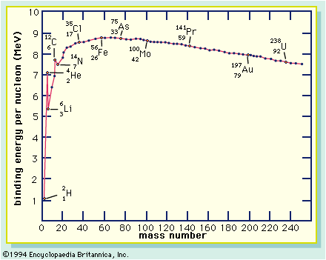

Figure 3: The proton-proton Cycle: This flow chart shows various paths through which the proton-proton cycle can occur.
³He + ³He → ⁴He + 2¹H

¹H + ¹H → ²H+ e⁺ + ν
²H + ¹H → ³He + γ

³He + ⁴He → ⁷Be + γ
⁷Be + e⁻ → ⁷Li + ν
⁷Li + ¹H →2⁴He

³He + ⁴He → ⁷Be + γ
⁷Be + ¹H → ⁸B + γ
⁸B → ⁸Be + e⁺ + ν
⁸Be → 2⁴He

Figure 4: Carbon Fusion Network: Carbon fusion occurs in a network that involves many possible reactions through which numerous heavy atoms are built. Here you can see through what steps it can form other elements then the ones listed in the equations in the paper.
¹²C
¹³N
¹³C
¹⁴N
¹⁵N
¹⁶O
¹⁷O
¹⁸O
¹⁸F
²⁰Ne
²¹Ne
²²Ne
²¹Na
²²Na
²³Na
²⁴Na
²³Mg
²⁴Mg
²⁵Mg
²⁶Mg
²⁵Al
²⁶Al
²⁷Al
²⁸Si
Figure 5: Star Shells: Here you see the fusion shells that are all that is left of each phase of fusion in a massive star.
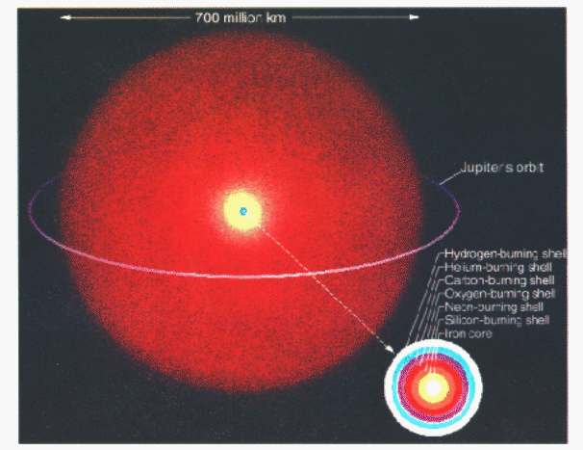

Figure 6: The S-Process: Here you see the s-process of neutron capture. Notice the diffrent paths that the process can take.
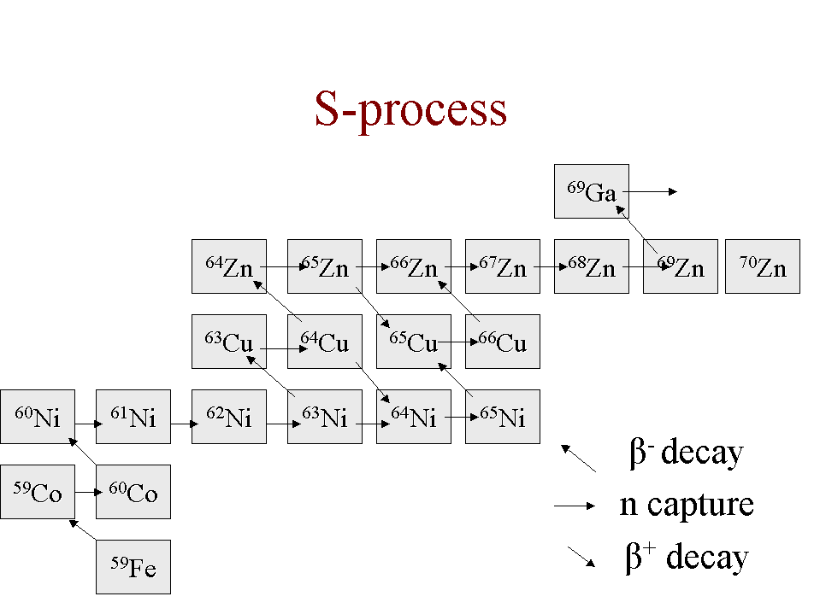
Figure 7: The R- Process: This is one path the R- process can take. Notice how many neutron captures can happen before beta decay ever occurs.
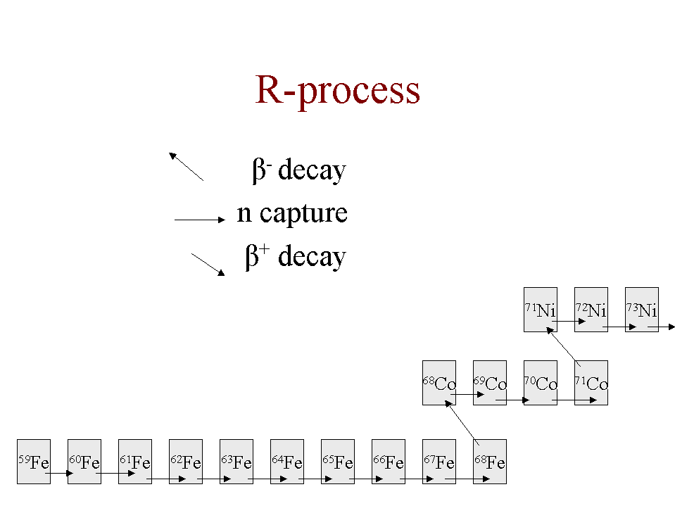

Figure 8: Relative Abundance of Elements:
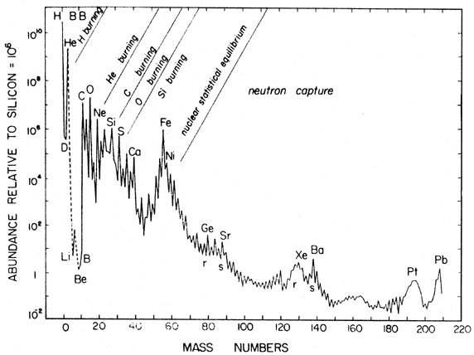
Source: http://nedwww.ipac.caltech.edu/level5/Pagel/Pagel1_3.html
References:
1. Krane, Kenneth. Modern Physics 2nd Edition, Wiley (1996) p428-p431, p497-506

2. Seeds, Michael A. Horizons, Exploring the Universe, 6th Edition, Brooks/Cole (2000), p155-156, p161-166, p191-192, p181-186, p234-236

3. Ehmann, William D. Radiochemistry and Nuclear Methods of Analysis ,Wiley (1991), p420-429

