Fission and Nuclear Power Plants

Jeff Gardner

4 December 2001

PHY 3091

Introduction
Nuclear fission is something man people take for granted today as being just another part of modern technology. However, when the idea of splitting an atom was first conceived approximately sixty years ago, physicists were frightened at the prospect of unleashing so much energy in such a short period of time. After all, ancient Greeks regarded the atom as the fundamental indivisible constituent of all matter. We now know that atomic nuclei can be split in a process called fission in relative safety. By understanding how this process came to be and what occurs during a fission reaction, we can harness that enormous amount of energy to create the power needed to live our lives.

A Brief History of Fission

Nuclear fission has been at the forefront of physics for over sixty years. Countless physicists have worked to understand the dynamics of the nucleus. The story of fission dates back to 1932. In that year, James Chadwick bombarded beryllium atoms with alpha particles, which are energetic helium atoms. This created carbon and a neutron. The neutron had been predicted by Lord Rutherford in 1920 but had not been experimentally observed until Chadwick’s feat, which won him the 1935 Nobel Prize for Physics [1]. In 1938, German chemists Otto Hahn and Fritz Strassmann performed an experiment in which uranium captured a neutron. The product of this reaction turned out to be barium and another mid-periodic table element which was later discovered to be krypton. Hahn and Strassmann were unable to account for this phenomena in which one element turned into two. Austrian physicist Lise Meitner explained the processes which had occurred and coined the term “fission” to describe it. She also calculated that the amount of energy released from such a reaction was far greater than that of any previously known reaction [2]. Frederick Joliot showed that besides the fission products, some neutrons were also released during a fission reaction. It was then proposed that a neutron could cause a reaction to occur and then the other two or three neutrons produced could cause new reactions. Thus a self-sustaining nuclear chain reaction would take place. It was then realized that these reactions could be harnessed to occur in a steady, predictable manner or in a rapid, uncontrolled fashion which would produce a destructive release of nuclear energy.
Since these discoveries and the outbreak of World War II occurred simultaneously, it was desirable to create a bomb which used the tremendous energy fission reactions produced. Thankfully, Hitler was not impressed by what his German physicists (many of them Jews) had come up with and nuclear physics in Germany was put on the back burner. When many of Germany’s finest scientists fled to Great Britain in 1940, it became the world capital of atomic physics research [2]. Theoretically, it was found that naturally occurring ²³⁵U could produce the effect necessary to create an atomic bomb. However, because Great Britain was in the midst of the German Blitzkrieg, all nuclear research was moved to the relative safe haven of the United States. Along with the research came Italian physicist Enrico Fermi. His already impressive resume was further heightened in 1942 when he built the first fission reactor under the stadium at Chicago University. In December 1942, the reactor went critical and became the first controlled nuclear chain reaction. Three years later the Oak Ridge National Laboratory created enough ²³⁵U and the plant in Hanford, Washington created enough ²³⁹Pu to produce nuclear bombs and forever change the world.
In the years following the Second World War, nuclear energy remained an important military element as the Cold War raged on. However, a less threatening application, that of nuclear power, surface on the technological front. United States Admiral Rickover saw the value of nuclear powered ships in that they would not have to refuel as often creating virtually unlimited ranges. For submarines, this meant extended stays underwater as well as near silent running. The need for a highly compact reactor led to the American designed and built PWR (pressurized water reactor). In 1955, the first nuclear submarine, the Nautilus, set sail and eventually sailed underneath the South Pole.
Another positive outcome of World War II nuclear research is the nuclear power plant. The first electricity producing nuclear power plant was a small reactor in Russia. However, the first high output nuclear plant was at Calder Hall in England. This plant became operational in 1956 and remains active today. The first electricity-generating nuclear power plant in the United States was built in Shippingport, Pennsylvania in 1957.

The Physics of Fission Reactions
By definition, nuclear fission is the process by which a heavy nucleus splits into two lighter nuclei. Within the nucleus, protons and neutrons experience both the electromagnetic and strong force. The Coulomb (electromagnetic) force can be written as:
F= kq₁q₂/ r² where k is Coulomb’s constant, q₁ and q₂ are the charges, and r is the separation distance between charges [3].
Given this relationship, protons within the nucleus tend to repel each other. However, at close distances, on the order of 1fm (1 x 10 ^{–15} m), the strong force dominates the electromagnetic force, thus it is possible for nuclei to contain more than one proton as well as many neutrons [4].

Spontaneous and Induced Fission
Two distinct types of fission reactions can occur. The first is called spontaneous fission. This occurs naturally at increasing probability as mass number, A, increases. In a spontaneous fission, the two fission products are relatively equal in size. This type of fission only becomes prominent at A>260 where is actually becomes the dominant decay mode. This means that it does not account for the stability or abundance of naturally occurring elements [5].
The second type of fission is called induced fission. This is the process discussed in this when dealing with nuclear reactors and weapons. It is marked by neutron capture and the production of two non-equal mass fission products and an average of 2.5 free neutrons. Induced fission is most likely to occur in Z-even, A-odd nuclei such as uranium (Z=92, A=235) or plutonium (Z=94, A=239). Since more neutrons are created in this process, one induced fission reaction can spawn another generation of fission events leading to a self-sustaining chain reaction [5].
When a neutron is captured by a ²³⁵U atom, a disturbance is created within the nucleus. The nucleus begins to stretch into an ellipsoid. If the nucleus is sufficiently elongated, then the strong force can no longer affect all of the nucleons within the nucleus. The nucleus then divides into the two smaller nuclei and on average 2.5 neutrons [2].
The first Uranium fission reaction experimentally observed was the following reaction:
n + ²³⁵U → ¹⁴¹Ba + ⁹²Kr + 3n
It is important to realize that this is just one possible fission reaction. Fission can also occur in ²³⁸U, however the neutron must have an energy greater than 1 MeV. Also, fission occurs in other elements besides Uranium. ²³²Th (Thorium) is the only other naturally occurring fissionable element. Fission in ²³²Th occurs with neutrons greater than 1.4 MeV. Two synthetically produced isotopes, ²³³U and ²³⁹Pu (Plutonium) become fissionable with neutrons of all energies, particularly low energy. Generally, the term “fissionable” is used when referring to ²³⁸U and ²³²Th or any isotope which fissions with neutrons of less than about 10MeV, and the term “fissile” is reserved ²³⁵U, ²³³U, and ²³⁹Pu because they fission with neutron of low energy, particularly below approximately 1MeV [2].

Fission Products
Another reason why not all fission reactions are the same has to do with the fission products. Again using the example of ²³⁵U, once the nucleus captures the neutron to become ²³⁶U, it has no memory of any of the physical quantities the neutron possessed. Characteristics such as linear and angular momentum, angle of incidence, and kinetic energy are all lost. Therefore, it is impossible to predict the exact fission products yielded during any one fission reaction. It is, however, possible to compile statistics on fission product yield percentages. All fission products lie between A= 70 and A=160. The most probable atomic mass numbers, which occur in roughly 6.5% of all fissions are A= 96 (such as Zr, Nb, Mo, and Tc) and A= 135 (such as Xe, Cs, Ba, and Ce). A symmetrical fission with two products of mass A= 117 occur in only 0.005% of all fissions [2].
Besides the isotopes formed during fission reactions, the neutrons produced are of
great significance, especially when one considers how to control chain reactions. Consider the following reaction:
²³⁵U + n → ⁹³Rb + ¹⁴¹Cs + 2n
The two neutrons created are called prompt neutrons, as they are emitted virtually at the instant of fission. However, if you examine farther down the decay chain of ⁹³Rb you will find that ⁹³Rb becomes ⁹³Sr via β-decay 98.6% of the time. The other 1.4% of the time, ⁹³Rb emits what is called a delayed neutron. It is so called because it is emitted well after the original fission event. Similarly, in 0.03% of ¹⁴¹Cs decays, a delayed neutron is produced [4]. This phenomenon makes controlling nuclear reactions a possibility. Without delayed neutrons, it would be very difficult, if not impossible to control the prompt neutrons.
Since the purpose of most nuclear fission reactions is to create energy, it is important to know how much energy they can produce. In order to determine the energy released during a fission reaction, we must know the total binding energy B of each isotope. In order to calculate this we must subtract the nuclear mass from the atomic mass. The nuclear mass is simply the atomic mass less the mass of the electrons in that given isotope. The equation for binding energy is:
B= [Nm_{n} +Zm_{p} –mA]c² masses are in amu (atomic mass units)
If you then divide B by the number of nucleons, you obtain the binding energy per nucleon or B/A. By plotting atomic number A versus B/A in MeV per nucleon, it is clear to see that lighter nuclei (such as Cs, Rb, or Zr) are more tightly bound than heavy nuclei (such as U, Pu, or Th)by approximately 1 MeV (see Fig 1). Then, given there are roughly 200 nucleons present per fission reaction, that yields 200MeV per atom. This is a tremendous amount of energy to be released in one reaction. In fact, it is about 10⁸ times the amount of energy released in a chemical reaction.

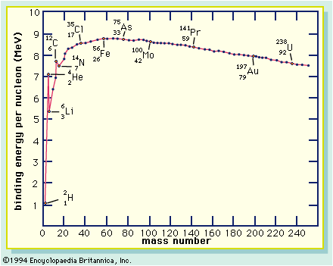
Fig 1: mass number A versus binding energy per nucleon B/A shows why fission reactions are energetically favorable.

Fission in Nuclear Power Plants

After learning the basics of nuclear fission reactions, it is useful to understand what real world applications these reactions have. One such application is the production of electricity via nuclear power plants. Nuclear fission is a particularly advantageous method of producing power for several reasons. First and foremost, nuclear energy is 20% less expensive than coal-firing plants. This is true even while considering the costs of operation, the fuel cycle, and decommissioning costs (each reactor has a finite lifetime) [2]. Secondly, and most surprisingly, nuclear power plants are relatively safe. Coal miner are at extreme risk of death due to accidents and pneumoconiosis “coal miner’s lung”. Also, fossil fuel burning produces carcinogenic byproducts such as benzo-a-pyrene which may account for many thousands of deaths per year. Fission waste products are so radioactive that they are very carefully stored away from human habitats. The magnitude of it’s danger has rendered it safer than the smoke which pours out of coal-firing smokestacks. The toll on the environment is also a bonus of nuclear power. Thermal pollution is the major drawback of nuclear power plants whereas fossil fuel plants create side effects such as acid rain, the so called “greenhouse effect”, as well as dangerous and unsightly smog.
Before discussing the power plant as a whole, it is vital to understand the parts of the actual reactor. These parts include the fuel, cladding, control rods, coolant and moderator.

Fuel
The fuel, which has already been addressed, is generally ²³⁵U. It is a desirable fuel because neutrons of very low energy can cause it to fission. The most common form of Uranium fuel is small cylindrical pellets of UO₂ (Uranium dioxide). This is a good fuel because it melts at 2865 ºC which allows for high amounts of thermal energy to be produced. It is also non-reactive with water, which makes it safe to use in water cooled reactors [2]. UC (Uranium carbide) is another somewhat commonly used fuel material. It is generally reserved for HTGRs (high temperature gas-cooled reactors). Some other fuel materials are PuO₂, MOX (mixed oxide fuel) which is a blend of plutonium and uranium, and Thorium in the form of ThO₂ and ThC₂. These fuels, however, are not used nearly to the extent that uranium oxide is used even though ThO₂ is a better fuel due to its greater stability under high temperature conditions [2].
Cladding
Cladding is a material used within the fuel cells to reinforce the fuel and resist thermal stress, structural deformation of the fuel, and build up of gas pressure and fission products. A good cladding material will not be susceptible to corrosion or reaction with the fuel or coolant and will have a low capture cross section. A cross section is the effective target area the neutron “sees”. This can be significantly larger or smaller than the actual geometric area of the target. Some of the useful cladding materials include Aluminum, Magnesium, and Zirconium as well as their alloys. These materials meet some of the qualifications for a good cladding, but none are ideal materials.
Control Rods
The control rods are perhaps the most important feature of any safely operating reactor. Ideal fission reactor conditions dictate that one neutron will cause one fission event giving rise to one liberated neutron causing one new fission event and so on. However, since there are on average 2.5 neutrons produced per reaction, uncontrolled reactions would occur far too quickly and fuel meltdown would occur. Control rods, therefore, are materials with high capture cross sections used to absorb some of the neutrons created during fission reactions. The most common control material is boron carbide, although indium and cadmium alloys and gadolinium are also frequently employed controllers.
Coolant
Coolants do exactly what their names would suggest. Reactor core temperatures must be kept well below the melting point of the fuel to maintain safe operating conditions. A coolant should have high thermal conductivity, density, and specific heat, and low viscosity. It should also be non-reactive with any of the reactor components and should not become radioactive due to neutron or gamma ray interactions, which are frequently experience within the reactor core [2]. Gas cooled reactors, which are popular in Europe, use carbon dioxide and the inert gas helium. In the United States, PWR reactors are cooled by pressurized water. At 150 atm, water boils at approximately 340 ºC, although the water temperature is limited to 325 ºC. Heavy water, similar to ordinary water, is also a very commonly used coolant.
Moderator
The moderator is a required part of a reactor core, although it is not a safety measure. The capture cross section of the fuel increases as the velocity of the incident particle, in this case the neutron, decreases. Since the neutrons that come out of a fission reaction have great kinetic energy, it is necessary to slow them down. This is accomplished via scattering off of a moderator. A good moderator will have a very small capture cross section and a very large scattering cross section. As it turns out, water, heavy water, and carbon (graphite) are the only available materials [2]. H₂0 or D₂0 have been shown to be better moderators than carbon for safety reasons. The Chernobyl accident was caused, in part, by the explosion of the carbon moderator on contact with the atmosphere. This violent reaction cannot occur with either H₂0 or D₂0. When people say that Chernobyl could not happen in the United States, it isn’t mere propaganda. The American made PWR (pressurized water reactor) and BWR (boiling water reactor) designs are moderated with H₂0. Therefore, a repeat of the Chernobyl incident is only possible in reactors which use carbon moderation.

Safety Equipment
When dealing with the incredible amounts of energy produced in a reactor as well as the magnitude of the danger related to the fuel and fission products, safety is a must. It is vital to have systems and people in place who constantly monitor the reactor and anticipate future malfunctions. There are three basic duties which a reactor safety system must perform. First and foremost, it must be able to rapidly and reliably shut down the reactor under any and all adverse circumstances. Secondly, it must provide containment of the fission products. If radioactive material is allowed to leak into the atmosphere, the simple and disturbing fact is that people will die. Finally, the system should remove fission product decay heat from the reactor as efficiently as possible to avoid meltdown. The first task is accomplished through the use of control rods. These can be inserted into the reactor using a mechanical or hydraulic device for used during normal operation, or manually for emergency shutdowns. Containment is provided, first by the cladding, and then by thick concrete and lead walls. Containment buildings are designed to withstand natural disasters such as earthquakes and hurricanes, and even aircraft impacts [2]. A computerized system called the APS (Automatic Protective System) constantly monitors many parameters within the reactor. It is designed to shut down the reactor immediately if any of the parameters fall outside of their margins. During the Chernobyl catastrophe, among other problems, the APS malfunctioned.

Besides the obvious difference between nuclear and chemical reactions, a nuclear power plant is fairly similar to a coal-firing plant. In essence, the reactor core is used to generate thermal energy. This energy heats and converts water into steam. The steam turns a number of turbines which generate electricity. Fig. 2 shows a Swedish built BWR (boiling water reactor) type. Currently, a standard United States built PWR has an electrical power output of 1300MW. A typical BWR has an electrical output of 1200-1260MW. CANDU (Canadian Deuterium Uranium) reactors operate at about 515MW of electrical output. However, they are rather inexpensive to run which offsets the low output [2]. See Fig. 3 for a typical CANDU reactor.

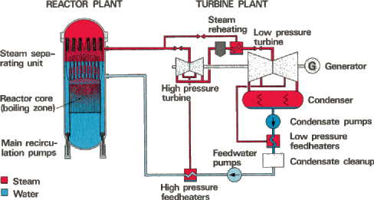
Fig. 2: A typical BWR showing the reactor as well as turbine assembly.

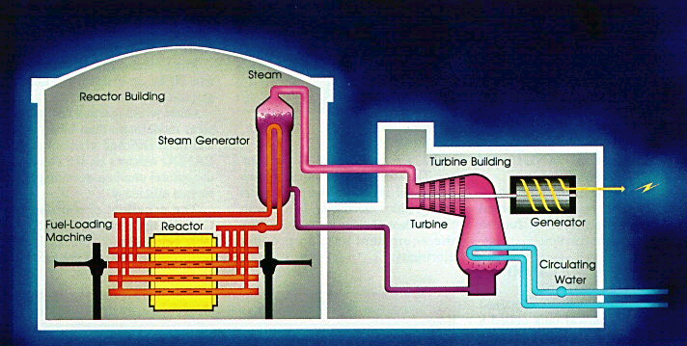
Fig 3: A CANDU reactor. Notice the similarity in design to the BWR.

Name | Fuel | Moderator | Coolant | Country
PWR  Pressurized Water Reactor | UO₂  enriched | H₂O | H₂O | USA
BWR  Boiling Water Reactor | UO₂  enriched | H₂O | H₂O  boiling | USA
PHWR/  CANDU  Pressurized Heavy Water Reactor,  Canadian Deuterium Uranium | UO₂  natural | D₂O | D₂O | Canada
AGR  Advanced Gas Cooled Reactor | UO₂  enriched | Graphite | CO₂ | United  Kingdom
RBMK  Boiling Water, Carbon Moderated Reactor  (unknown acronym) | UO₂  enriched | Graphite | H₂O  boiling | Soviet  Union

Table 1: This table shows the names of some famous reactor types and the type of fuel,
moderator, and coolant used. It also shows the country which developed each reactor design.

The Chernobyl Accident
Nuclear power plants cannot be thoroughly discussed without mentioning nuclear accidents. There is no tale which is more vivid or sobering that that of Chernobyl. The terrible accident at Chernobyl on April 26, 1986 can only be briefly outlined in this sized discussion. To completely examine all of the physical, environmental, physiological, and sociological implications of this disaster takes an entire volume unto itself.
The Chernobyl power plant, located about 80 km north of Kiev, Ukraine in the former Soviet Union, was an RBMK-1000 type reactor. It was water cooled and graphite moderated. It was well known to Western scientists that the RBMK was an unsafe design, built primarily for its cost effective qualities. The most startling of the safety oversights was the lack of an adequate containment building surrounding the reactor core. This is an especially important feature in water cooled reactors as the possibility of steam or foundry explosions exists in the event of improperly vented decay product heat [2].
The events leading up to the disaster began with a test to see if power needs could be met during short interruptions in power to the plant. The experiment began at 1:06am on April 25, 1986 when reactor power reduction began. Approximately twelve hours later, one of the two turbines was completely shut down. However, around this time, the Kiev power grid controller informed Chernobyl that he needed power supplied to the city by the plant. For some reason, the Chernobyl staff agreed to this, and the plant was allowed to operate for eleven hours without proper safety systems available (as per experimental procedure). Shortly after midnight on April 26th, the reactor’s thermal power dropped to 30MW. This was well below the desired experimental level of 700-1000MW. By 1:00am, the thermal power was brought to 200MW. This was still far below the required level and the experiment should have ceased. Due to the low thermal power and an increase in coolant pressure (since one of the turbines was shutdown, all of the coolant flowed through a single pipe), the coolant began to boil. About twenty-three minutes later, power began to rise above 200MW. In fact, power reached 530MW in three seconds. The power continued to rise exponentially as the shift foreman ordered an emergency shutdown. The control rods had to be manually dropped into place. Unfortunately this command came too late. The swift rise in thermal power caused the fuel cells to shatter and melt. Then the carbon moderator reacted with atmospheric oxygen and exploded. This occurred around 1:24am. Since there was no containment building, radioactive nuclei from the fuel, spent fuel, and fission products was free to leak into the atmosphere for ten days [6]. Through the heroic work of firefighters, the reactor fire was put out and a concrete sarcophagus (containment building) was erected. All of the men who fought the fire at Chernobyl, thirty-one in all, died of radiation sickness and an untold number of workers and nearby residents have since died of cancers and similar diseases. It is estimated that several thousand people will die in the coming decades as a result of the Chernobyl accident [2].
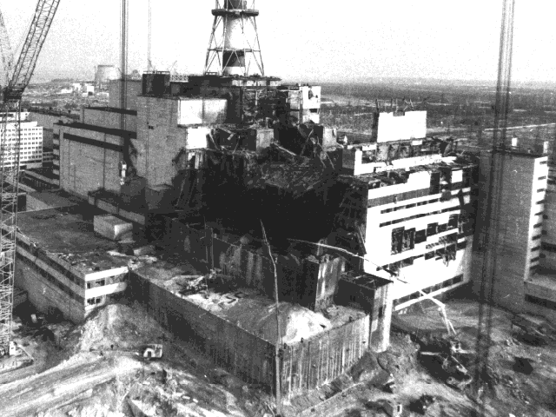
Fig. 4: The Chernobyl Nuclear Power Plant reactor No. 4 shortly after the fires were put out. Note that inside the visible cavity is the unshielded reactor.

The effects on the local population and environment are astounding. The Chernobyl plant was located near the Pripyat and Dnieper Rivers as well as the Kiev Reservoir. All of these bodies of water were highly contaminated, especially with radioisotopes of cesium, xenon, and strontium [6]. Also, the towns of Chernobyl and Pripyat, where most of the plant’s workers and their families lived, were completely evacuated and relocated. Approximately 135,000 people were permanently moved within a five hour period the day after the accident. One of the most startling facts about the Chernobyl accident is that 30 km² can never be used again [6]. This is mainly due to ²³⁹Pu which has a half-life of 24,100 years [4]. It is amazing what damage nuclear energy can do if improperly handled.

Conclusion
Manmade nuclear fission has only existed for sixty years, yet it has already become an inseparable part of human history. It is an amazing process with even more amazing applications. Although fission was first used to create maximum destruction, it is possible that the future of nuclear fission will bring a far different purpose. As technology improves in the areas of nuclear fuel design and waste disposal, the negative aspects of fission may be dwindling. Fossil fuels can only take human beings so far before they become as extinct as the creatures responsible for their creation. Nuclear energy is at the forefront of the alternative energy race, and with a greater understanding of fission, physicists will be leading the charge to newer and better fuel sources.

References

1. The Nobel Prize in Physics. http://www.nobel.se/physics. 8 October 2001.

2. The Elements of Nuclear Power, Bennet, D.J. and Thompson, J.R. John Wiley & Sons,
Inc. (1989)
3. Physics for Scientists and Engineers vol. 2, Tipler, Paul A., W.H. Freeman and Co.
(1999)
4. Modern Physics, Krane, Kenneth S., John Wiley & Sons, Inc. (1996)
5. Nuclear and Particle Physics, Williams, W.S.C. Clarendon Press. (1991)
6. Chernobyl Record- The Definitive History of the Chernobyl Catastrophe, Mould,
Richard F., Institute of Physics Publishing (2000)

