Stellar Evolution

For Us Having Never Taken Astrophysics

Chris Bradley

Features, And How They Are Determined:

- Elements It Contains:

. When the star is formed, most of it is hydrogen, about a quarter is helium, maybe 1 part per thousand will be heavier elements.
. Looking at what wavelengths of light are present on emission/absorption spectra will tell exact constituents.

Examples:

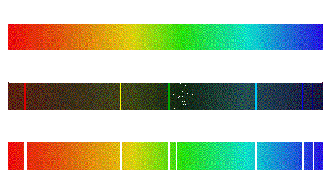

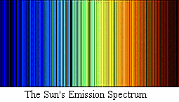




- Distance:

. Parallax:
Can use the small angle formula to find the distance.

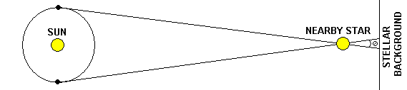

. Spectroscopic Parallax:
Measure the spectral type of the star, then use Hertzsprung-Russel diagram to get the absolute magnitude. With the absolute and apparent magnitudes, the distance is found.

M = m + 5 – 5logr M - Absolute magnitude
m - Apparent magnitude
r - Distance (in Parsecs, 3.26 light years)

. Comparing a star’s spectrum to its red shifted spectrum allows the star’s velocity to be determined. The distance of the star can be determined from its velocity using Hubble’s relation:

v = Hd H - 50 - 100 km s⁻¹ Mpc⁻¹

- Size:

. The radius can be determined from the luminosity to temperature relation:

. Star size classifications:

Dwarfs

Subdwarfs

Main Sequence

Subgiants

Giants

Supergiants

. Mass is difficult to determine, estimates are made based on luminosity, temperature, and radius. The most accurate measurements come from easily observed binary stars, where the total mass can be determined by using Kepler’s laws of planetary motion.
M(a) + M(b) = r³/p² r - star’s distance from one another
p - the period of the system in years

If the stars are visual binaries, their stars’ individual masses can be determined through a ratio of their distances from the system’s center.

- Age:
. For a star around one solar mass, it takes a few million years to move to the main sequence. At twice this mass it takes less than a million years, and at half the mass it can take over a hundred million years.

. The majority of a star’s life is spent in the main sequence. A formula for approximating its age (while on the main sequence) is:
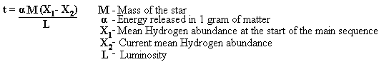

. Like the evolution from protostar into star, less massive stars leave the main sequence faster and more massive stars leave the main sequence faster. Extremely low mass stars have lifespans of dozens of billions of years

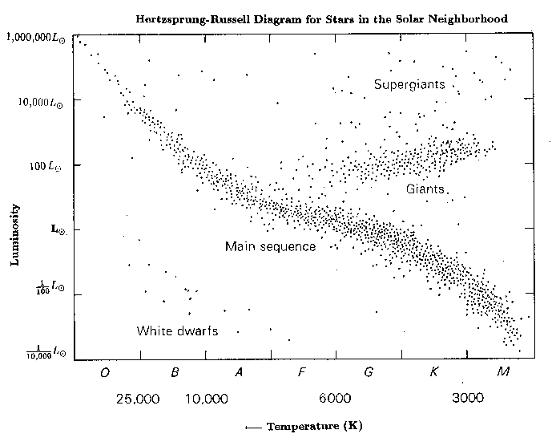

Harvard Classification of Stars:

Type: | Color: | Surface Temp.: | Spectral Lines: | Local Examples:
O | Blue | 30,000K - 60,000K | Ionized Helium, Oxygen, and Nitrogen | (Too Rare)
B | Blue - White | 10,000K - 30,000K | Neutral Helium, Hydrogen Lines | Rigel
A | White | 7,500K - 10,000K | Strong Hydrogen Lines, Ionized Calcium | Sirius
F | Yellow - White | 6,000K - 7,500K | Hydrogen, Ionized Metals (Ex. Iron) | Procyon
G | Yellow | 5,000K - 6,000K | Numerous Ionized and Neutral Metal Lines | Sol
K | Yellow - Orange | 3,500K - 5,000K | Neutral Metal Lines | Arcturus
M | Red | < 3,500K | Stronger Molecular Lines | Antares

Formation:

Interstellar Gases, instead of a true vacuum exist between stars.

Some areas have denser clouds of gas, including:
-Molecular Hydrogen, H2
-Interstellar Dust (Carbon compounds, Silicates, impure ice crystals)

There are 2 types of zones in these clouds:
-H I zones, containing neutral hydrogen, with a temperature often around 100K
-H II zones, containing ionized hydrogen, with a temperature often around 10,000K. The clouds absorb ultraviolet light and retransmitted it as visible/IR light. These clouds are visible as nebulae.

Density in these nebulae is usually about 10 atoms/cm^3, brighter nebulae have up to several thousand atoms/cm^3. Outside these clouds, the density is a hundred times less.

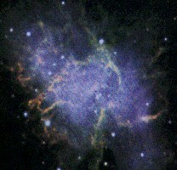

Stars start from these larger, denser clouds of gas. Any small deviation in density will break the whole cloud into a number of condensed groups, if a group has over a certain mass, gravity will be strong enough to condense it into a star.

First, a high mass cloud will contract, then begin breaking apart and each individual mass will break apart and contract at different rates (depending on the mass of each condensation). Evident in the grouping of stars into clusters, and all the stars are the same age in these clusters.

The cloud can condense at an unimpeded free-fall rate until its own infrared radiation can’t escape.

When this happens, the cloud dims and greatly slows in its condensation, the IR radiation provides and outward force and starts heating the new protostar.

A star finally stops condensing and maintains its size when inward gravitational pressure is balanced by outward gas and radiation pressure.

Evolution:

Hydrogen fusion process:
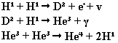

Triple alpha process:

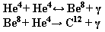

- When the core’s hydrogen drops to about 1%, the star contracts and increases in temperature. When all the hydrogen is gone from the core, the reactions take place in the shell around the core, as the helium in side the core grows. The core then heats and contracts.

The radius of the star expands quickly, the temperature of the star drops accordingly, the star becomes a red giant.

- This is determined primarily by the mass of the star:

. <.08 Solar Masses: The temperature and pressure weren’t great enough to cause any hydrogen fusion at all, the star passes through the main sequence.

. ~.08 - .3 Solar Masses, the the hydrogen burning can only produce Helium 3.

. .3 - 1.2 Solar Masses: It will expand into a red giant, then fall back down into a white dwarf, slowly cooling.

If the star’s mass is high enough (>1.2 Solar Masses), the fusion process repeats with the newly formed heavier elements.

. 1.2 - 2.4 Solar Masses: It supernovas. The outside explodes, the inside collapses and stabilizes, forms a Neutron star.

Neutron Star: Electrons have been forced into the nucleus from gravitational pressures combining with the protons, releases on formation a large burst of x-rays and neutrinos. They have a radius of only a few kilometers and with an extremely high density.
If a neutron star’s axis of rotation is greatly off from it’s magnetic poles (~30 degrees), it’s seen as a pulsar.

. >2.4 Solar Masses: Also supernovas. But after collapsing, inward gravitational pressure is greater than outward atomic pressures, the star becomes a black hole.

Black Hole: An object so dense no light can escape from it.

