Jesse Weiner

Quantum Teleportation

- Definition
  - Teleportation is the name given by science fiction writers to the feat of making an object or person disintegrate in one place while a perfect replica appears somewhere else (IBM).
  - Quantum Teleportation provides a way to "beat" the Uncertainty Principle and make an exact copy. (Harrison)
- Einstein-Podolsky-Rosen Correlation or Entanglement
  - The Principal
  - The Relevance
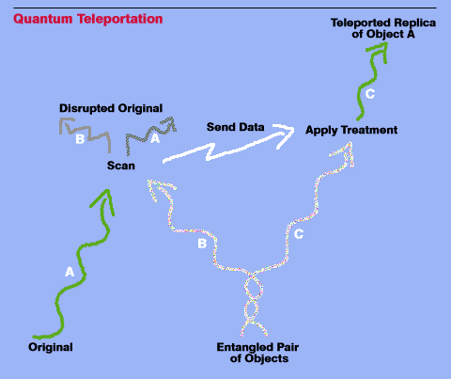
- The Experiment

