Cosmology:
Refinement of the Platonic universe
-Earth does not move
-Earth is the center of the universe (geocentric)
-everything else moves in a perfect circle around it
-the universe has a finite size, anything outside does not exist
-Earth is unmoving, geostatic

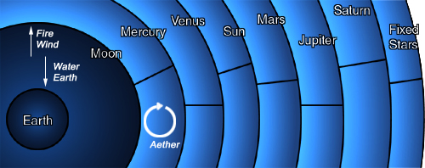

Matter:
Matter is grouped into only 4 elements, 5th element, quintessence exists
-elements try to reach their highest concentration
-higher masses move toward this concentration faster
-believed in a vacuum things do move the same speed, but a vacuum is impossible in a finite universe

Motion:
Motion is of two types, Natural and Violent
-Natural is at rest, or heading toward an element
-No motion unless a force acts on an object
-Combines inertia and friction
-directions are up, down and circular
-Violent is any motion living creatures produce, other directions

