Instruction Manual

for

Franck-Hertz Apparatus

Model P67103

©Pacific Science Supplies, Inc
1-800-530-1500

Instruction Manual
for
Franck-Hertz Apparatus
Model P67103

1. Applications

The Franck-Hertz Apparatus (Model P67103) is designed for college students to demonstrate the existence of quantized states. The experiment can be performed in less time because the use of argon tube eliminates the heating of a tube. The data can be recorded manually, or directed to an oscilloscope or computer for display.

2. Identification

The controls on the panel of the device are shown in Fig.1.

3
4
9
5
6
10

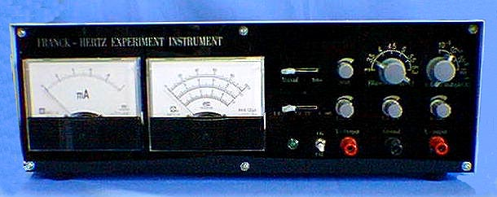

16

15

14
12
11
2
1
7
8
13

Fig.1

1 Milliameter 2 Voltmeter 3 Manual/Auto Switch
4 Scan Control 5 Filament Voltage Selector 6 Current Multiple Selector
7 Voltage Range Selector 8 1.3 –5V Adjustment 9 1.3–15V Adjustment
10 0-100V Adjustment 11 Power Indicator 12 Power Switch
13 Y-output Terminal 14 Ground 15 X-output Terminal
- Observation Window
3. Specifications

- Voltage supplied to Franck- Hertz tube.
U_{G1K} 1.3 ∼ 5V
U_{G2A} (rejecting voltage) 1.3 ∼ 15V
U_{G2K} point- measure observe 0 ∼ 100V
Sawtooth wave on oscilloscope 0 ∼ 50V
U_{H} (filament voltage) AC: 3V,3.5V, 4V, 4.5V,
5V, 5.5V, 6.3V.

- Parameter about sawtooth wave.
Scanning Voltage 0 ∼ 50V
Scanning Frequency 115 ± 20Hz
Voltage amplitude of scanning output ≤ 1V

- Low-current Measuring range
10⁻⁹ ∼ 10⁻⁶ A(4 steps)
- Observable numbers of spectrum amplitude
Point – measuring 5
Observe on universal oscilloscope 2

- Operating condition
Ambient temperature -10 ∼ 40°C
Relative humidity ≤85%(40°C)
Operating power AC 220V ± 22V, 50H_{z}
Preheating time ≤5 min
Continuous operating time 8 hours
Rated input power ≤15W
Dimensions 1 X b X h_{mm}: 400 X 230 X 130

4.Working Principle

The Franck-Hertz tube in this instrument is a tetrode filled with argon. Figure 2 describes the symbols of every electrode and relations between voltages.

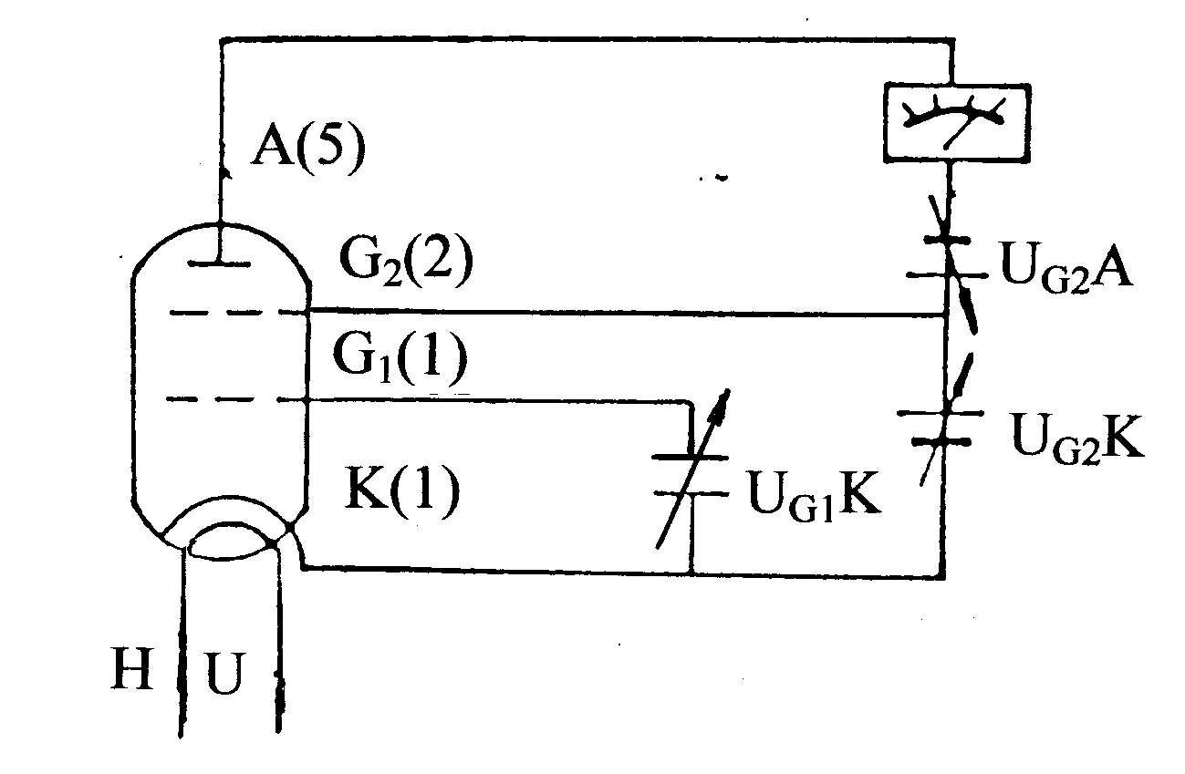
Fig.2
A voltage of about 1.5V is added between the first grid (G1) and the cathode (K) to dismiss the effect of space charge on cathode scattering electrons.
When the filament is heated, the electrons transmitted by the cathode oxide are accelerated in the electric field between the second grid (G2) and the cathode, obtaining more and more energy. But at the beginning, because of the low voltage between the second grid and cathode, the electron energy is low. Thus the energy exchanged is little even if the electrons collide with the atom. So the plate current I_{A} formed by electrons penetrating the second grid will increase with the increase of U_{G2K.} (segment OA in Figure 3)

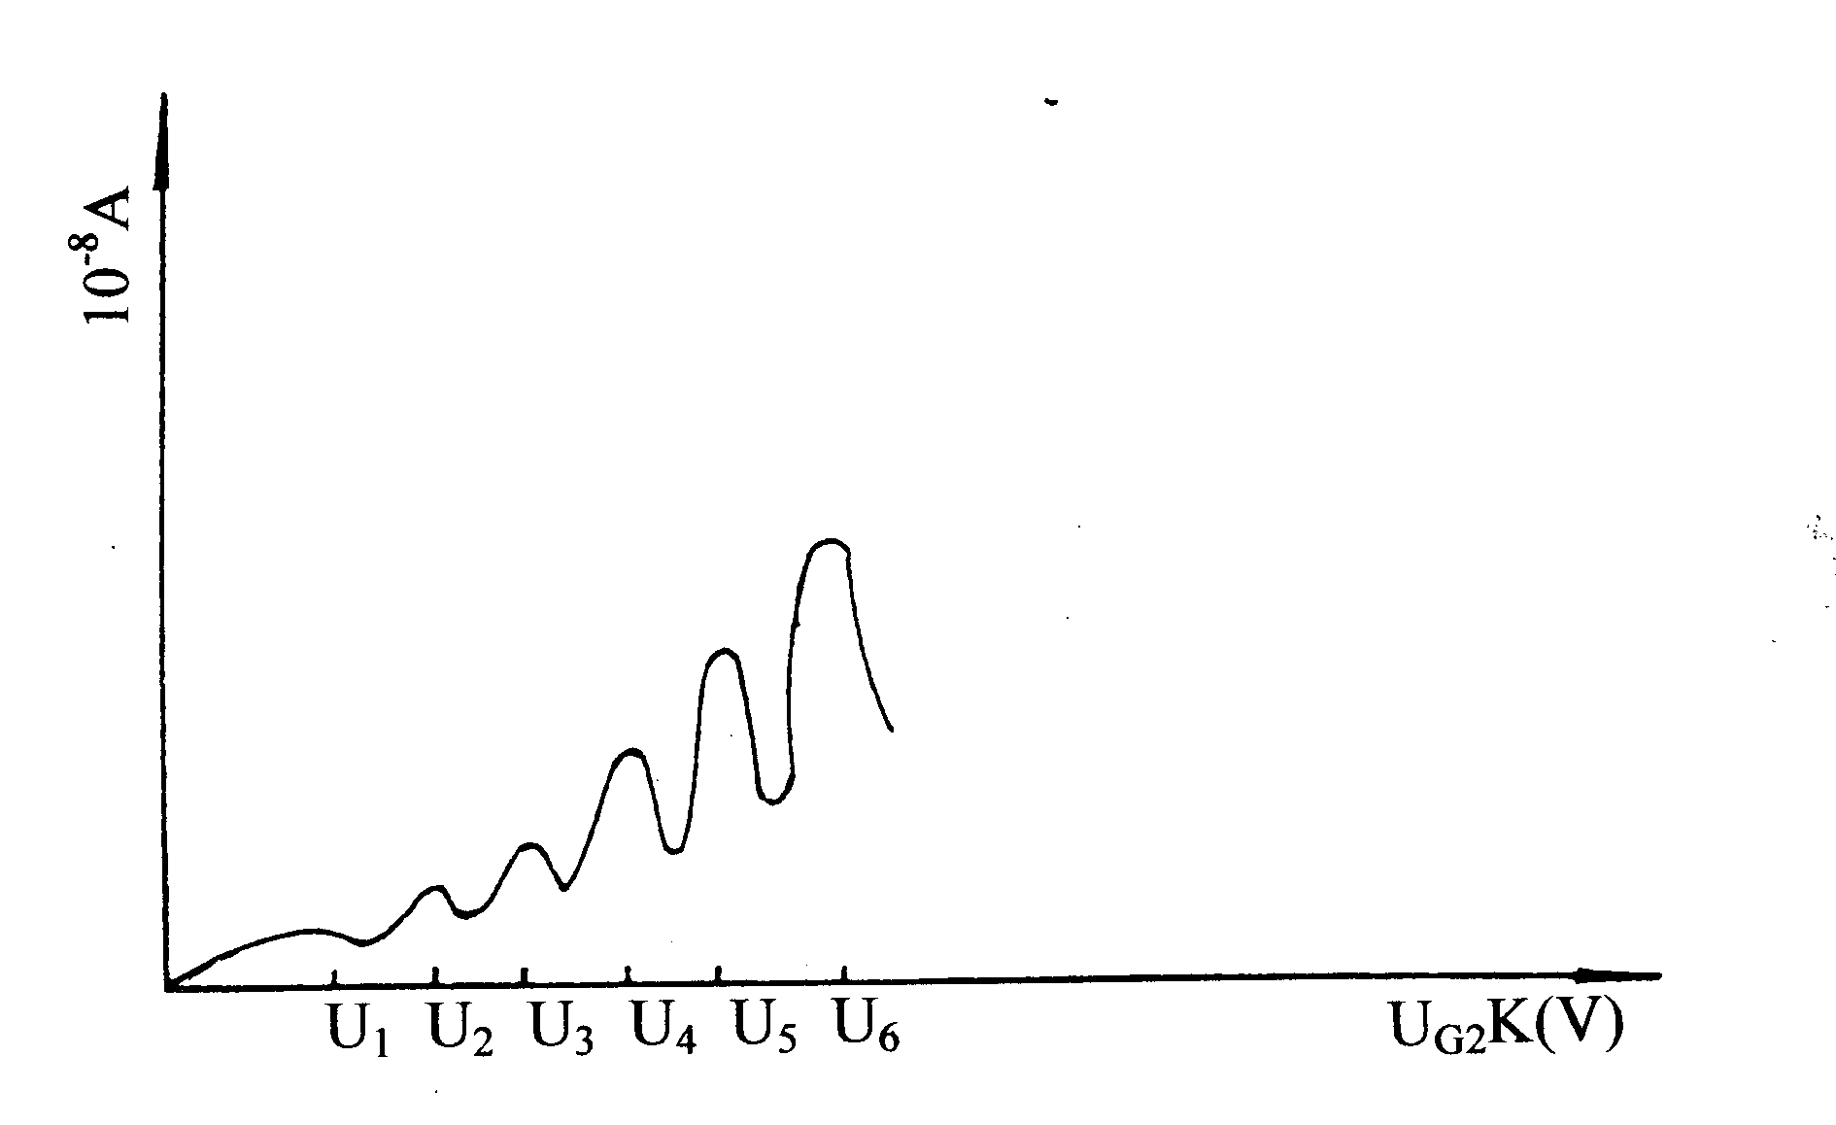
Fig. 3

When U_{G2K} reaches the first excitation potential of the argon atom, electrons collide with argon atoms near the second grid (it is a non-elastic collision), and transfer total energy obtained in the accelerating field to argon atoms, exciting them from ground state to the first excitation state. But electrons themselves, transferring all energy to argon atoms, can’t overcome the reverse field. They are drawn back to the second grid even if some of them penetrated the second grid. So the plate current I_{A} decreased obviously. Then, with the increase of U_{G2K,} the electron energy increased too. There will be enough energy left after the collision with argon atom. Thus they can overcome the reverse field and reach plate A. And at this time current I_{A} begins to increase again, until U_{G2K} is 2 times the voltage of argon atom’s first excitation potential, when electrons between G2 and K lost energy again because the second non-elastic collision causes the second decrease of acceleration voltage U_{G2K}
Let U_{G2K} be the horizontal ordinate and I_{A} the vertical axis. We can plot the spectrum amplitude curve. The voltage difference between two consecutive valley point (or peak point) is the first excitation potential of argon atom. This experiment illustrates the fact that the slow electrons in Franck-Hertz tube collide with argon atoms, excite the atoms from low level to high level. By measuring the argon’s first excitation potential (13.1V, which is constant) We can verify that the energy absorbed and transmitted is discrete, not continuous.

5. Operations

- Switch on the power. The indicator will flash.
- Turn the “Manual-Auto” switch to “Manual”, rotate the Scan knob counter-clockwise to end, turn “Filament Voltage Selector” to 3.5V, “Current Multiple” selector to 10⁻⁷.
- Turn “Voltage Stepper” to 1.3 ∼ 5V, and rotate 1.3 ∼ 5V adjust knob until the voltmeter reads 1.5V to set U_{G1K} =1.5V.
- Turn “Voltage Stepper” to 1.3 ∼ 5V, and rotate 1.3 ∼ 5V adjust knob until the voltmeter reads 7.5V to set U_{G2A} =7.5V (rejecting voltage).
- Turn “Voltage Stepper” to 0 ∼ 100V, and rotate 0 ∼ 100V adjust knob until the voltmeter reads 0V to set U_{G2k} =7.5V(accelerating voltage).

When you have finished step 2 ~ 5, with U_{H}=3.5V (Filament voltage), U_{G1K} = 1.5V (the voltage between the first grid and kathode), U_{G2A} =7.5V( The voltage between the second grid and anode) you are ready to do the experiment These are suggested voltages for the experiment. You can do the experiment by parameters marked on the argon tube either.

- Turn off the power, move the top cover of the instrument, place the Franck-Hertz tube in lamp socket, replace the top cover and turn on the power The indicator will flash. Preheat 3 minutes, before the experiment.
- Rotate “ 0 ∼ 100V” adjust knob, and at mean time observe the variation of rheometer and voltmeter’s readings. With the increase of U_{G2K} (accelerating voltage), the rheometer’s reading appears peak and valley periodically. Record the corresponding voltage and current. Let the output current be the vertical ordinate, and U_{G2K} the horizontal ordinate. Plot the spectrum amplitude curve.
- Turn “Manual-Auto” switch to “Auto”, and connect the instrument’s Y, ground, X socket to Y, ground, X of a student oscilloscope. Put the scanning range switch of oscilloscope to “external X”. Switch on the power of oscilloscope, adjust the Y and X shift to make the scan baseline on the bottom of screen, aand adjust X Gain” to make scan baseline 10 grids. Rotate the scanning knob of this instrument, and observe the waveform on the oscilloscope’s screen. Adjust the “Y gain” and “X gain” of the oscilloscope’s attenuation to make the waveform clear and Y amplitude moderate. Rotate scanning potentiometer clockwise to end, set the maximum scan voltage to 50V, measure the horizontal distance of two consecutive crest ( count the grids). Multiply the distance by 5V/grid, to obtain the value of argon atom’s first excitation potential.

6. Caution

- During the experiment, pay attention to the output current indicator when the voltage is over 60V. If the rheometer’s reading increases suddenly, decrease the voltage at once to avoid the damage to the tube.
- If you want to change the value of U_{G1K}, U_{G2A} and U_{H} during the experiment, rotate the “0 ~ 100V” adjust knob counter-clockwise to end, before making the changes.
- The filament voltage of this instrument is 3V, 3.5V, 4V, 4.5V, 5V, 5.5V, 6.3V. You can do the experiment with these filament voltages. If skewness occurred on the top of waveform (that means the anode output current is too strong and causes the amplifier to distort), the filament voltage should be decreased.

7. Packing List

- Franck-Hertz Apparatus 1 each
- Argon Tube 1 each
- Connect wires of power 1 each
- Connect wires of host machine and oscilloscope 1each
- Operating instruction manual 1 each

