Invention of flip coil (« Earth inductor ») :
Delezenne [Charles Edouard Joseph] 1776-1866.
Notions élémentaires sur les phénomènes d'induction [par Delezenne] Lille, Impr. de L. Danel, 1845.
[3], 132 p. 2 fold. plates, charts. 21.8 cm.
"Extrait des Memoires de la Societe royale des sciences, de Lille."
Provenance: Mr. Becquerel (inscription)
In Ronalds.
(entry from Website http://www.thebakken.org/library/books/19d.htm)
Also quoted at http://physics.kenyon.edu/EarlyApparatus/Electricity/Earth_Inductor_or_Delzennes_Circle/Earth_Inductor_or_Delzennes_Circle.html
The apparatus was devised by Charles Edouard Joseph Delzenne (1776-1866) and described in his two papers "Notices elementarie sur les phenomenes de induction", Lille, Memoires de la Societe des Sciences, 23, 1-132 (1844); 27, 10-160 (1847)
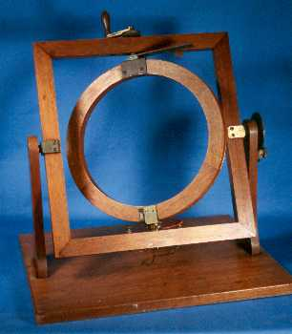
The apparatus was devised by Charles Edouard Joseph Delzenne (1776-1866) and described in his two papers "Notices elementaires sur les phenomenes de induction", Lille, Memoires de la Societe des Sciences, 23, 1-132 (1844); 27, 10-160 (1847)

