IE.1 The Earth 's Magnetic Field

1. Purpose: To measure the magnitude and direction of the earth magnetic field.

2. Apparatus: Earth inductor (flip coil),
Helmholtz coil,
mutual inductance coil,
galvanometer,
current controlled power supply,
bipolar switch,
resistor box,
multimeter.

- Introduction:
In this experiment, an earth inductor is used to measure the earth magnetic field B. The earth inductor is a "flip coil" -- it consists of a flat coil of wire of many turns mounted on a frame so that it can be made to quickly rotate ("flip") about one of its diameters. During this rotation, the magnetic flux through the coil changes, inducing a voltage [1]. The total charge from the resulting current pulse can be measured, e.g. with a ballistic galvanometer. The deflection of the galvanometer can be shown to be proportional to the magnitude of the component of the earth's field perpendicular to the coil.

- Experimental setup and procedure:
The table on which the apparatus sits has markers on the table surface which allow the flip-coil to be aligned with the N - S and E - W directions.

4.1 Measurement of the earth magnetic field components:
Connect the coil of the flip-coil to the galvanometer via a current-limiting series resistor R₁
of about 700 to 1000 Ω. Measure the deflection d caused by flipping the coil at least
five times. Do this for three orientations of the coil, with the coils axis vertical,
parallel to the meridian (N - S), and perpendicular to the meridian (pointing east - west), to
measure the three components of the earth magnetic field vector.

When the coil is flipped in a magnetic field then the EMF Є produced is

Є = n dφ/dt (1) where n = number of turns in the coil, φ = flux through the coil

This EMF must equal the potential drop around the circuit:

n dφ/dt = i_{T}R₁ (2) where i_{T} = current in the circuit.

The total charge that flows into the galvanometer during the flip is obtained by integrating over the duration of the flip:
Q = ∫ i_{T}dt = (n/R₁) Δφ (3)

For a 180° flip, Δφ = 2B_{e}A, where B_{e} = component of the earth's field
perpendicular to the coil,
A = area of the coil

Then: Q = (n/R₁)(2B_{e}A) (4)

Now a ballistic galvanometer's deflection is proportional to the charge that flows through it

d = KQ (5) where d = deflection,
K = proportionality constant
Then d/K = (n/R₁) (2B_{e}A) (6) or

B_{e} = d R₁ /(2nAK) (7)

This equation relates the component of the earth's field B_{e} to the deflection of the galvanometer d. However, although n, A, and R₁ can be measured, K is still unknown. Therefore, a method of calibration of the instrument is needed.

4.2. Calibration of the flip coil with a known mutual induction pair:
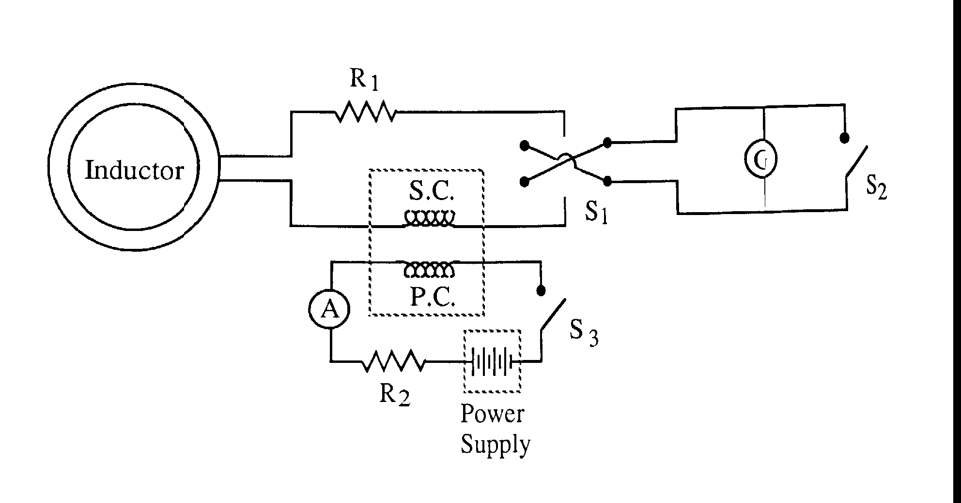

G = Ballistic Galvanometer
S₁ = Bipolar switch
S₂ = Shorting switch
R₁ = Current limiting resistor
S.C. = Secondary coil
P.C. = Primary coil
R₂ = P.C. current adjust
S₃ = Switch
A = Ammeter

The bottom circuit (one with S₃ and power supply) is a calibration circuit.
If S₃ is closed, a current will begin to flow in the circuit. S.C. and P.C. are the secondary and primary coil in a mutual induction pair. Thus as the current changes in the bottom circuit an EMF Є is produced in the top circuit.

Є = M di_{B}/dt = i'R₁ (8) where M = mutual inductance between P.C. and S.C.
i_{B} = current in bottom circuit
i' = current in top circuit

Using similar arguments as before it can be shown that

Q' = Mi_{B}/R₁ (9) where Q' = induced charge flow in top circuit

This also gives a deflection for the galvanometer:
d_{c} = KQ' (10) where d_{c} = calibration deflection,
K = the same proportionality constant as above

Then K = d_{c}/Q' = [d_{c}/(Mi_{B})] R₁ (11)

Substituting into Equation (7):

B_{e} = [dR₁/(2nA)] [Mi_{B}/(d_{c}R₁)] = [Mi_{B}/(2nA)] (d/d_{c)} (12)

which can then be used to get an absolute value for B_{ε}.

4.3 Calibration using a known B - field change
A second calibration procedure may also be used. Suppose the earth inductor (flip coil) is placed in a known magnetic field such as that generated by a Helmholtz coil. If this field is suddenly shut off, an EMF Є will be induced in the earth indicator coil:

Є = n dφ_{c}/dt (13) where φ_{c} = the calibration flux

Using the same argument as above it can be shown that

B_{c} = d_{c}R₁/(nAK) (14) where B_{c} = calibration field
d_{c} = calibration deflection of the
galvanometer

Then substituting Eq. (14) into Eq. (7)

B_{e} = [dR₁/(2nA)] [nAB_{c}/(d_{c}R₁)] = B_{c} d/(2d_{c}) (15)

4.4 Calibration using a known B - field
A third calibration method consists in placing the flip coil (earth inductor) into a known magnetic field (e.g. from a Helmholtz coil), and measuring the effect of flipping the coil in the total magnetic field (which is now the sum of the earth magnetic field and the field due to the Helmholtz coil). Measure the deflection several (at least 10) times, for a number of current values in the Helmholtz coil. You should choose the current values so as to cover as wide a range of deflections as possible (limited by the maximum deflection that you can measure with the galvanometer).
Note that the total field component perpendicular to the coil, as well as the total deflection are algebraic sums (i.e. sums of signed quantities) of the individual contributions from the earth magnetic field and the calibration field.

We have: B_{t} = B_{e} + B_{h,} d_{t} = d_{e} + d_{h,}

where B_{t} is the total magnetic field, is the (known) field due to the Helmholtz coil, and is the earth magnetic field (or rather their components perpendicular to the flip coil), and the d's are the corresponding deflections.

B_{t} = d_{t}R₁/(nAK) = (d_{e} + d_{h} ) R₁/(nAK) (16)
B_{e} = d_{e}R₁/(nAK)

Therefore B_{h} = B_{t} - B_{e} = (d_{t} - d_{e} ) R₁/(nAK) (17),
and finally B_{e} = B_{h} d_{e} / (d_{t} - d_{e} ) (18)

Another way to write this is
B_{e} = C d_{e} , where the constant C is given by
C = B_{h} / (d_{t} - d_{e} ); (19)

This constant C can be determined from the calibration measurements (using the deflection d_{e} measured for the earth's vertical field component), and can then be applied also to the other two components of the earth magnetic field.
For every non-zero value of I (and thus B_{h}), measurement of d_{t} gives you a measurement of the calibration constant C, using d_{e} determined from the measurement with I = 0. Use the average of all of these in your analysis. To get good results, choose the currents in the Helmholtz coil so as to cover the widest possible range of total deflections d_{t} .

Equation (19) can also be written as
d_{t} = (B_{h} /C) - d_{e ,} (20)
a form which shows you that another way to obtain C and d_{e} is to plot d_{t} (y-axis) vs B_{h} (x-axis). The slope of the best straight line through these points is 1/C, and the intercept is d_{e} . Spread sheet programs like MSExcel offer the possibility to plot the "trendline" which is the best straight line through the data points, and to determine the parameters of the line.

The field of the Helmholtz coil can be obtained using the formula
where N = number of turns in each coil,
I = current through the coils in amperes,
a = radius of coils in meters, and
μ_{o} = permeability of free space.

$Β=\frac{8μ_{0}\text{ΝΙ}}{a\sqrt{\text{125}}}$

5. Suggested Procedure:

Position the table on which the apparatus sits such that it has a known orientation with respect to the laboratory (align it with the wall for example). Connect the ballistic galvanometer to the flip coil through a current-limiting resistor (about 500 to 1000 Ω), with the value chosen so as to put the deflection within the range. Measure the components of the earth's field. Measure each component enough times to get reasonable statistics. Calibrate using one of the methods outlined above. Make sure that you have the same resistor(s) in the flip coil circuit for the calibration as for the earth magnetic field measurement. Again, do enough measurements to give reasonable statistics. Calculate the total field and its direction. Do a complete error analysis. Compare with the earth magnetic field values expected for your location [2]. Discuss agreement and/or disagreement , taking into account the experimental uncertainty of your measurement.

- More details on the analysis:

6.a Determination of calibration constant:

6.a.1 Method 4.4 is recommended for the calibration. Take at least 20 points, covering as wide a range of deflection as possible.

6.a.2 Once you know d_{e} , every deflection and current measurement yields a measurement of the calibration constant C. Take the average of all of these C values.

6.a.3 You can also determine C from the slope of the straight line fit to a plot of d_{t} vs B_{h},

and the intercept of this straight line is the best estimate for d_{e}. Compare the two values of C.

6.b. Determination of experimental uncertainties ("Error Analysis"):

Here are guidelines for the determination of uncertainties, assuming you used the calibration method described in sect. 4.4 (calibration with a known magnetic field).

6.b.1 Uncertainty on individual measurements of C: Make sensible assumptions/guesses

about the precision with which you measure the deflections, the current and the radius of the

Helmholtz coil.

Using "error propagation", this can be translated into an uncertainty on the individual measurements of C. Do this for every determination of C, and take the average of all of these uncertainties.

6.b.2 Another way to get an estimate of the uncertainty on C is by using the fact that you

have multiple measurements of the same quantity C. The standard deviation gives you a

measure for the uncertainty on C.

6.b.2 From the best straight line through the points representing your measurements of d_{t} and

B_{h}, you can also determine C (1/slope) and d_{e} (the intercept), as well as an uncertainty on

these (See e.g. the chapter on statistics in the textbook on information on how to determine

the uncertainty on the fitted parameters of the straight line)

You should compare the values obtained by the different methods and discuss their relative

merit.

6.c Determination of Earth’s magnetic field:

6.c.1 From the measured deflections d_{e} in the three orientations of the flip coil, determine the

components of the Earth’s magnetic field in the three directions.. Also determine the

horizontal component and the magnitude, as well as the uncertainties on all of these.

Compare vertical and horizontal component, as well as magnitude with the accepted values

that you can find on the website quoted in ref. [2].

7 References:
[1] William B. Fretter, Introduction to experimental physics, Dover 1968
[2] See geomagnetic data at the Website of National Geophysical Data Center,
(http://www.ngdc.noaa.gov/seg/potfld/geomag.shtml)

