IO.5 Elliptically Polarized Light

- Purpose:
Analyze elliptically polarized light;
determine the orientation of the vibration ellipse and the ratio of its semi-axes.

- Apparatus:
Gaertner Scientific spectrometer,
Wollaston prism,
Nicol polarizer,
quarter-wave plate.

- Theory:
If two mutually perpendicular simple harmonic motions,

x(t) = a sin (ωt) and y(t) = b sin (ωt + δ) (1)

are compounded by the elimination of time, t, between these two expressions,
the resultant path is

x²/a² + y²/b² – (2xy/ab)cos δ = sin² δ (2)

which is a rather general expression for an ellipse.
For δ = 0 or π the ellipse degenerates into a straight line:

x/a ± y/b = 0 (3)

For δ = π/2, the expression becomes:

x²/a² + y²/b² = 1 (4)

which is an ellipse whose axes coincide with the x and y directions. On the other hand, if we rotate the coordinates through an angle θ such that tan 2θ = (2ab/(b² - a²))cos δ, eq. (2) will go into the form:

x'²/a'² + y'²/b'² = 1 (5)

This may be interpreted as an ellipse obtained by compounding simple harmonic with phase motions along the x' and y' axes with amplitudes a' and b' and with phase difference π/2. It is, however, still the same ellipse as that given by eq. (2). Therefore any ellipse (in particular, any elliptically polarized light), however obtained, may be analyzed in terms of two perpendicular simple harmonic motions of phase difference π/2. This fact will be used in the experiment.

Consider a thin uniaxial crystal with its faces cut parallel to the optic axis. Let a plane-polarized beam of monochromatic light vibrating with amplitude A at an angle φ with the optic axis be incident normally upon such a crystal. Upon entering the crystal, the light will break up into two components, E with vibrations parallel to the principal section, and O with vibrations perpendicular to the principal section. The amplitudes of the E and O vibrations are, respectively

a = A cos φ and b = A sin φ (6)

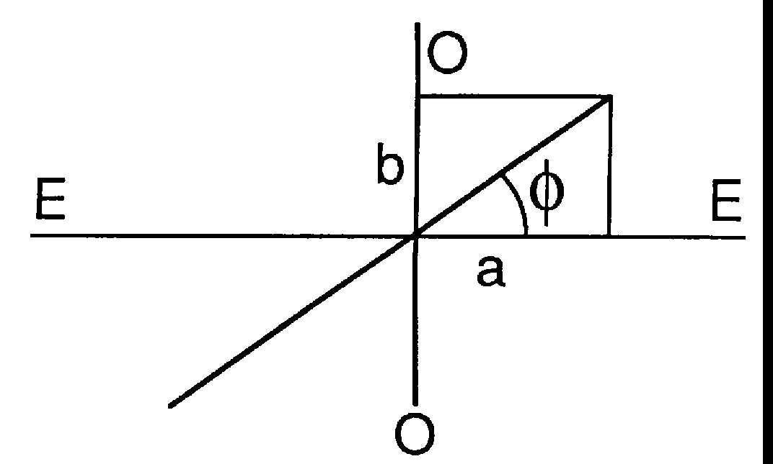
For crystals cut as indicated, the two beams will follow the same path inside the crystal, but one
will travel with greater speed than the other, hence, when they emerge from the crystal, one will be ahead of the other in phase, and the motion of the end of the resultant electric vector will be elliptical as in (2). If the crystal is of such a thickness that one beam is a quarter wavelength ahead of the other upon emergence, the crystal is known as a quarter-wave plate, and (4) holds for the resultant vibration. If φ, the angle between the plane polarization of the incident light and the optic axis of the quarter wave plate is 0 or π/2, the emergent light is plane-polarized, while if φ = π/4, then a = b, and the emergent
light is circularly polarized.

Let light from the collimator of a spectrometer be polarized in a known direction, and a Nicol crossed with this to extinguish the light. Introduce a quarter-wave plate with its axis parallel (or perpendicular) to the plane of extinction of the Nicol. The plane of polarization remains unchanged and the analyzer still passes no light. Now place a doubly refracting plate of unknown thickness and orientation of optic axis in the beam between the polarizer and the quarter-wave plate. This will produce elliptically polarized light of unknown orientation and ratio of axes, which is to be analysed. ln general, some light will now get through the analyzer.

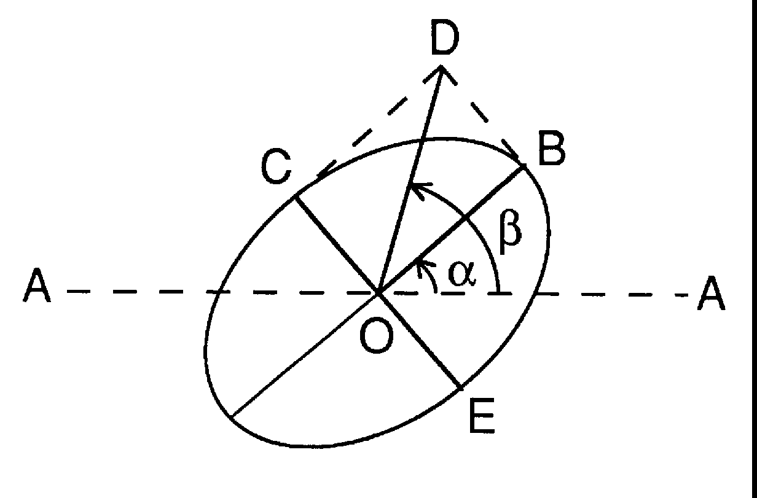
In the figure, let A-A be the direction of the plane of extinction of the analyzer (and also the direction of the axis of the quarter-wave plate). Suppose the semi-axes of the unknown ellipse are OB and OC. If the quarter-wave plate is rotated through an angle α so that its axis lies along one of the axes of the ellipse, it will add or subtract a phase difference of π/2 to the existing phase difference of π/2 between the component simple harmonic motions along OB and OC. Then we will have two simple harmonic motions perpendicular to one another and in phase or out of phase by π. In either case they will combine to give plane polarized light. Let's say they are in phase and the light is polarized along OD. Then if the plane of extinction of the analyzer is rotated through an angle β, the light will again be extinguished. Now it is clear from the figure that the orientation of one of the axes of the ellipse to be analyzed is at an angle α from A-A and the other at an angle α + π/2. Furthermore the ratio of the semi-axes is

OC/OB = BD/CD = tan(BOD) = tan(β- α) (7)

There is some ambiguity in the definition of the angles α and β. For example α could have been taken from OA to OE and/or the plane of the emergent light might have been between OB and OE. The student can easily verify that all possibilities will lead to ± tan (β - α) or ± cot (β - α). The sign is immaterial, and since cot is 1/tan this simply means taking the ratio of semi-axes the other way. Therefore, one is certain of the ratio, but uncertain which is the direction of major and minor axis. This final ambiguity may be removed by observing the changes in intensity when the quarter-wave plate is taken out of the beam and the Nicol analyzer rotated. The positions of maxima or non-zero minima will give approximate locations of major and minor semi-axes.

4. Procedure

4.1. Preparation of Apparatus and Measurements.

(1) Adjust telescope and collimator of spectrometer for parallel light.
- Place Wollaston prism in revolving holder on collimator and rotate until one slit
image appears above the other.
- Insert analyzing eyepiece, readjust telescope, and rotate until one or the other of the
slit images disappears.
- Replace the Wollaston prism by the Nicol polarizer, and rotate polarizer until
extinction of the slit occurs in the eyepiece. The light leaving the polarizer is now
plane-polarized in the horizontal or vertical plane. A glance at the end of the Nicol
prism will determine which plane it is.
- Place the quarter-wave plate over the objective of the telescope and rotate it until
extinction of the image occurs.
The equipment is now ready for the analysis of the ellipse.
- Insert the unknown mica plate in the grating holder on the spectrometer table and set it normal to the line of sight by inspection.
- Locate a minimum approximately by turning the analyzer. Then rotate the
quarter-wave plate through a small angle and again find the minimum with the
analyzer. If this minimum is darker than before, the quarter-wave plate was turned in
the right direction. Repeat this procedure until the position of extinction of the slit
image is found. Note the angles through which the quarter-wave plate and
analyzer were turned.
- Remove the quarter-wave plate and study the intensity of the slit image when rotating the analyzer. Note the direction of maximum or minimum intensity, whichever is easier.

4.2 Report

- From the measurements under (7), determine the orientation of the ellipse
and the ratio of its semi-axes.
- (2) From the measurements under (8), indicate which is the major and which the
- minor axis.
- Sketch a diagram showing the major and minor axes of the ellipse and their orientation
with respect to the direction of vibration of the light incident on the unknown
mica plate.

4.3 Analysis of the Polarization of Light Totally Internally Reflected.

When polarized light is totally internally reflected, the magnitude of the E vector is equal to the magnitude of the incident, but there is a phase change upon reflection, which is in general different for the component E_{p} parallel to the incident plane and the component E_{s} perpendicular to it. If A and R refer to incident and reflected amplitudes respectively, then:

R_{p} = A_{p} e^{iδp} (8)

R_{s} = A_{s} e^{iδs} (9)

and the Fresnel relations imply:

tan δ_{p}/2 = n √(n² sin²i - 1)/ cos i (10)

tan δ_{s}/2 = √(n² sin²i - 1)/(n cos i) (11)

Where n is the index of refraction and i is the angle of incidence upon the totally reflecting surface. And the phase difference δ = δ_{p} - δ_{s} is given by:

tan δ/2 = cos i √(n² sin²i - 1)/ (n sin² i) (12)

Measurements:

Be sure that the plane of the table is normal to the axis of rotation of collimator and telescope and that the latter moves in a plane perpendicular to this axis.

Since p and s components of light in air reflected at a glass surface have in general different reflection coefficients, it is most convenient to have the light enter and leave the short faces normally. In this experiment a "rectangular" equilateral prism is used. Measure the angles of the prism by reflecting the light from the collimator at the prism faces. Set the telescope so that its axis makes an angle of 180° - A with the collimator axis, where A is the large angle (approximately 90°). Rotate the prism until the image of the slit is at the cross-hairs of the telescope. The light now enters and leaves the faces normally. Measure the index of refraction for sodium light by the method of minimum deviation.

Analyze the polarization of the light from a sodium source when the polarized light incident on the prism has its E vector vibrating at an angle of 0°, 45°, 90° to the collimator slit. Compare the result in the 45° case with the prediction of equation (12). The light in the 0° and 90° cases should be plane polarized.

