IO.1. Fabry-Perot Interferometer

1. Purpose: To make some optical measurements using a Fabry-Perot etalon.

- Apparatus: Fabry-Perot etalon,
light source (Hg 5461 A),
measuring micrometer eyepiece,
good quality achromatic lens.

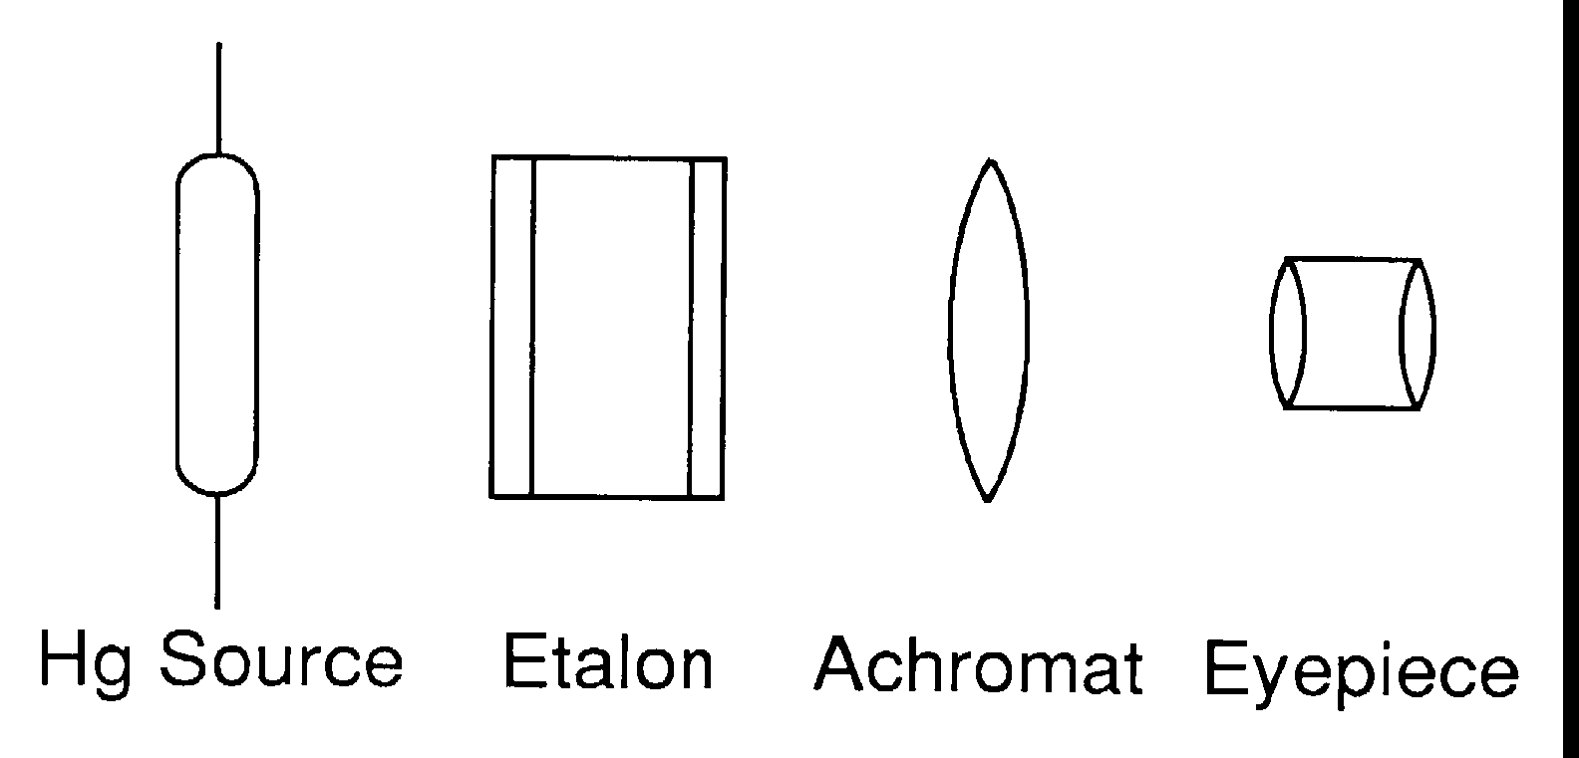

Fig.1: Lay-out of Fabry-Perot apparatus

- Theory and Procedure

3.1 Introduction:
Arrange the apparatus as shown in Fig 1. The light source, the Fabry-Perot etalon, the achromatic lens and the measuring microscope are arranged in a straight line with the distance between the lens and the focal plane of the eyepiece equal to the focal length of the eyepiece. Carefully adjust until circular fringes are observed through the eyepiece.
In order to understand this experiment better, consider the following:
If m_{n} is the order of the n the circular fringe from the center of the pattern, t is the thickness or distance between the plates, and θ_{n} is the angular diameter of the n th circular fringe, then

2t cos (θ_{n}/2) = m_{n} λ ; solving for m_{n} : = (2t/λ) cos (θ_{n} /2) (1)

Since θ is small, cos θ may be expanded:
cos θ = 1 - θ²/2! + θ⁴/4! - θ⁶/6! + -…., , i.e. cos θ_{n}/2 = 1 - (θ_{n}/2)²/2! = (1 - θ_{n}²/8)

and m_{n} = 2t/λ (1 - θ_{n}²/8) (2)

If d_{n} is the linear diameter of the nth circular fringe and f is the focal length of the achromat which forms the image in the eyepiece's focal plane, then, θ_{n} = d_{n}/f (See Fig 2) and
m_{n} = (2t/λ) (1 - d_{n}²/8f²) (3)

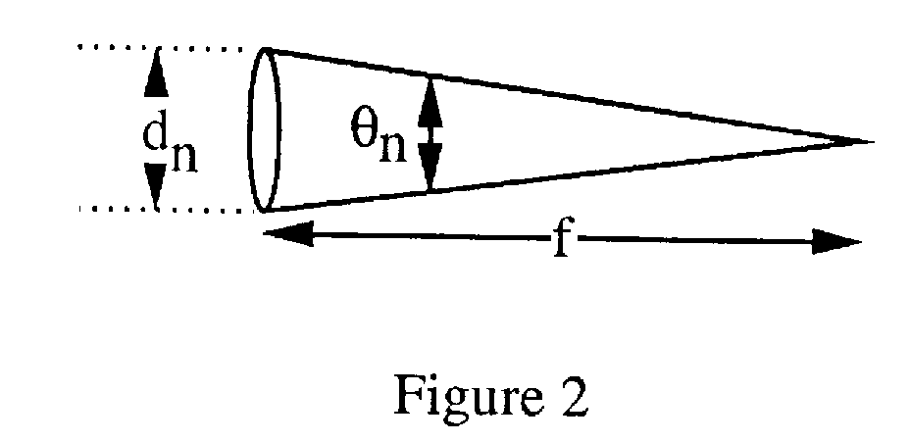
Definition of θ_{n}

3.2. Constancy of d_{n}² - d_{n-1}² :

With the micrometer eyepiece, measure the diameter of 10 circular fringes and record data as in Table 1. When measuring the diameters, the micrometer should be moved in one direction ONLY across fringes, stopping to take a reading on each fringe and then calculating the diameters.

Complete the calculations as shown in Table 1 and compare the values of d_{n}² - d_{n-1}².

Table 1
──────────────────────────────────────────────────────────────
Circular Fringe No. Diameter d_{n}² d_{n}²- d_{n-1}²
(cm) (cm² ) (cm² )
──────────────────────────────────────────────────────────────
1 .6275 .3938 .7882
2 1.0872 1.0872 .8117
3 1.4120 1.9937 .7789
4 1.6551 2.7726 .8139
5 1.8938 3.5865 .7862
6 2.0911 4.3727 .7775
7 2.2694 5.1502 .8078
6 2.4409 5.9580 .7812
9 2.5960 6.7392 .8140
10 2.7483 7.5332
──────────────────────────────────────────────────────────────

Average .795 cm²
─────────────────────────────────────────────────────────────-

F.M Phelps III (J. Opt. Soc. Am., 59, 362 1969) has pointed out that a more precise way to handle these and similar data (pages 29, 35) is to use a "simple least-squares fit" or to form

d₁₀²- d₅² = 3.9667 d₉²- d₄² = 3.9666 d₈²- d₃² = 3.9643
d₇²- d₂² = 3.9682 d₆²- d₁² = 3.9789 (d_{n}² - d_{n-5}²)_{av} = 3.9689

and (d_{n}²- d_{n-5}²)_{av}/5 = 0.7938 rather than 0.795 above.

  - Thickness or distance between the interferometer's plates:

Starting with Eq (2):

m_{n} = 2t/λ (1 - θ_{n}²/8) and m_{k} = 2t/λ (1 - θ_{k}²/8)

now take m_{n} - m_{k} and

m_{n}-m_{k} = (2t/λ) (1 - θ_{n}²8) - (2t/λ) (1 - θ_{k}²/8) = (2t/λ) ((θ_{k}² - θ_{n}²)/8)

Solving for t:
t = 4λ (m_{n} - m_{k})/( θ_{k}² - θ_{n}²) (5)

where n and k are numbers of any two fringes as shown in Fig 3. The angles θ_{n} and θ_{k} are defined as shown in Fig. 2 and Fig. 3.

If we make use of the diameters of the 7th, 8th, 9th, and 10th fringes from Table 1, it is easy to obtain the thickness or distance (t) between the plates of the etalon using Eq. 5. These results are given in Table 2.

Table 2
───────────────────────────────────────
k n t (cm)
───────────────────────────────────────
7 8 1.032
7 10 1.041
8 9 1.068
9 10 1.025
───────────────────────────────────────
Average 1.042

Which measurement thus far in the experiment has had the least number of significant figures?

3.4. The value of Δλ for one fringe shift:

The change in wavelength which corresponds to a shift of one fringe, is to be determined. If d_{n} and d'_{n} represent the linear diameter of the n th fringe for wavelengths λ and λ + Δλ, the following equations may be obtained from Eq 3.

Solving Eq. 3 for λ:

λ = (2t/m_{n}) (1 - d_{n}²/8f²) and λ + Δλ = (2t/m_{n})(1 - d'_{n}²/8f²)

Subtracting the first equation from the second and solving for Δλ; we get

Δλ = 2t d_{n}²/(m_{n}8f²) - 2t d'_{n}²/(m_{n}8f²) = (2t/m_{n}) (d_{n}²- d'_{n}²)/8f²

and Δλ ≅ λ ((d_{n}²- d'_{n}²)/8f²) (4)
since from Eq 1 : λ ≅ 2t/m_{n}.

Therefore the value of Δλ for a shift of one fringe may be obtained by substituting the value of d_{n}²- d_{n-1}² into Eq 4 as follows:

Δλ = 5460.74 x 0.795 / (8 x 61.8²) = 0.142 Α (for 1 fringe shift)

where the focal length (f) of the lens used was 61.8 cm. If a line with a satellite is photographed, eq. 4 permits the calculation of the wavelength of the satellite line. Such a calculation will be made in the experiment on the Zeeman Effect, Advanced Laboratory.

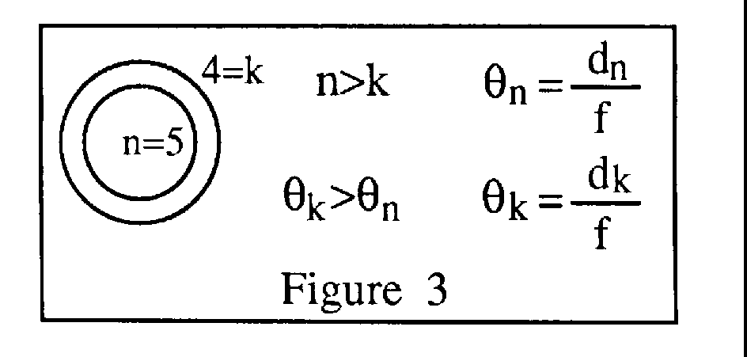

3.5. References: [1] Jenkins, F.A. & White, H.E., Fundamentals of Optics, 1957, pp. 274-84
- [2] Hilton, W. A., Construction and Use of Fabry - Perot Interferometer;
American Journal of Physics, Vol. 30, pp. 724-26, 1962 (Oct.) Page 34.

