IE.3. Hysteresis loop of an iron sample

1. Purpose: Investigate the hysteresis loop of an iron sample.

2. Apparatus: Iron ring,
50-Ω rheostat,
ammeter,
galvanometer,
bipolar switch,
variac.

Fig. 1

3. Experimental setup:
The iron sample is in the form of a thin ring, about 5 inches in diameter. A primary or magnetizing coil of coarse wire is wound on the ring, completely around it, and secondary coil of many turns of fine wire is wound over a portion of the primary. Current i sent through the primary produces a magnetizing field B_{app} within the iron. The iron becomes magnetized and gives rise to a total magnetic field B, corresponding to a magnetic flux Φ through the secondary coil. Changes of primary current i change B_{app}, and hence B and Φ. A ballistic galvanometer joined to the secondary winding gives deflections proportional to the changes in Φ. The purpose of the experiment is to obtain a series of deflections, corresponding to known changes of primary current, from which to plot a curve whose coordinates are proportional to the values of B_{app} and B in the iron.
Fig. 1 shows the circuit used. Ammeter A (0 - 1 A range) registers the primary current, which is limited to a maximum of about 0.6 A by the 10Ω resistor P. A suitable sequence of other values is obtained by means of the variable rheostat R, the knife switch K, and the reversing switch RS. The 1000Ω resistor Q in the secondary circuit is used to avoid excessive deflections, and to reduce sluggish motion of the galvanometer coil.

- Procedure:
First, connect up the primary circuit, only, and note the positions r_{i} (i = 1,..,6) of the rheostat slider that give currents of roughly 0.1, 0.2, 0.3, 0.4, 0.5 and 0.6 A. In the regular runs, it will not be possible to have exactly those current values, but it is good to plan on intervals of about 0.1 A.
Before the run, the iron is demagnetized by joining the primary winding to a source of AC current (≈ 1A) which is then gradually reduced to zero. Fig. 2 shows a demagnetizing circuit. The variac is set at about "100," and the knob is gradually turned to "0." Be careful to have the variac off before touching any contacts in the circuit!
Fig. 2: Demagnetizing circuit

Now wire up the circuit of Fig.1. Set R to its maximum value, with K open, before connecting the demagnetized ring. Now connect the galvanometer to the secondary, through Q, and close the reversing switch to the right. By gradually reducing R to zero, the sample is moved along the magnetization curve. Note qualitatively, the rising primary current registered by A, and the deflection of the galvanometer due to the increase of flux through the secondary coil. At his point, no data for the magnetization curve will be taken.

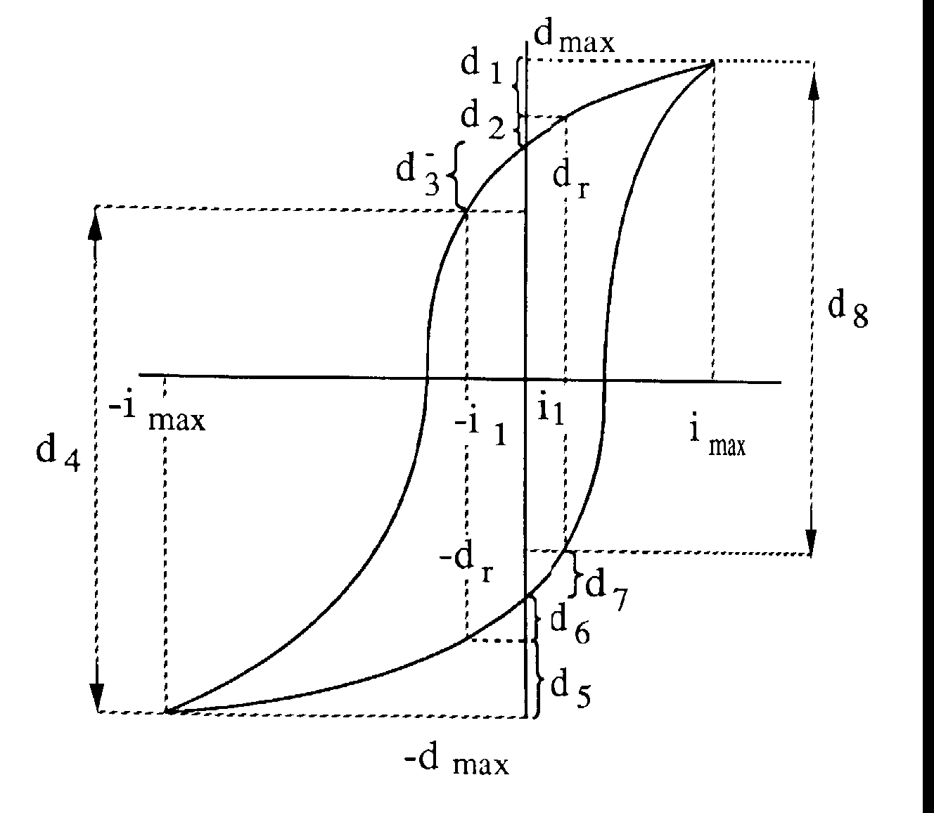
To achieve the "cyclic state", the reversing switch is thrown back and forth some twenty times, but with the secondary circuit open to protect the galvanometer. This process carries the sample from one tip of the hysteresis loop to the other, and back. End with RS to the right and close K. Record the current i (about 0.6 A)

Fig. 3: Sketch of the hysteresis loop, with definitions of deflections and currents.

1st cycle. With K closed, set R to position r₁, so as to give the current i₁ (about 0.1 A) when K is opened. Open K and obtain the momentary deflection d₁, to the nearest millimeter; read i₁ carefully. (Do not alter R in order to get an "exact" value of i₁.) Next, open RS so that the current falls to zero, and read d₂. Then throw RS to the left to get d₃; check i₁. Close K to get d₄. (Note: In Fig. 3, d₁, d₂, d₃ represent intervals, like d₄ but smaller, and similarly for d₅, d₆, d₇; (i_{max},d_{max}) represents the rightmost point.)

The sample is now at the lower tip of the hysteresis loop. The sum of the four deflections is 2d_{max}, (see Fig. 3) This defines the coordinates of the tips of the loop, (i_{max},d_{max}) and (-i_{max},-d_{max}). Subtraction of d₁ from d_{max} locates a point (i₁, d_{max}-d₁) in the first quadrant, while subtraction of d₁ + d₂ locates the point (0, d_{r}), corresponding to residual induction in the iron. Finally, subtraction of d₃ from d_{r} (addition of d₄ to -d_{max}) gives a point in the second quadrant, viz. (-i₁, -(d_{max} -d₄)).

The foregoing operations are now repeated, in reverse. Open K for deflection d₅. Open RS for deflection d₆. Throw RS to the right to get d₇. Close K to get d₈. The sum, d₅ to d₈ should evidently equal the previous sum d₁ to d₄, and d₅ + d₆ should equal d₁ + d₂, etc., from symmetry. In practice there will be slight but unimportant discrepancies.

The sample has been returned to the upper tip of the hysteresis loop, and the cycle may now be repeated to check the deflections, or to catch one that was missed. From other cycles, below, there will be additional checks on the sums that give d_{max} and d_{r}, but not on the four points corresponding to ~ i₁.

2nd cycle: With RS to the right and K closed, set R to the position r₂, i.e. at the value for i₂ (about 0.2 A). Now repeat the eight steps outlined in cycle 1, and record the deflections.
Note that four new points on the curve are obtained, corresponding to ~ i₂.

Other cycles: Repeat the cycle, with R set to position r₃, to give i₃ (about 0.3 A) when K is opened. Repeat again for i₄ and for i₅ to complete the data. The following scheme suggests a convenient way of tabulating deflections: i_{max}, and i₁ to i₅ are indicated in parentheses, as are the sums needed to evaluate d_{r} and d_{max,}.

Note: If a mistake is made in any cycle, it is necessary to "get back on the loop." Hence, reverse the incorrect step, and continue around the cycle without taking readings. After opening the secondary circuit, throw RS. back and forth a number of times, at maximum current (K closed). Then start the cycle again, this time taking reading.

Results: Plot the results carefully on graph paper, preferably a large sheet of good quality. Choose convenient scales, so as to approximately cover the sheet used. Note that all the points from all the cycles should be plotted in the same graph, and connected by one closed line depicting the hysteresis loop.

- Questions:
- Give a clear and complete explanation of what happens in this experiment:
- Within every cycle you change the current in the primary circuit through a series of values; what are these values, and in which order are they attained?
- What is the direct consequence of these current changes?
- What happens in the Fe torus due to the consequence of the current change?
- Whatever happens in the iron torus causes something in the secondary circuit -- what is this, and how does it influence the galvanometer?

(2) How would the applied magnetic field B_{app} be found from the current i and the specifications of the toroidal coil? Give the relationship between B_{app} and and the total field B.
Explain susceptibility, κ, and permeability μ.

(3) How can the total field in the ferromagnetic material B be computed from the galvanometer deflection, if the relation between ballistic deflection and charge is q = K_{R}d. (K_{R} is the ballistic constant for the particular resistance present in the secondary circuit.)

(4) If the coordinates of your loop were B and B_{app} rather than d and i, how would you find the energy needed to put your sample through one hysteresis cycle? Judging from the loop, would your sample appear to make a good transformer core?

(5) Explain how the symmetry of your loop depends: (i) on the data; (ii) on the method of plotting.

(6) As an optional experiment, remove Q from the secondary circuit and note the effect on the deflections. How does it come about that adding resistance: (i) decreases the deflections, yet (ii) also decreases the damping?

-------------------------------------------------------------------------------------------------------------------
(i₁) (i₂) (i₃) (i₄) (i₅)
-------------------------------------------------------------------------------------------------------------------
Defl. Sums Defl Sums Defl. Sums Defl. Sums Defl. Sums
====================================================================
d₁
d₂ (d₁+d₂) ( ) ( ) ( ) ( )
d₃
d₄ (d₃+d₄) ( ) ( ) ( ) ( )
d₅
d₆ (d₅+d₆) ( ) ( ) ( ) ( )
d₇
d₈ (d₇+d₈) ( ) ( ) ( ) ( )
2d_{max} = ( ) ( ) ( ) ( ) ( )

6. References:
[1] Michael Ference, Harvey B. Lemon, Reginald J. Stephenson:
”Analytical Experimental Physics”, Univ. of Chicago Press, 1956; Ch. 28;
[2] Leonard B. Loeb: “Electricity and Magnetism” (2nd ed.),
John Wiley & Sons, NewYork 1947; Ch. XVII.
[3] William B. Fretter: Introduction to Experimental Physics, Dover 1968.

