PHY3802L: INTERMEDIATE LAB

Iel.1 Operational amplifier circuits

1. Purpose: Learn about operational amplifiers.

2. Apparatus: power supply (+/- 15V)
oscilloscope
breadboard
electronic components (resistors, op.amp. chip, ..)
DVM

3. Background information:

3.1 About operational amplifiers:
An operational amplifier is a differential amplifier with very high gain ("open-loop gain" A₀), very high input impedance (Z_{in}), and very low output impedance (Z _{out}).
+
_

v₊

v₋
v_{out}
V₊
V₋
_
+
5
6
7
8
4
3
2
1

Fig. 1 Fig.2

In normal operation, it needs to be supplied by symmetric voltages V₊ and V₋ (V₋ = -V₊ ).
Its behavior is described by v_{out} = A₀ (v₊ - v₋ ). In amplifier applications it is usually used with "negative feedback", i.e. part of the output signal is fed back to the negative input (i.e. effectively subtracted from the input signal). The behavior of such circuits can be calculated using the "opamp rules":
1. the input currents are 0: i₊ = i₋ = 0
2. the input voltage difference is 0: v₊ - v₋ = 0
(These rules are strictly speaking only valid for an ideal opamp, but are a reasonable approximation for real opamps).
The opamp chip that we are using in this lab is the 741A opamp. It comes in an 8-pin dual-inline package (DIP) (see fig. 2). The connections for the pins are as follows: pins 2 and 3 are for v₋ and v₊ , pin 4 is for negative supply voltage, pin 7 for positive supply voltage, and pin 6 is for the output.

3.2 Negative feedback
In amplifiers, opamps are used in circuits with "negative feedback", i.e. a circuit in which a fraction of the output voltage is subtracted from the input.
The effective input voltage v' is therefore

v' = v_{in} - B ∙ v_{out} ,

where B = "feedback factor" (feedback fraction) is determined by details of the feedback circuit.
The amplification with feedback, A_{f} (called "closed-loop gain"), is defined as
$A_{f}=\frac{v_{\text{out}}}{v_{\text{in}}}$
From the property of the opamp, it follows that v_{out} = A₀ v' = A₀ (v_{in} - B v_{out} ),
and therefore

$A_{f}=\frac{A_{0}}{1+A_{0}B}$ Note:
- A_{f} < A₀
- $A_{f}≈\frac{1}{B}$A₀ B >> 1, then
i.e. the gain of the amplifier depends only on the feedback fraction B, not on the open-loop gain A₀ of the opamp;
so, variation of A₀ does not matter!

4. Procedure:

- Construct the summing amplifier shown in fig. 3, using resistor values R_{f} ≈ 8kΩ, R₁ ≈ 2kΩ and R₂ ≈ 1kΩ. Use 12 V as supply voltage.
- Apply a sinusoidal signal of about 200mV amplitude (from the function generator) to each input separately with the other grounded and measure the sign and magnitude of the amplification factor.
- Then connect the same signal to both inputs and measure the output magnitude. Compare with predicted values.
- Apply a sinusoidal signal to both inputs; vary the amplitude of the input signal from 100mV to 1.2V (in 100mV steps) and measure the gain (i.e. ratio of amplitude of the output signal and amplitude of input signal). Plot it as a function of the nominal output signal amplitude (i.e. the output signal amplitude expected from the formula given in fig.3). Comment on your observations.
- For a fixed input amplitude (abut 0.5V), measure the gain $\frac{v_{\text{out}}}{v_{\text{in}}}$
as a function of frequency of the sinusoidal, from about 500Hz to the maximum frequency available on the function generator. Take data for 3 frequency values per decade.

- Instead of a sinusoidal signal, use a triangular wave and a square wave as input, and observe the output waveforms. Draw the waveforms and comment on your observations. What characteristic specifications of the opamp are important here?

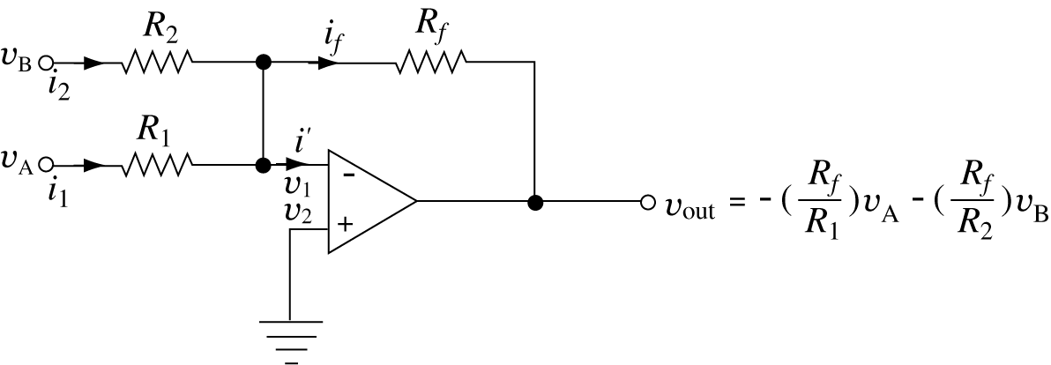
Fig. 3: Summing amplifier

5. Bibliography:
There are many books on modern electronics; examples of more useful ones are:
- Robert E. Simpson: Introductory Electronics for Scientists and Engineers,
Allyn and Bacon, Newton, Mass. 1987
- William L. Faissler: An Introduction to Modern Electronics
John Wiley & Sons, New York 1991
- Paul Horowitz and Winfield Hill: The Art of Electronics,
Cambridge University Press, Cambridge 1989
- D.V. Bugg: Electronics Circuits, Amplifiers and Gates, Institute of Physics Publishing,
Bristol 1991
- Mark N. Horenstein: Microelectronic Circuits and Devices, 2nd ed., Prentice Hall, 1995
- A. de Sa: Electronics for Scientists, Prentice Hall, 1997

