IO.4 Reflection of polarized light from dielectrics,

Fresnel's equations

1. Purpose: Verify Fresnel's Equations of Reflection

2. Apparatus: Gaertner Scientific spectrometer,
two polarizers,
monochromatic light source.

- Procedure:
The reflectance of a dielectric for light at non-normal incidence is dependent on the polarization of the incident light.

(a) Align the spectrometer. With unpolarized "monochromatic" light falling on the face of the prism and the angle between the telescope and collimator around 115°, place a piece of polaroid in the telescope beam. By making adjustments in the orientation of the polaroid and the incident angle, obtain a minimum in the reflected intensity.

The minimum corresponds to a plane polarization of the incident light such that the electric vector is parallel to the surface. The angle of incidence for complete polarization is called Brewster's angle and it is given by n = tan i.

Obtain a value for n and compare with the value obtained by other means.

(b) Place a polaroid in the incident beam oriented at 45° so as to put equal components of both polarizations into the prism. Using a range of values for i, rotate the analyzer polaroid for maximum extinction.

Determine the angle of the analyzer relative to the plane of incidence for the above measurements and obtain the ratio of the amplitudes of the two components of the reflected light. Plot and compare your results with the theoretical curve. (See explanation below.)

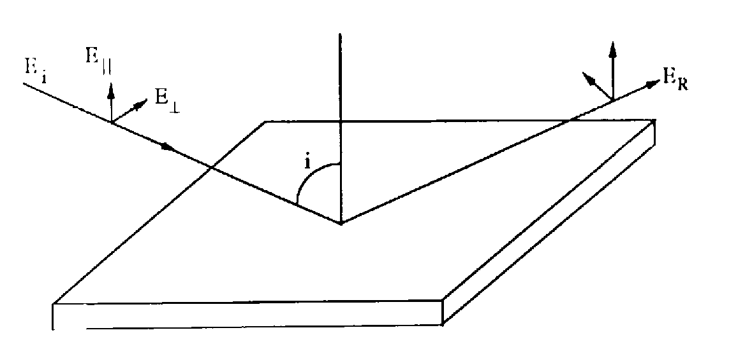

Fig. 1: Electric field components of incidence and reflected light

The Polaroid turned at 45° gives equal components of both polarizations (parallel and perpendicular to the plane of incidence).
After reflection, the two components are no longer equal and the resultant is no longer at 45°.

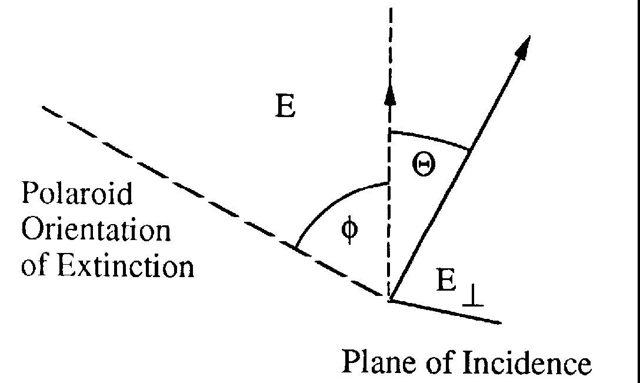

Fig. 2: Electric field components after reflection

Measurement of tan ϑ yields E⊥/E║ .

If i and n are known, this ratio can be compared with the theoretical value which can be derived from Fresnel's equations for reflection of polarized light.

- References:
See, e.g., Jenkins & White: Fundamentals of Optics, 4th ed., Mc Graw Hill 1976,
Chapters 24 and 25.

