PHY 4822L (Advanced Laboratory):

Analysis of a bubble chamber picture

Introduction
Elementary particles are everywhere around us [1,2]. Apart from the standard matter particles proton, neutron and electron, hundreds of other particles have been found [3], produced in cosmic ray interactions in the atmosphere or by accelerators. Hundreds of charged particles traverse our bodies per second, and some will damage our DNA, one of the reasons for the existence of a sophisticated DNA repair mechanism in the cell.

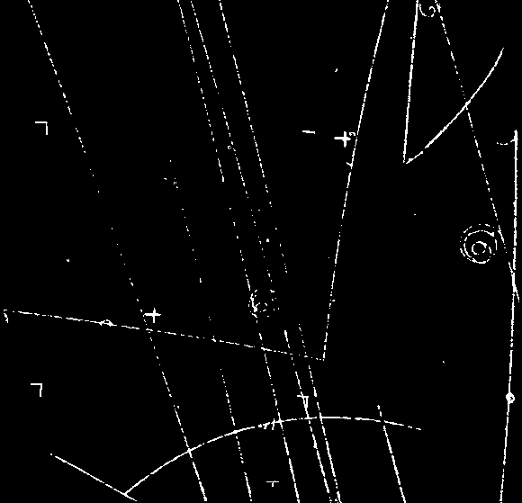
Figure 1: Photograph of the interaction between a high-energy π⁻-meson from the Berkeley Bevatron accelerator and a proton in a liquid hydrogen bubble chamber, which produces two neutral short-lived particles Λ⁰ and K⁰ which decay into charged particles a bit further.

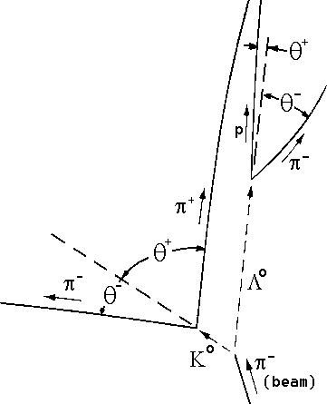
Figure 2: illustration of the interaction, and identification of bubble trails and variables to be measured in the photograph in Figures 3 and 4.

The data for this experiment is in the form of a bubble chamber photograph which shows bubble tracks made by elementary particles as they traverse liquid hydrogen. In the experiment under
study, a beam of low-energy negative pions (π⁻ beam) hits a hydrogen (p for proton) target in the form of a container with liquid hydrogen normally kept just below its boiling point (T=20 K). As the pions enter the detector a piston slightly decompresses the liquid so it becomes "super-critical'' and starts boiling, and bubbles form, first at the ionization trails left by the charged particles traversing the liquid.

The reaction shown in Figure 1 shows the production of a pair of neutral particles (that do not leave a ionized trail in their wake), which after a short while decay into pairs of charged particles:

π ⁻ + p → Λ⁰ + K⁰ ,
where the neutrals decay as follows:

Λ⁰ → p + π ⁻, K⁰ → π⁺ + π⁻.

In this experiment, we assume the masses of the proton (m_{p} = 938.3 MeV/c²) and the pions (m_{π}⁺ = m_{π}⁻ = 139.4 MeV/c²) to be known precisely, and we will determine the masses of the Λ⁰ and the K⁰, also in these mass energy units.

Momentum measurement
In order to “reconstruct” the interaction completely, one uses the conservation laws of (relativistic) momentum and energy, plus the knowledge of the initial pion beam parameters (mass and momentum). In order to measure momenta of the produced charged particles, the bubble chamber is located inside a magnet that bends the charged particles in helical paths. The 1.5 T magnetic field is directed up out of the photograph. The momentum p of each particle is directly proportional to the radius of curvature R, which in turn can be calculated from a measurement of the “chord length” L and sagitta s as:

r = [L²/(8s)] + [s/2] ,

Note that the above is strictly true only if all momenta are perfectly in the plane of the photograph; in actual experiments stereo photographs of the interaction are taken so that a reconstruction in all three dimensions can be done. The interaction in this photograph was specially selected for its planarity.
In the reproduced photograph the actual radius of curvature R of the track in the bubble chamber is multiplied by the magnification factor g, r = gR. For the reproduction in Figure 3, g = height of photograph (in mm) divided by 173 mm.

The momentum p of the particles is proportional to their radius of curvature R in the chamber. To derive this relationship for relativistic particles we begin with Newton's law in the form:

F = dp/dt = e v×B (Lorentz force).

Here the momentum (p) is the relativistic momentum m v γ, where the relativistic γ-factor is defined in the usual way
γ = [√(1- v ²/c²)]⁻¹.

Thus, because the speed v is constant:

F = dp/dt = d(mvγ)/dt = mγ dv/dt = mγ (v²/R)(-r) = e v B (-r) ,

where r is the unit vector in the radial direction. Division by v on both sides of the last equality finally yields:
mγv /R = p /R = e B ,

identical to the non-relativistic result! In “particle physics units” we find:

p c (in eV) = c R B ,  thus p (in MeV/c) = 2.998•10⁸ R B •10⁻⁶ = 300 R (in m) B (in T) | (1)

Measurement of angles
Draw straight lines from the point of primary interaction to the points where the Λ⁰ and the K⁰ decay. Extend the lines beyond the decay vertices. Draw tangents to the four decay product tracks at the two vertices. (Take care drawing these tangents, as doing it carelessly is a source of large errors.) Use a protractor to measure the angles of the decay product tracks relative to the parent directions (use Fig. 3 or 4 for measurements and Fig. 2 for definitions).

Analysis
The laws of relativistic kinematics relevant to this calculation are written below. We use the subscripts zero, plus, and minus to refer to the charges of the decaying particles and the decay products.
p₊sinθ₊ = p₋sinθ₋ | (2)
p₀ = p₊cosθ₊ + p₋cosθ₋ | (3)
E₀ = E₊ + E₋,
where E₊ = √(p₊²c² + m₊²c⁴) , and E₋ = √(p₋²c² + m₋²c⁴)

m₀c² = √(E₀² - p₀²c²)

Note that there is a redundancy here. That is, if p₊, p₋, θ₊, and θ₋ are all known, equation (2) is not needed to find m₀. In our two-dimensional case we have two equations (2 and 3), and only one unknown quantity m₀, and the system is over-determined. This is fortunate, because sometimes (as here) one of the four measured quantities will have a large experimental error. When this is the case, it is usually advantageous to use only three of the variables and to use equation (2) to calculate the fourth. Alternatively, one may use the over-determination to "fit'' m₀, which allows to determine it more precisely.

K⁰ decay

- Measure three of the quantities r₊, r₋, θ₊, and θ₋. Omit the one which you believe would introduce the largest experimental error if used to determine m_{K}.
- Use the magnification factor g to calculate the actual radii R and equation (1) to calculate the momenta (in MeV/c) of one or both pions.
- Use the equations above to determine the rest mass (in MeV/c²) of the K⁰.
- Estimate the error in your result from the errors in the measured quantities.

]Λ⁰ decay:

  - The proton track is too straight to be well measured in curvature. Also, θ₊ is small, and the value of m_{Λ} is quite sensitive to this measurement. Assume that θ₊ = (0.32±0.05)° (check this with your protractor). Measure r₋ and θ₋.
  - Calculate m_{Λ} and its error the same way as for the K⁰.
  - Finally, compare your values with the accepted mass values (the world average) [3], and discuss.

Bonus question: (25% extra credit)
Calculate the momenta for both neutral particles, and hence find their lifetimes, both in the laboratory, and in their own rest-frames. Compare the latter with the accepted values [3].

References:

[1] G.D. Coughlan and J.E. Dodd: “The ideas of particle physics”, Cambridge Univ. Press, Cambridge 1991
[2] “The Particle Adventure”, http://particleadventure.org/
[3] Review of Particle Physics, by the Particle Data Group, European Physical Journal 15, 1-878 (2000) (available on WWW: http://pdg.lbl.gov)
[4] Kenneth Krane: Modern Physics, 2nd ed.; John Wiley & Sons, New York 1996

Note: Experiment adapted from PHY 251 lab at SUNY at Stony Brook (Michael Rijssenbeek)

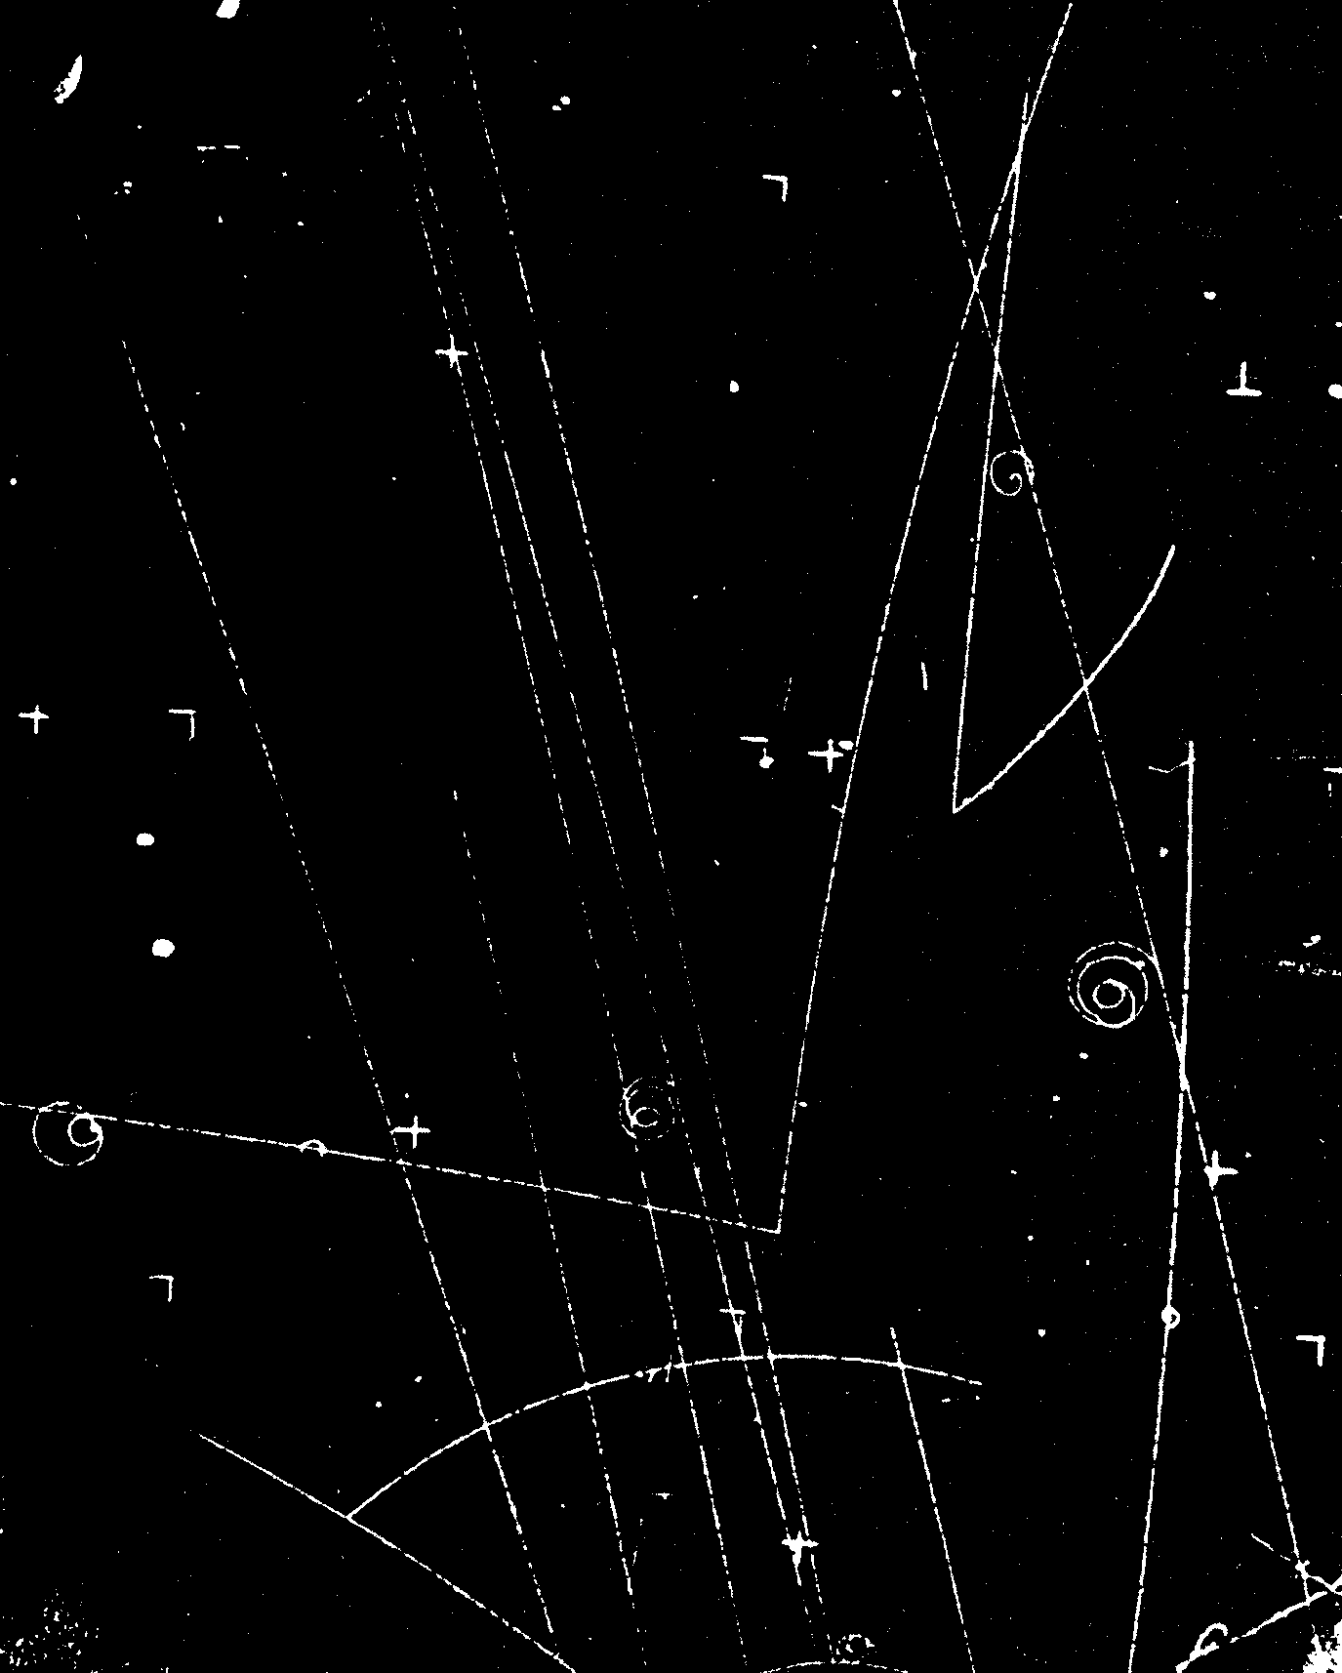
Figure 3 : Photograph of the interaction between a high-energy π⁻-meson from the Berkeley Bevatron accelerator and a proton in a liquid hydrogen bubble chamber. The interaction produces two neutral particles Λ⁰ and K⁰, which are short-lived and decay into charged particles a bit further. The photo covers an area (H•W) of 173 mm • 138 mm of the bubble chamber. In this enlargement, the magnification factor g = (height (in mm) of the photograph )/173 mm.
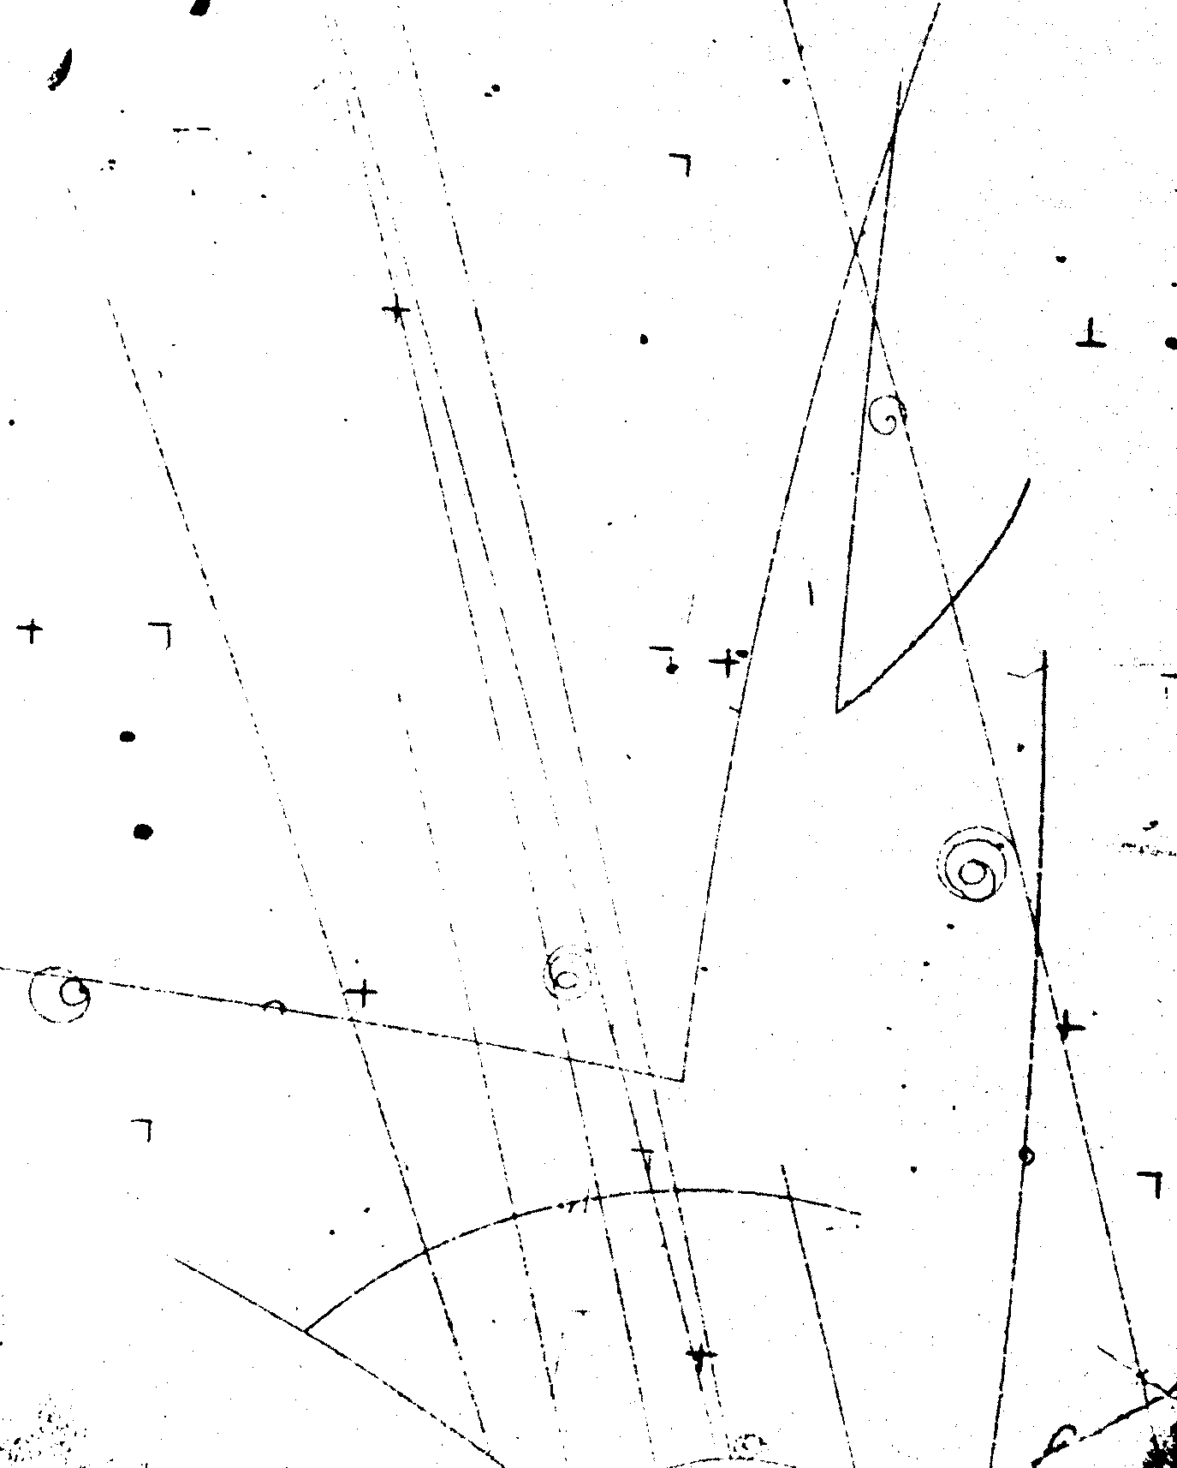

Figure 4 : Negative of photograph of Fig. 3.

