ESR 101 Laboratory 2, Week #4
Due Week #6

Energy

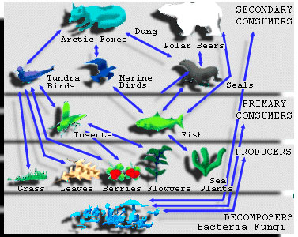

Objective
To explore the relationship between energy and the chemical forms of biological material. Specifically, you will analyze your role in the global food chain by recording consumption and subsequent energy production. The energy-producing value of food is measured in calories. In this exercise you will calculate the number of calories as a direct result of consumption of different foods.

Overview
Energy, the ability to do work, has been described as the basic currency of ecosystems. The specific rate of energy flow or amount of energy ultimately controls the size of populations of species in any natural or human-managed ecosystem.
The sequence of organisms, each of which is a source of food for the next, is called a food chain. It is commonly represented in terms of trophic levels. Producers belong to the first trophic level, primary consumer to the second trophic level, secondary consumers to the third and so on.
At each level of the food chain, about 90% of the energy is lost in the form of heat. The total energy passed from one level to the next is only about one-tenth of the energy received from the previous organism. Therefore, as you move up the food chain, there is less energy available. Animals located at the top of the food chain need a lot more food to meet their energy needs.

Procedure
You will need to record all of the various foods that you consume in one day. Write down everything that you consume (food and beverages.) It is also necessary to record the size of the portions that you consume. On the same day that you record consumption, also record daily activities, eg walking, running and the length of time spent on each activity.
After recording consumption and activities for one day you will need to calculate the total number of calories from each food and total number of calories burned via activities. To make consumption calculations go to: http://www.ag.uiuc.edu/~food-lab/nat/ Click on “energy calculator” then Nats version 2.0 and begin. To calculate number of calories burned go to http://www.nat.crgg.com/energy/daily.html.

Assignment
A written report which includes the stated objective and how this objective was achieved (1 page). Also, please attach to the report all data sheets, with calculations (you can print, in tabular form, calculations from the website,) as well as answers to the questions (1 page) that are attached to this laboratory.

Questions
- What are the various units of energy, power and heat (give examples)? What units did you calculate energy in?
- Where in the food chain do you fit in? Which trophic level best represents you? What type of a consumer are you (eg herbivore?) What are some reasons for eating lower on the food chain?
3) What biological process converts the food you consumed to energy? Are you using organic or inorganic energy sources?

Helpful information for this lab:
A calorie is a unit of energy. We tend to associate calories with food, but they apply to anything containing energy. Specifically, a calorie is the amount of energy, or heat, it takes to raise the temperature of 1 gram of water 1 degree Celsius (1.8 degrees Fahrenheit). One calorie is equal to 4.184 joules, a common unit of energy used in the physical sciences.
Most of us think of calories in relation to food, as in "This can of soda has 200 Calories." It turns out that the calories on a food package are actually kilocalories (1,000 calories = 1 kilocalorie). The word is sometimes capitalized to show the difference, but usually not. A food Calorie contains 4,184 joules. A can of soda containing 200 food calories contains 200,000 regular calories, or 200 kilocalories. A gallon of gasoline contains 31,000 kilocalories.
The same applies to exercise -- when a fitness chart says you burn about 100 Calories for every mile you jog, it means 100 kilocalories. (http://www.howstuffworks.com/calorie.htm)

