The upgraded D0 detector:
The central tracking detectors (which were gaseous drift chambers) are replaced by a silicon microstrip detector and a scintillating fiber tracker arranged in concentric cylinders around the beam pipe. A solenoid magnet is added to allow momentume measurement.
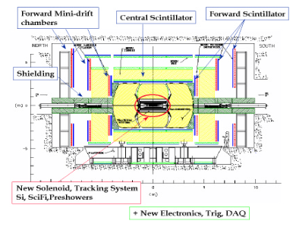

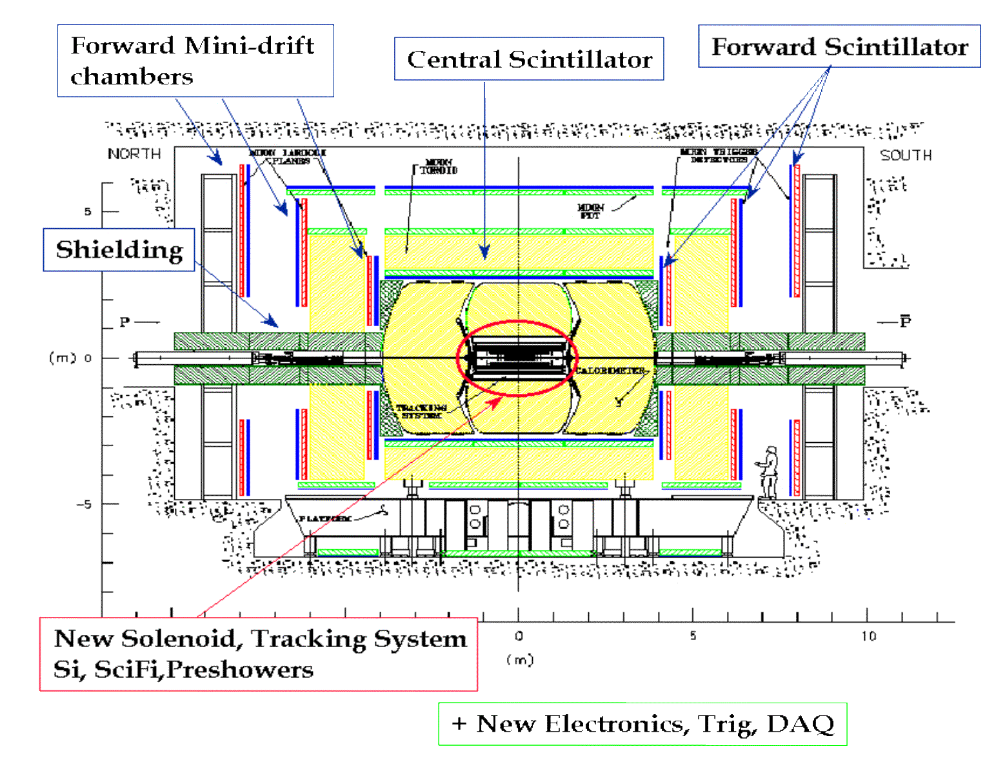

The old D0 detector:

The o

ld
The new tracking detector

Trigger = device making decision on whether to record an event
why not record all of them?
we want to observe “rare” events;
for rare events to happen sufficiently often, need high beam intensities, therefore many collisions take place
e.g. in Tevatron collider, proton and antiproton bunches will encounter each other every 132ns
at high bunch intensities, every beam crossing gives rise to collision Þ about 7 million collisions per second
we can record about 20 to (maybe) 50 per second

why not pick 20 events randomly?
We would miss those rare events that we are really after: e.g. top production: » 1 in 1010 collisions Higgs production: » 1 in 1012 collisions
Þ would have to record 50 events/second for 634 years to get one Higgs event!
Storage needed for these events: » 3 ´ 1011 Gbytes
Trigger has to decide fast which events not to record, without rejecting the “goodies”

The Silicon microstrip tracker of D0. Shown are the six "barrels" in the center, and the small and large disks. The whole detector has about 800,000 strips. Only the axial strips
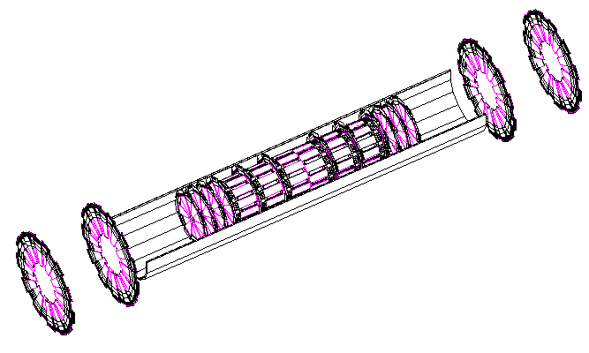
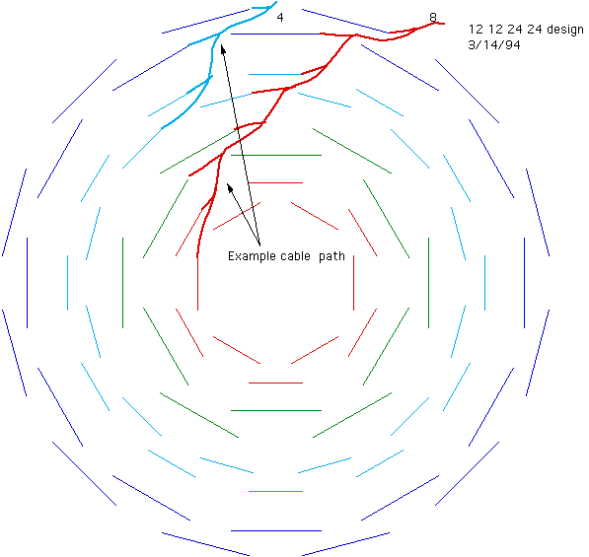
of the barrel are used in the trigger.
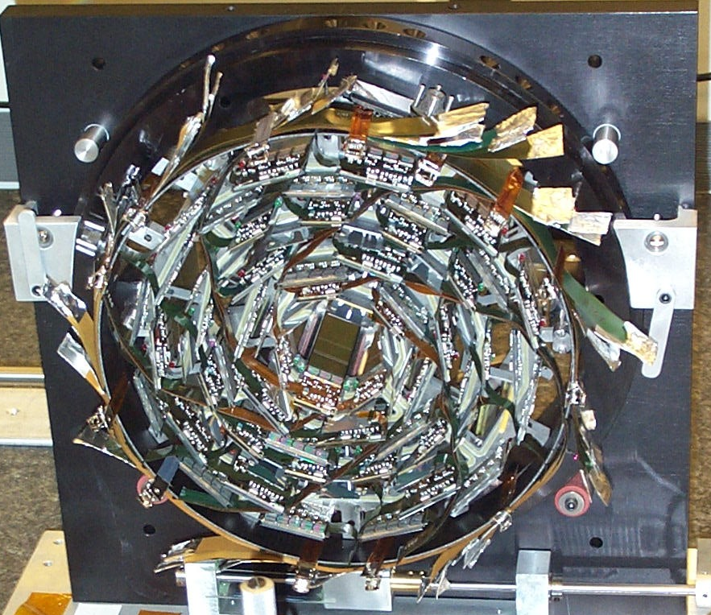
a photograph of one of the barrels of the silicon microstrip tracker

