Appendix B: TOP LEVEL SCHEMATICS OF THE STC MAIN DATA PATH AND THE SIMULATION RESULTS

B.1: STC -- MAIN DATA PATH

B.2: STRIP READER AND CENTROID FINDER MODULES WITH MAIN MEMORY DECODER AND MISCELLANEOUS PARAMETERS MEMORY SPACE

B.3: MISCELLANEOUS PARAMETERS MEMORY SPACE

B.4: PULSE THRESHOLD MEMORY SPACE

B.5: CLUSTERING THRESHOLD MEMORY SPACE

B.6: CHIP RANGE MEMORY SPACE

B.7: MISCELLANEOUS REGISTER MEMORY SPACE

B.8: STRIP READER AND THE CENTROID FINDER MODULES

B.9: STRIP READER MODULE

B.10: TEST MEMORY SPACE

B.11: BAD CHANNEL MEMORY SPACE

B.12: GAIN AND OFFSET MEMORY SPACE

B.13: CENTROID FINDER MODULE

B.14: HIT FILTER MODULE

B.15: HIT FILTER CONTROL MODULE

B.16: COMPARATOR MODULE

B.17: HIT READ OUT MODULE

B.18: FUNCTIONAL SIMULATION OF THE TEST DATA STREAM

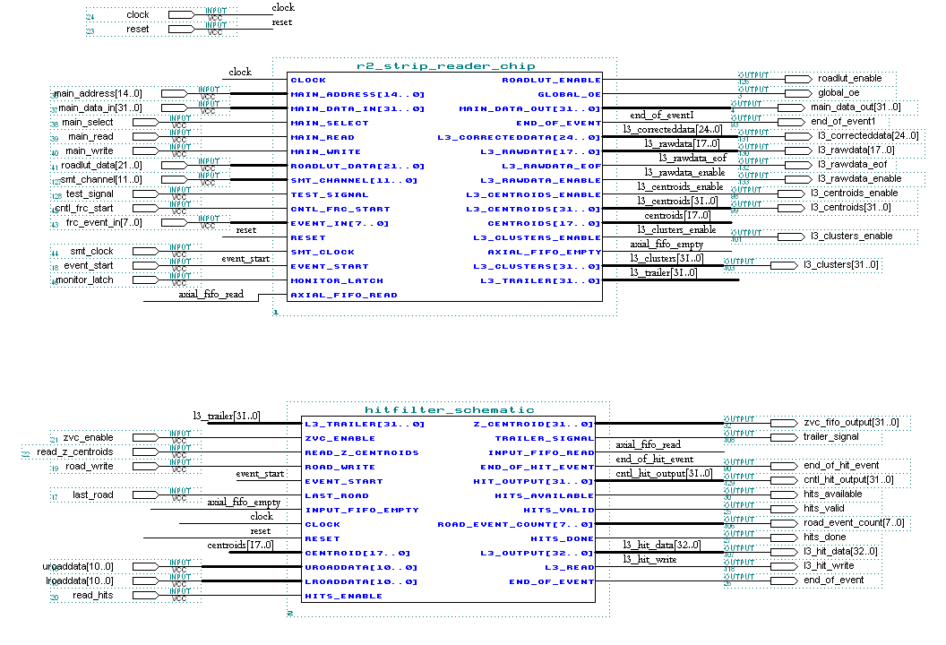
B.1: MAIN DATA PATH

B.2: STRIP READER AND CENTROID FINDER MODULES WITH MAIN MEMORY DECODER AND MISCELLANEOUS PARAMETERS MEMORY SPACE
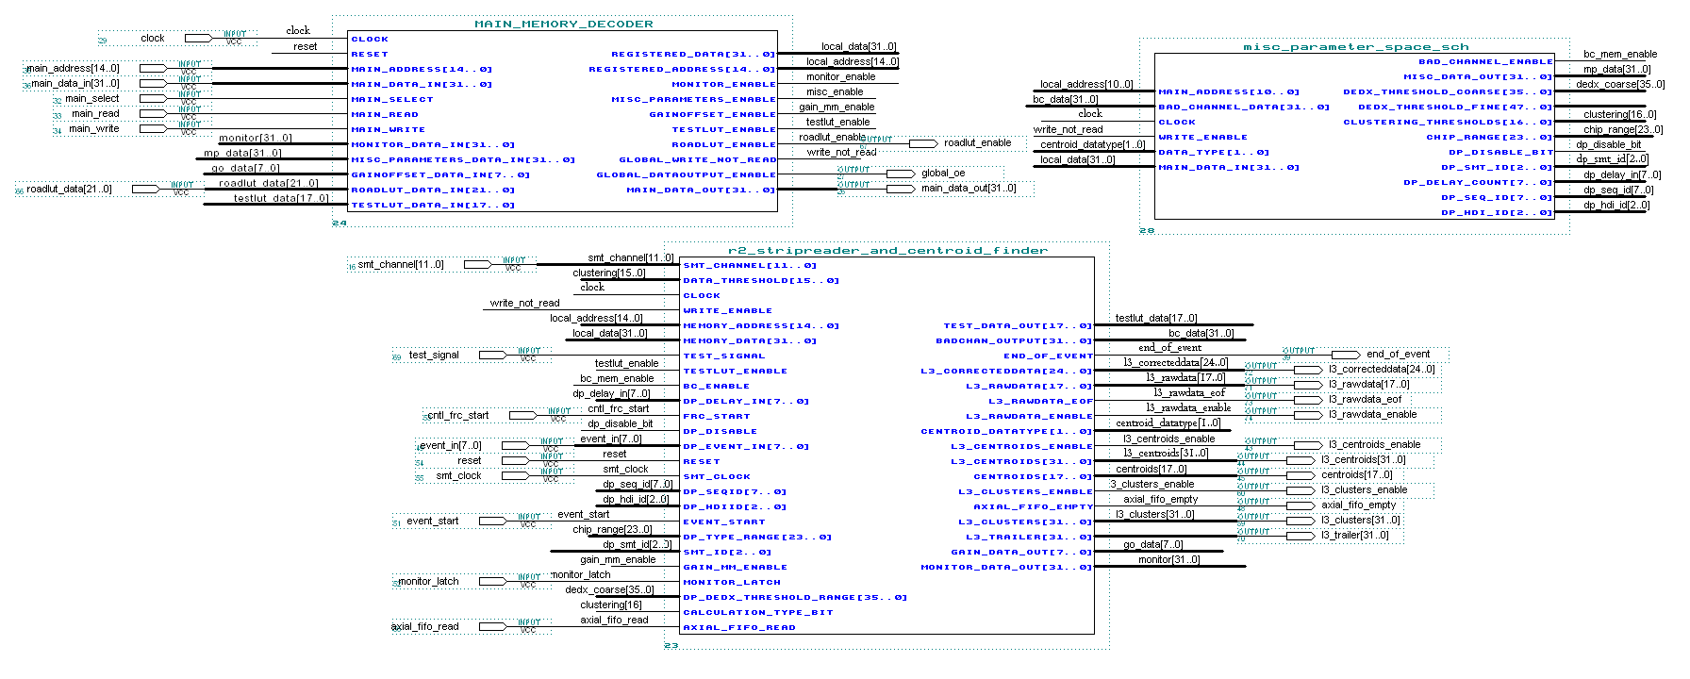

B.3: MISCELLANEOUS PARAMETERS MEMORY SPACE

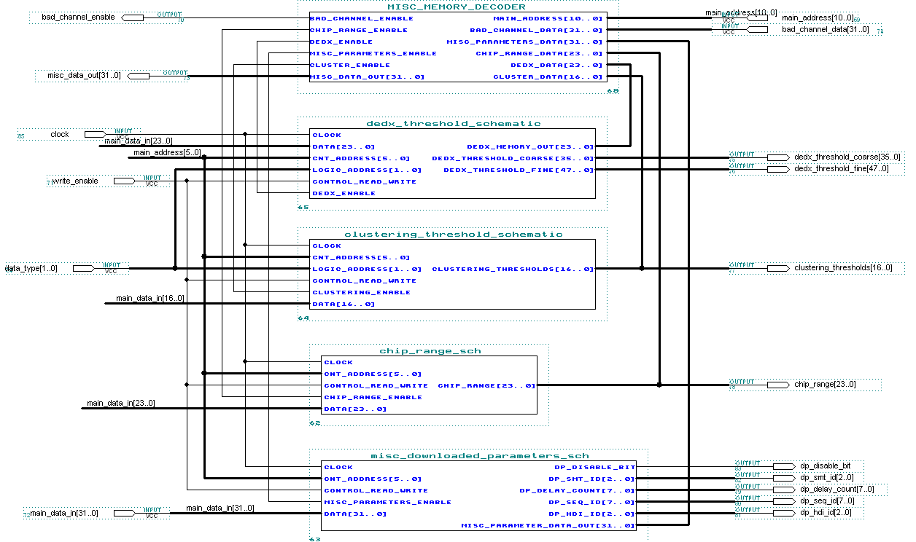

B.4: PULSE THRESHOLD MEMORY SPACE

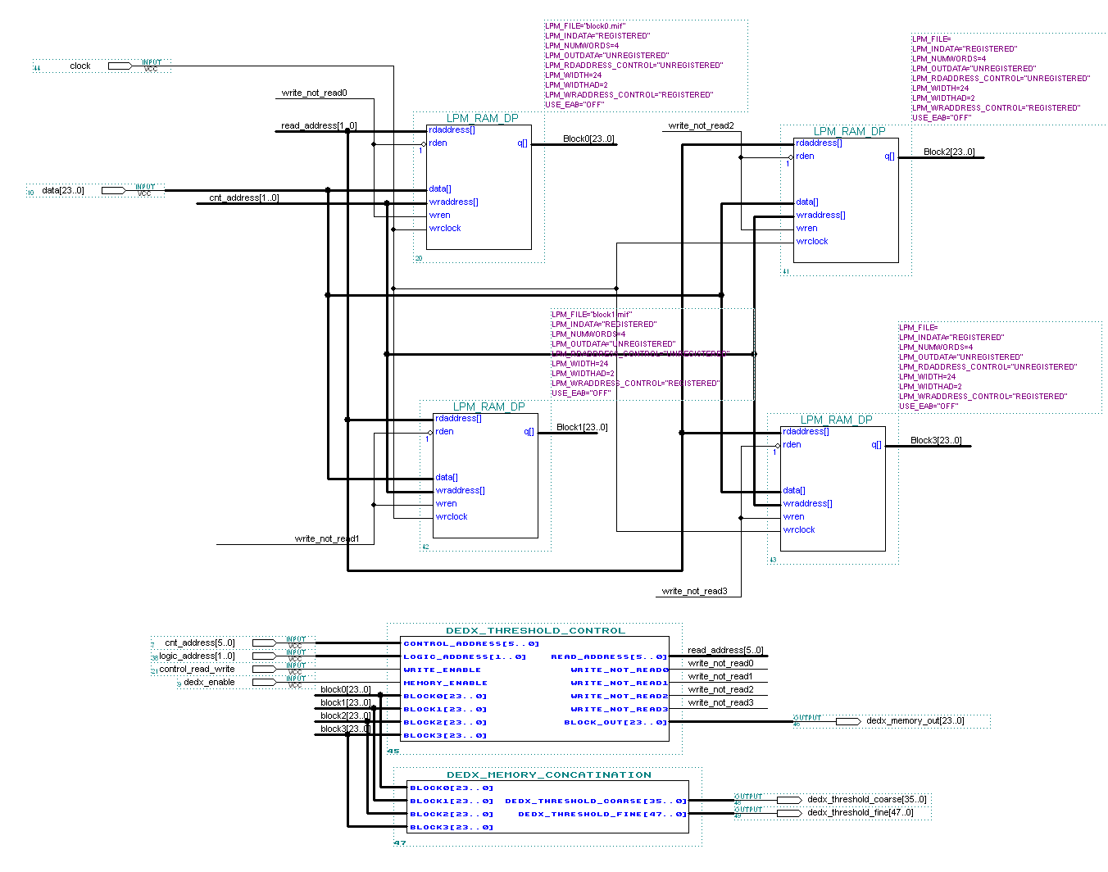

B.5: CLUSTERING THRESHOLD MEMORY SPACE

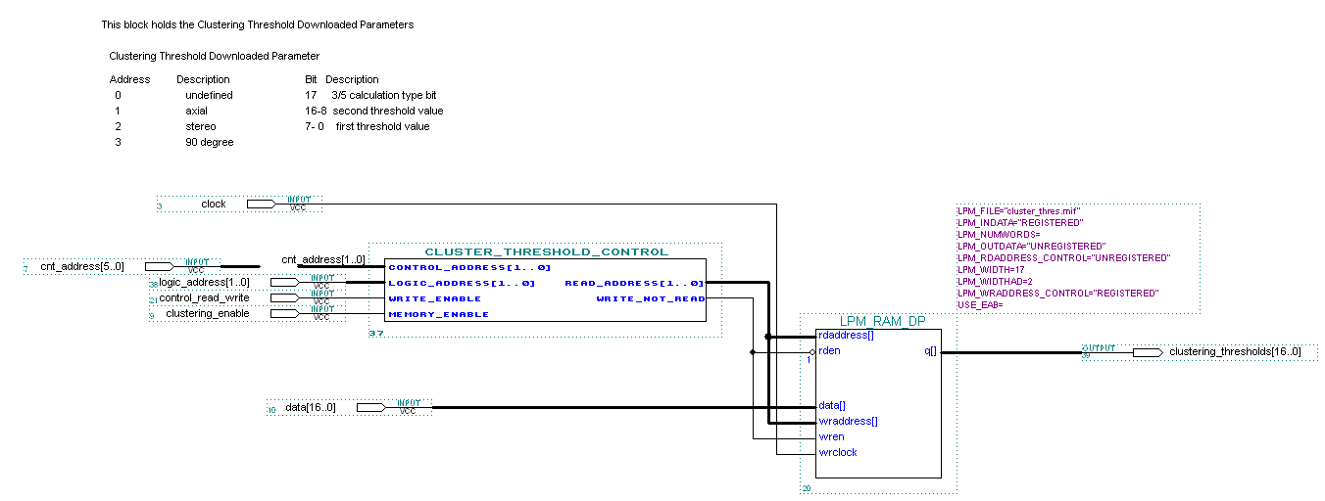

B.6: CHIP RANGE MEMORY SPACE
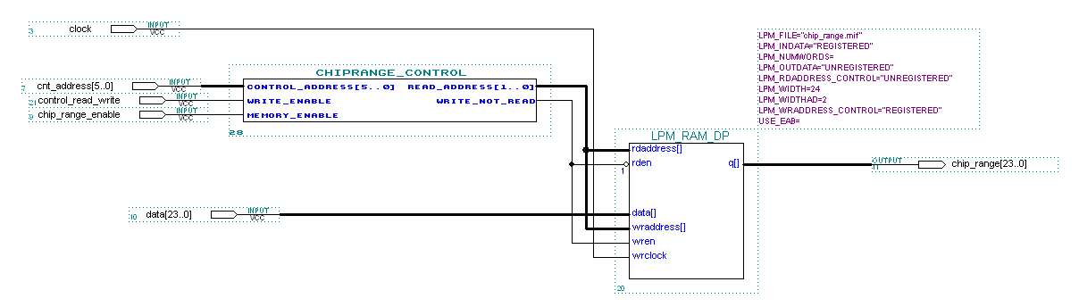

B.7: MISCELLANEOUS REGISTER MEMORY SPACE
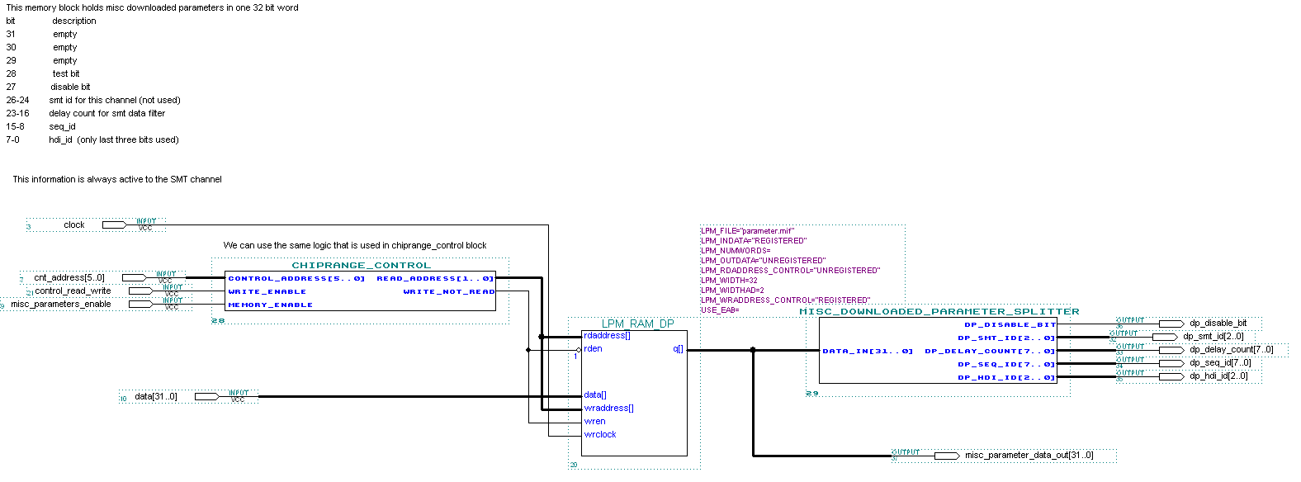

B.8: STRIP READER AND THE CENTROID FINDER MODULES

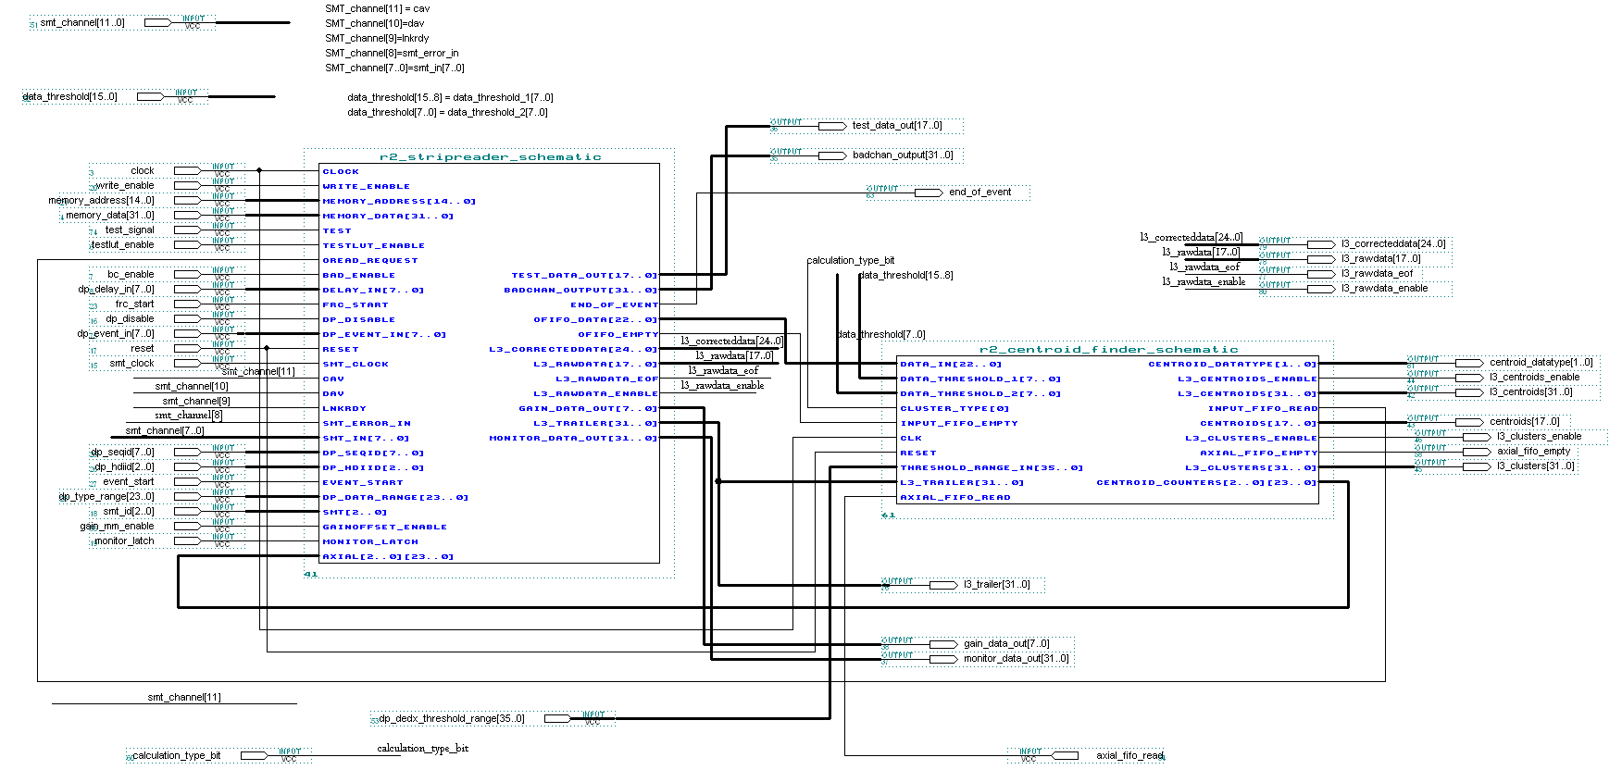

B.9: STRIP READER MODULE

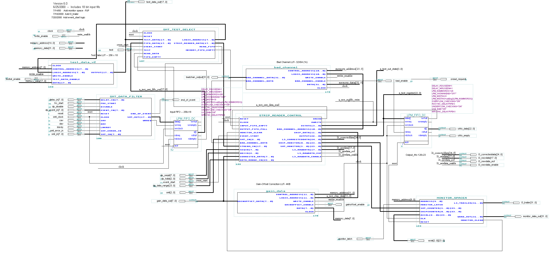

B.10: TEST MEMORY SPACE
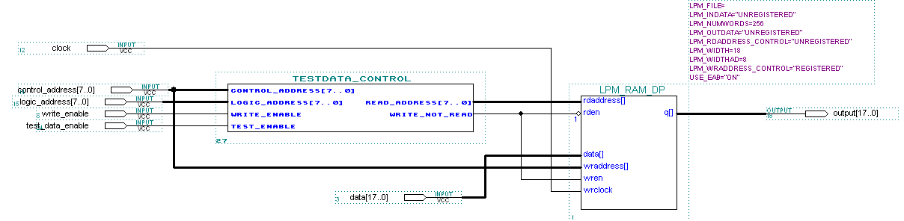

B.11: BAD CHANNEL MEMORY SPACE
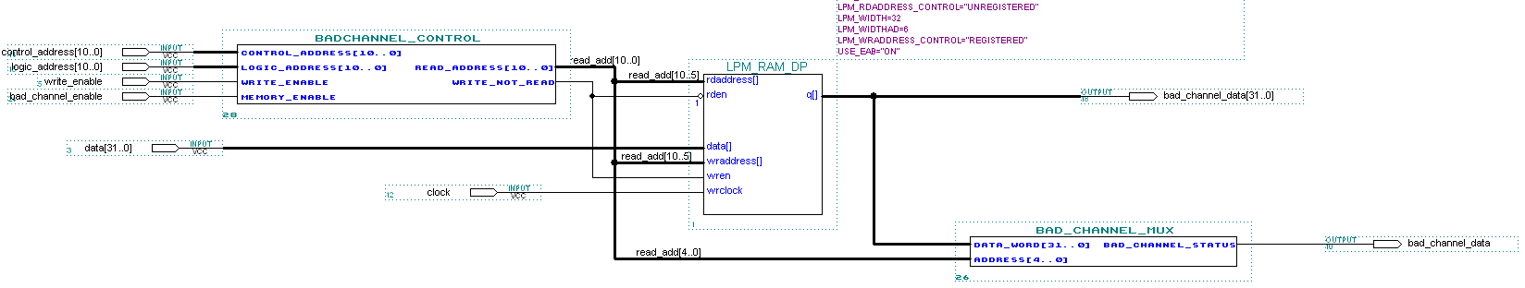

B.12: GAIN AND OFFSET MEMORY SPACE
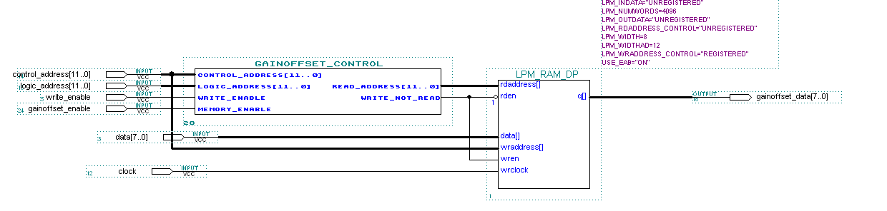

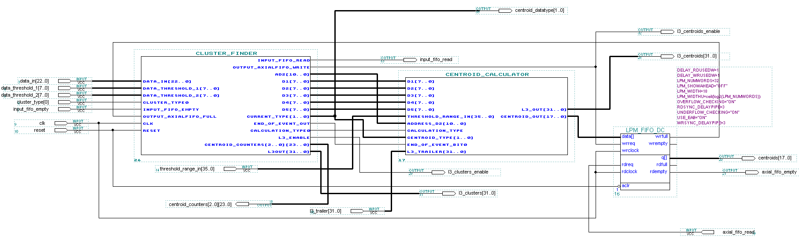
B.13: CENTROID FINDER MODULE

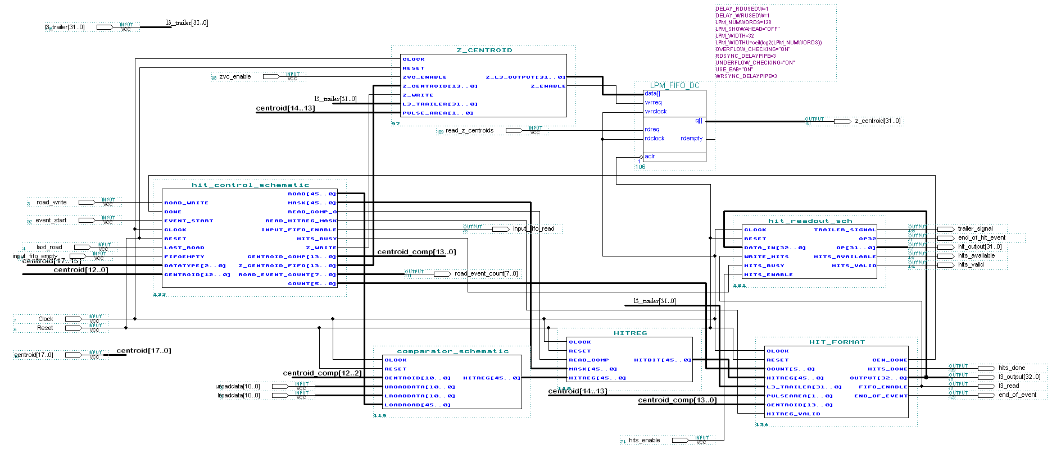
B.14: HIT FILTER MODULE

B.15: HIT FILTER CONTROL MODULE
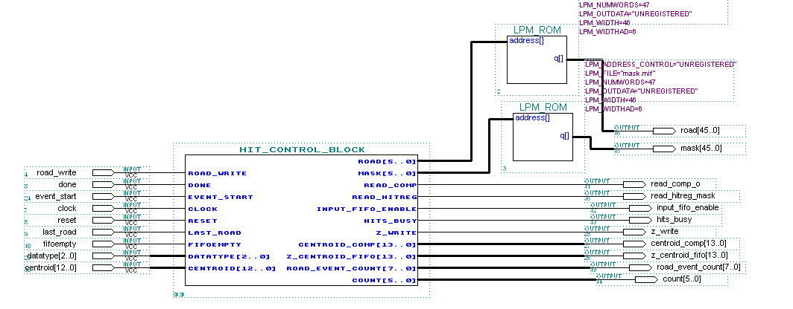

B.16: COMPARATOR MODULE
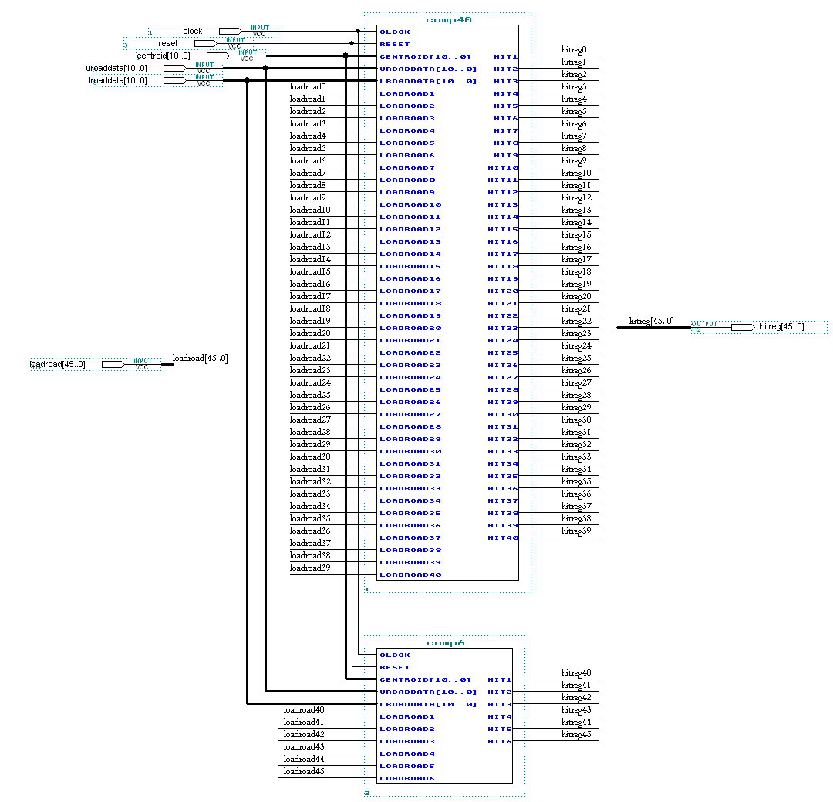

B.17: HIT READ OUT MODULE
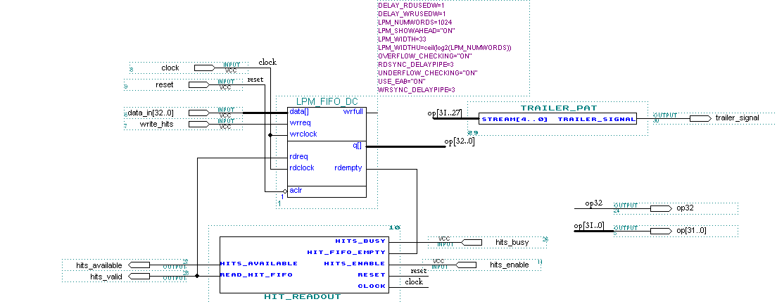

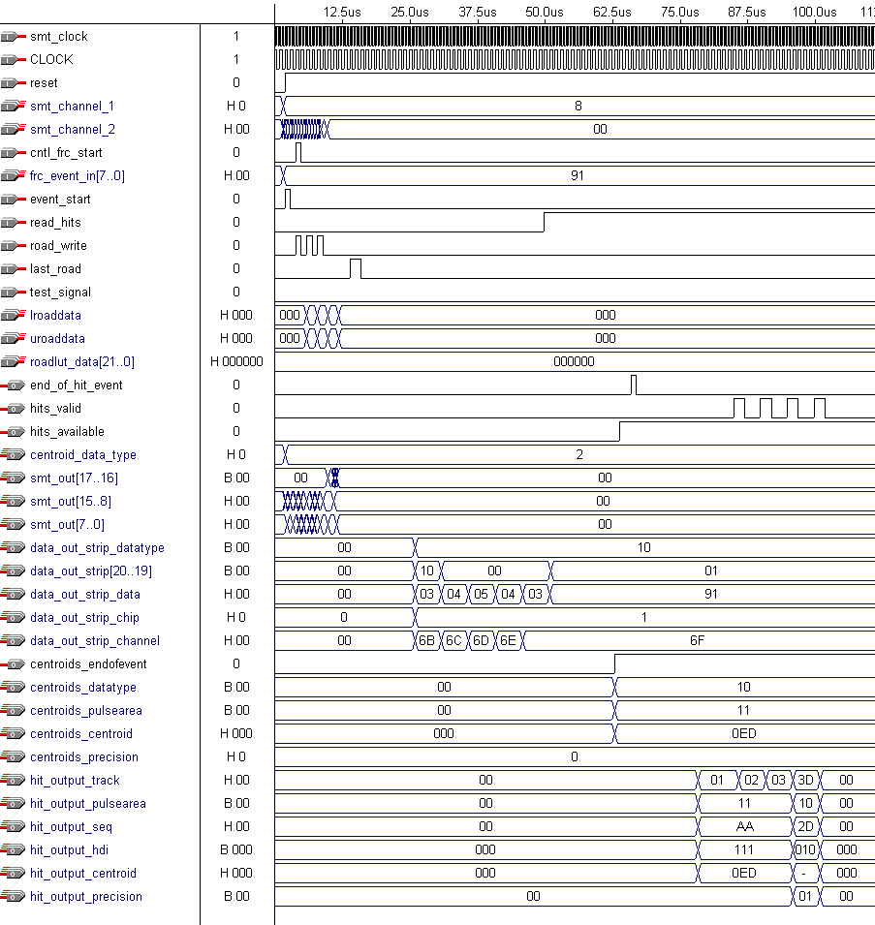
B.18: FUNCTIONAL SIMULATION OF THE TEST DATA STREAM

