APPENDIX B
SCHEMATICS OF THE STC MODULES

Hit Filter Interface:

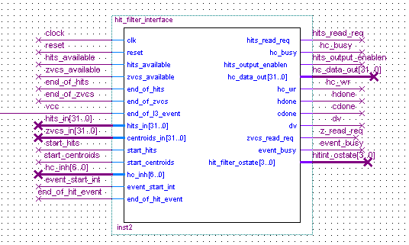

Hit-Filter Implemented with only a CAM

Road-set Generator and the CAM for a single road.

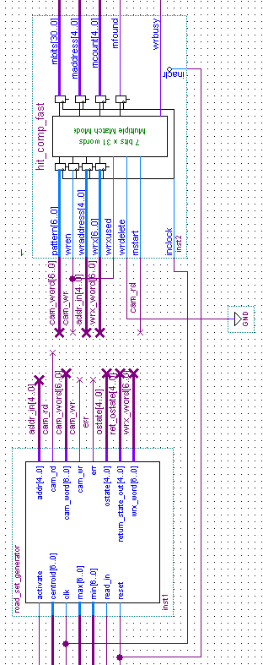

Hit-Filter Implemented with a comparator and Hit-Word Generator Block:

Comparator Module for 46 roads

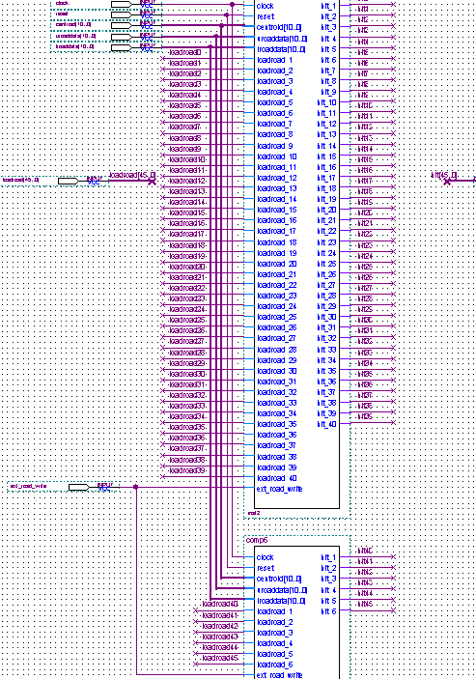
Hit Word Generator and the Hit-FIFO
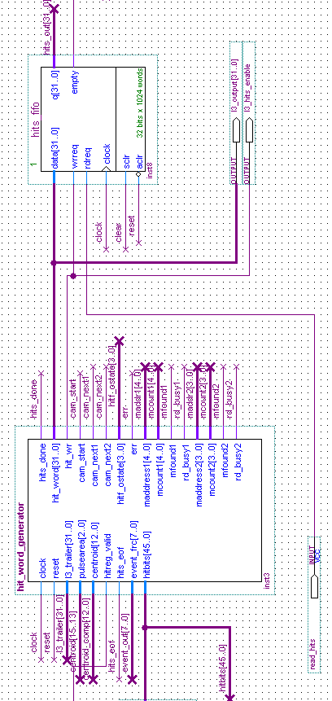
Hit-Word Generator Module

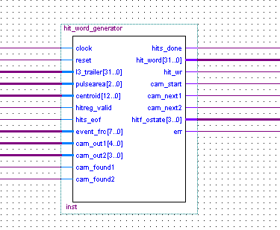

Hit-word Generator Module:
Hit_generator and the two CAMs

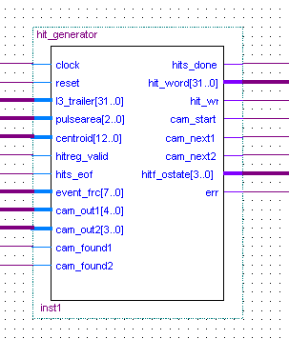
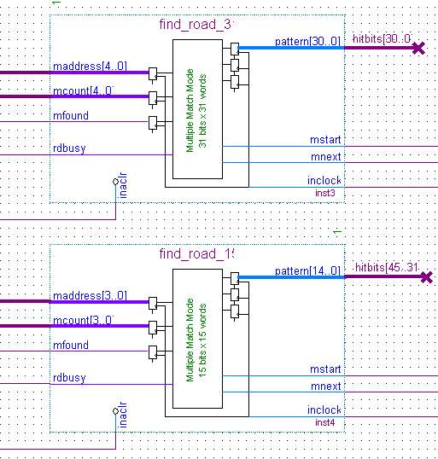

The L3 write control module (L3_sch) and L3 read control module (L3_readout_control_edf)
